Napa Valley Intergroup Meeting Agenda

April 13, 2024

Call To Order

A Moment of Silence followed by the Serenity Prayer

New Rep Introduction
New Intergroup Reps and Officers packets can be found on aanapa.org
https://aanapa.org/service/intergroup/welcome-new-intergroup-reps
Please provide your email and contact information to the Secretary.

Meeting Participant Introductions

Sobriety Birthdays

Review and approval of minutes

Monthly Tradition Reading from 12 Traditions Illustrated & Discussion
Reader: Jason
4th Tradition: Each group should be autonomous except in matters affecting other groups or A.A. as a whole.

7th Tradition
We have no dues or fees in A.A. We are entirely self-supporting, declining outside contributions. Visit https://www.aanapa.org and use the Venmo link or mail your contribution to NVIG, P.O Box 10948, Napa, CA 94581-2948. Venmo link for IG contributions: https://www.venmo.com/u/NapaIG-AA

Housekeeping Motions
Please wait your turn to speak and utilize the “raised hand” function to be called on to speak

Announcements

Reports:

Chair: Meghan T.
chair@aanapa.org

No submission

Alternate Chair: VACANT
altchair@aanapa.org

No submission

Secretary: Meg P.
secretary@aanapa.org

Nothing to report.

Literature Chair: Mary W.
literature@aanapa.org

MARCH 2024 | Literature Report
New Life Women’s Group | 3 Big Books | 36.00
Thursday night Participation | 4 Daily Reflections, 1 As Bill Sees It, 1 Experience, Strength and Hope, 1 Pass It On (Balance owed $5.50) | 73.50
Kiss Monday Women’s Meeting | 4 Big Books | 48.00
Sunday Night Big Book | 1 As Bill Sees It | 11.00
Thank God Its Monday to Sunday | 2 Large Print Big Books, 5 Living Sober, 2 As Bill Sees It, 1 Dr. Bob and the Good Old Timers | 88.00
TOTAL $256.50

I am having shoulder surgery in May and will be unable to do this position for a few (several?)
months. If you are interested in taking over during this time, please give me a call (707)260-5672. (Mike has offered to fill in for Mary while she heals)

The online literature order form is working well. It, as well as the Printable Literature Order form, can be found on our website - aanapa.org.
Select “Resources”, Select “Literature”, select “Online Literature Order form” or “Printable Literature Order form.”

In Service,

Mary W.
literature@aanapa.org
707.260.5672

Hotline Chair: Janet
hotline@aanapa.org

No submission

Web Editor: Alex W. (Intergroup)
Website Committee Chair: Jeff D. (District 11)
webeditor@aanapa.org

Business Meeting
1) ADA Compliance
a. Working to ensure our website is ADA Compliant - Ongoing
2) Updated Meeting calendar
3) Updated format of the “news” section

Meeting Schedule Chair: Mandy B.
meetings@aanapa.org

No submission

Newsletter Chair: Jean
newsletter@aanapa.org

Audience
The newsletter now has over 100 subscribers, with 24 potential contributors.
Publication Date / Mailchimp Issues
I recommend pushing the publication date back to June 1, due to issues with Mailchimp’s delivery system. The issues could well be the fault of the user (me); I’m not sure. I tried several tests to friends on our subscriber list, and the test email invariably wound up in the dreaded Spam folder. I later realized that Mailchimp had sent me an email requesting domain verification at the time of the test, but that email wound up in my own spam folder. That does not inspire confidence. I will keep trying to work it out with Mailchimp.
Content
- Calendar of events
- Intergroup News
- General Service News
- Step and Tradition related essays
- Personal experience essays

Delegates at Large: Laura / Rick
delegateatlarge@aanapa.org

No submission

General Service Liaison: Jason

District meeting was rescheduled to allow for post-conference assembly (to 4/13). A comprehensive report back will occur during the May IG meeting.

Post Conference May 11th
Unity Day June 15th
Summer Assembly Aug 10th
Pacific Regional Forum July 12-15th

Hospitals and Institutions Liaison: Teri C.

No submission

Birthday Meeting Co-Chairs: Jeff/Alex W.
birthdaymeeting@aanapa.org

No submission (add from Alex’s email)

Treasurer: Christina (Tena)
treasurer@aanapa.org
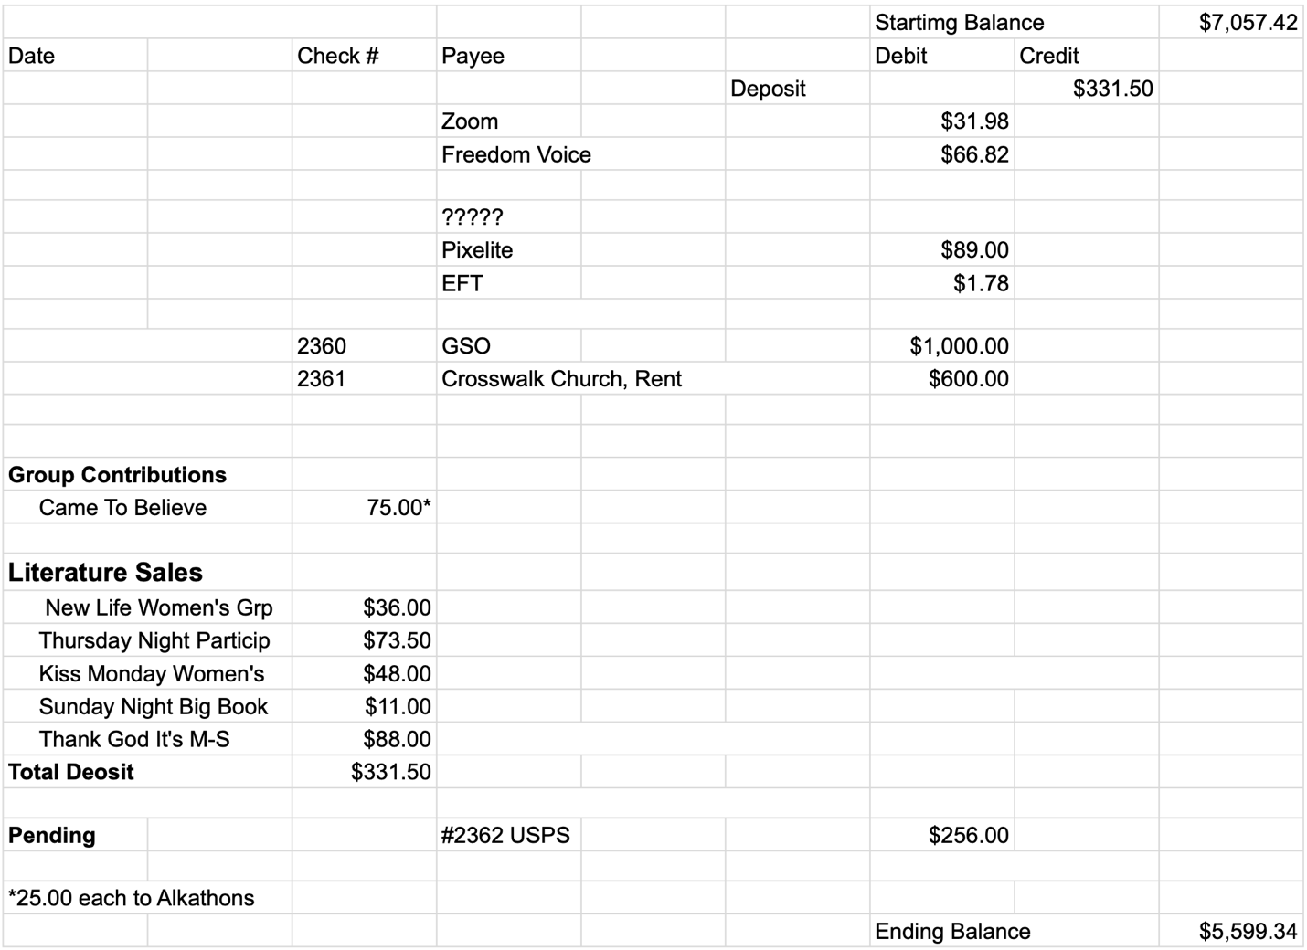

Financial Oversight Committee:
financial@aanapa.org

No meetings held. Nothing to report.

2.) Committee Appointees

2024-2025 |  | 2024 (2025-2026 Staggering)
Chair | Meghan T. | Secretary | Meg P.
Alt Chair | VACANT | District Liaison | Jason A.
Bday Co Chair | Jeff | Newsletter | Jean
Bday Co Chair | VACANT | H&I Liaison | Teri C.
Hotline Chair | Janet | Treasurer | Tena
Female Delegate at Large | Laura | Web Editor | Alex W.
Male Delegate at Large | Rick | Literature Chair | Mary W./Mike B (interim)
Printed Meeting Schedule Chair | Mandy B. | Events Chair | VACANT

Old Business
In-person meeting for IG (keeping on old business to keep discussion open)

New Business
Discuss possibility to have a meeting per quarter or semiannually in person to be available to those who cannot access zoom

Tech workshop for Zoom “AA on the Web”

Next Meeting Saturday, May 11, 2024, 10:00am (Officers at 9:00am)
Next tradition reader: ?

Closing

The Responsibility Statement:

“I am Responsible. When anyone, anywhere, reaches out for help, I want the hand of A.A. always to be there. And for that: I am responsible.”

