Napa Valley Intergroup Meeting Agenda

March 9, 2024

Agenda

Call To Order

A Moment of Silence followed by the Serenity Prayer

New Rep Introduction
New Intergroup Reps and Officers packets can be found on aanapa.org
https://aanapa.org/service/intergroup/welcome-new-intergroup-reps
Please provide your email and contact information to the Secretary.

Meeting Participant Introductions

Sobriety Birthdays
Meaghan P 18 months

Review and approval of minutes
Minutes were accepted

Monthly Tradition Reading from 12 Traditions Illustrated & Discussion
Reader: Jason A.
3rd Tradition: The only requirement for A.A. membership is a desire to stop drinking.

7th Tradition
We have no dues or fees in A.A. We are entirely self-supporting, declining outside contributions. Visit https://www.aanapa.org and use the Venmo link or mail your contribution to NVIG, P.O Box 10948, Napa, CA 94581-2948. Venmo link for IG contributions: https://www.venmo.com/u/NapaIG-AA

Housekeeping Motions
No housekeeping motions

Old Business
It was decided at the Officers meeting that we would make a one-time larger disbursement to GSO per new business of the last meeting in February. FOC did not make a recommendation.

New Business

Reports:

Chair: Meghan T.
chair@aanapa.org

No submission

Alternate Chair: VACANT
altchair@aanapa.org

No submission

Secretary: Meg P.
secretary@aanapa.org

Nothing to report.

Literature Chair: Mary W.
literature@aanapa.org

FEBRUARY 2024 | Literature Report
Meagan C, Sat night speaker mtng | BB-3, BB large print-1, 12x12 hard cover – 2, 12x12 soft -1, Living Sober -1, Daily Reflections-2, As Bill Sees It soft – 1 Cash | $122.00
Geoff M, Sunrise Group | BB-2, 12x12 soft -1 Check #371 | 36.00
Jason A, Crosstalk@Crosswalk | BB-12, Living Sober -6 Check #543 | 180.00
J Herman, TGIM-S | BB – 5, BB large print – 2 Check #192 | 84.00
Cathy F, Silverado Bookstudy | BB portable -1, 12x12 soft – 2  Cash | 31.00

Matt H, Came to Believe Came to Believe – 12 Check #1204 72.00

C. Collins,
Calistoga Gliders BB Portable – 1, 12x12 soft -2, Daily Reflections – 1, 49.50
Living Sober – 1 Cash

Mark B,
St Helena Discovery BB -1, 12x12 soft -1, Daily Reflections – 1, Living Sober – 2, 46.50
Cash

Jo M, Odd Balls BB Large print – 5, 12x12 Large Print – 5 Check #136 115.00

TOTAL SALES: $736.00
The online literature order form is up and running. It, as well as the Printable Literature Order form, can be found on our website - aanapa.org.

Select “Resources”, Select “Literature”, select “Online Literature Order form” or “Printable Literature Order form.”

It appears there are still many members unaware that literature can be ordered online, or even how to go about ordering literature from Intergroup. Reps, please announce at meetings you attend. Thanks.

In Service,
Mary W.
literature@aanapa.org
707.260.5672

Hotline Chair: Janet
hotline@aanapa.org

I need the “Pass It On” info from the previous Hotline Chair. Could I have their contact information please? I’ll need login access to the hotline software, reporting info, hotline phone people, etc. Thank you.
Yours in Service,
~Janet S

Web Editor: Alex W. (Intergroup)
Website Committee Chair: Jeff D. (District 11)
webeditor@aanapa.org

Business Meeting
1) ADA Compliance
a. Working to ensure our website is ADA Compliant - Ongoing
2) Started organizing old media for upload to AA Google Drive
3) Updating Meeting calendar (Need to install new software)

Meeting Schedule Chair: Mandy B.
meetings@aanapa.org

No submission

Newsletter Chair: Jean
newsletter@aanapa.org

Mailchimp Audience Report

Napa County Intergroup
Your audience has 80 contacts. 80 of these are
subscribed.
From February 6, 2024 to March 7, 2024

Tags 31 contributor / 2 graphic artist

Editorial Calendar

● Week of March 11 Welcome email to subscribers
● Week of March 11 Welcome email to potential contributors
● March 15 Select newsletter template
● April 10 Submission deadline for May issue
● April 15 Email to contributors for June issue
● May 1 Publication
● May 10 Submission deadline for June issue

Content

● Calendar of events
● Intergroup News
● General Service News
● Step and Tradition related essays
● Personal experience essays
● Artwork / Graphic Art submissions

Delegates at Large: Laura / Rick
delegateatlarge@aanapa.org

Laura: Has been to meetings and was looking for a list of which meeting need a rep so she can best serve the position

Rick: Didn’t make it to meetings this month, but last month he gave announcements to what we do and encouraged them to attend IG meetings

General Service Liaison: Jason

General service meeting deferred due to PRAASA. Meeting will take place following IG meeting.

Hospitals and Institutions Liaison: Teri C.

H&I welcomes anyone to join us at our monthly business meeting 6:45 pm on the first Friday of the month at the Sea Scout Building 402 Riverside Drive Napa, CA 94559. Learn about the workings of H&I and how to get involved. Did you know that there are facilities that you can attend without filling out clearance paperwork, make a commitment or even share? Currently Area 51 brings 26 meetings a week and literature to the Archway Recovery Services, Women’s Jail, Men’s Jail, Men’s Jail Spanish, California Medical Facility, Crestwood Behavior Center Vallejo, Crestwood Behavior Center Angwin, National Vallejo, Napa South Shelter, Napa State Hospital Spanish, Napa State Hospital English, Queen of the Valley Hospital, and Vallejo Detox. You can learn more about H&I by going to http://www.handinorcal.org or by contacting John Curnutt 707-477-0422 john@curnutt.org

Birthday Meeting Co-Chairs: Jeff/Alex W.
birthdaymeeting@aanapa.org

No submission

Treasurer: Christina (Tena)
treasurer@aanapa.org

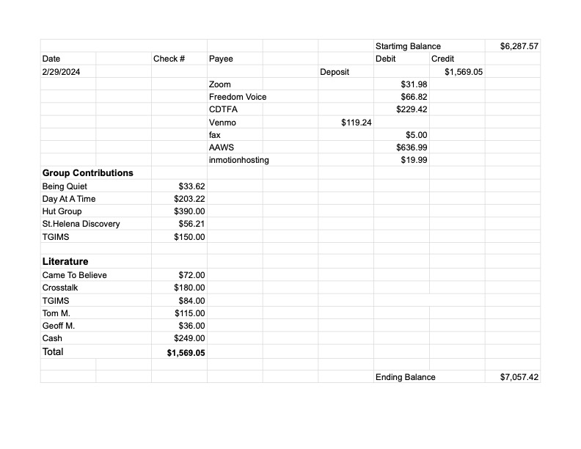
Financial Oversight Committee:
financial@aanapa.org

No meetings held.

Treasurer has approached the FOC to consider a distribution from excess funds over prudent reserve. The FOC will be working to evaluate proposal in line with IG budget and GSO / area and district needs.

2.) Committee Appointees

2024-2025 |  | 2024 (2025-2026 Staggering)
Chair | Meghan T. | Secretary | Meaghan P.
Alt Chair | VACANT | District Liaison | Jason A.
Bday Co Chair | Jeff | Newsletter | Jean
Bday Co Chair | Alex W.(Temporary) | H&I Liaison | Teri C.
Hotline Chair | Janet | Treasurer | Tena
Female Delegate at Large | Laura | Web Editor | Alex W.
Male Delegate at Large | Rick | Literature Chair | Mary W.
Printed Meeting Schedule Chair | Mandy B. | Events Chair | VACANT

Announcements

- Next Meeting Saturday, April 13, 2024, 10:00am (Officers at 9:00am)
- John K - Service Workshop proposal: “Foreign Service—Opportunities outside the rooms of AA” - group unanimously voted to distribute to this workshop which is scheduled to take place on May 11th.
- Jason A – reminder of Agenda topics meeting
- Discussion about going to in person or hybrid, will be continued. No motion to be made

Closing

The Responsibility Statement:

“I am Responsible. When anyone, anywhere, reaches out for help, I want the hand of A.A. always to be there. And for that: I am responsible.”

