Napa Valley Intergroup Meeting Agenda

May 11, 2024

Call To Order

A Moment of Silence followed by the Serenity Prayer

New Rep Introduction
New Intergroup Reps and Officers packets can be found on aanapa.org
https://aanapa.org/service/intergroup/welcome-new-intergroup-reps
Please provide your email and contact information to the Secretary.

Meeting Participant Introductions

Sobriety Birthdays

Review and approval of minutes

Monthly Tradition Reading from 12 Traditions Illustrated & Discussion
Reader:
5th Tradition: Each group should be autonomous except in matters affecting other groups or A.A. as a whole.

7th Tradition
We have no dues or fees in A.A. We are entirely self-supporting, declining outside contributions. Visit https://www.aanapa.org and use the Venmo link or mail your contribution to NVIG, P.O Box 10948, Napa, CA 94581-2948. Venmo link for IG contributions: https://www.venmo.com/u/NapaIG-AA

Housekeeping Motions
Please wait your turn to speak and utilize the “raised hand” function to be called on to speak

Announcements

Reports:

Chair: Meghan T.
chair@aanapa.org

No submission

Alternate Chair: VACANT
altchair@aanapa.org

No submission

Secretary: Meg P.
secretary@aanapa.org

Nothing to report.

Literature Chair: Mary W.
literature@aanapa.org

APRIL 2024 LITERATURE REPORT
St Helena Book Study | 1- Daily Reflections | 12.50
Calistoga Gliders | 1 Big Book portable, 1- Big Book Large Print, 1- 12 x12 Large print, 1 – Daily Reflections large print, 1- Living Sober large print | 52.50
No Ma’am | 5 Big Books | 60.00
Mon-Sun SS | 3 – AA Comes of Age | 36.00
Individual sale | 1 – Service Manual/Concepts | 4.00
KCB | 5 – Big Books | 60.00
TOTAL $225.00

I am having shoulder surgery in May and will be unable to do this position for a few (several?)
months. If you are interested in taking over during this time please give me a call (707)260-5672.

The online literature order form is working well. It, as well as the Printable Literature Order form, can be found on our website - aanapa.org
Select “Resources”, Select “Literature”, select “Online Literature Order form”, or “Printable Literature Order form” if you prefer to fill out manually, take a photo with phone and email to me.

In Service,

Mary W.
literature@aanapa.org
707.260.5672

Hotline Chair: Janet
hotline@aanapa.org

No submission

Web Editor: Alex W. (Intergroup)
Website Committee Chair: Jeff D. (District 11)
webeditor@aanapa.org

Business Meeting
1) Website running and secure
2) Found 1 user still using old google sheet from 2 years ago (Data deleted)
3) Need to connect with the new hotline chair. Have been unable to reach via email.

Alex W
Web Admin, Intergroup
Jeff D
Web Admin, District 11

Meeting Schedule Chair: Mandy B.
meetings@aanapa.org

New Spring printed trifold schedules (500 total) were printed and folded at Copy Corner with a printing date of 4/22/24. They were not available for pick up until 4/30/24. Some have been stocked in both meeting rooms at Crosswalk, and more will be disseminated to Sea Scouts and up valley locations (Veteran’s Home, Joe’s Group, Tucker Farm Center, etc.) throughout the week. Any corrections or comments should be directed to me and/or the web editor to be made in real time and for the next printing. If anyone would like physical printed schedules for their meetings, groups, or facility, please contact Mandy at (707) 225-2309 and I can arrange getting them to you. Thank you for allowing me to be of service.

Newsletter Chair: Jean
newsletter@aanapa.org

- Difficulties with MailChimp seem to have been worked out. I will continue testing up until publication date.
- Lead story will be “Artists in Sobriety” which will include pictures of the artwork and personal profiles of four artists who are AA members.
- Other content will feature:
  - Personal essays on recovery
  - Intergroup Calendar
  - “What is Intergroup” brief definition and description
  - Unity Day flyer (to support the event sponsored by General Service)
- We are on target for early June publication.

Delegates at Large: Laura / Rick
delegateatlarge@aanapa.org

No submission

General Service Liaison: Jason

Key takeaways
Post-assembly conference (hybrid) this weekend in Willits – to share feedback/results of the General Service Conference.
District will return to hybrid meetings in July or August
“Meeting in a Pocket” copies are available from Sandy or Jeff D

District key dates
1. Post-Conference Assembly – May 11th, Willits Community Center
2. Unity Day – June 15th, 2024, Crosswalk Church
3. Summer Assembly – August 10th, Campbell Community Center
4. Pacific Regional Forum – July 12th-15th - find information at https://area72aa.org/event/pacific-regional-forum-2/
5. Fall Assembly – November 9th – Cornerstone Fellowship of Livermore, CA

Hospitals and Institutions Liaison: Teri C.

No submission

Birthday Meeting Co-Chairs: Jeff/Alex W.
birthdaymeeting@aanapa.org
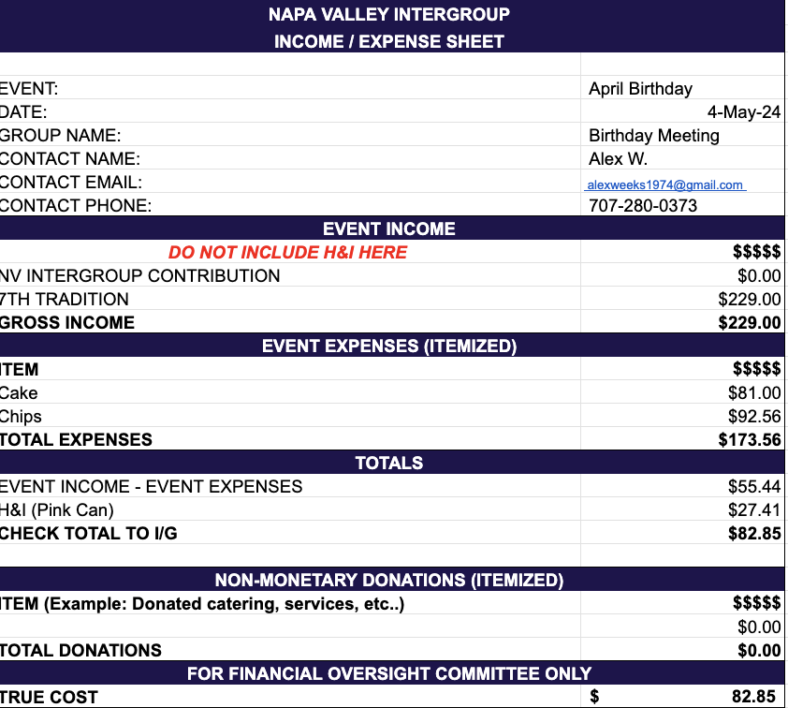

Treasurer: Christina (Tena)
treasurer@aanapa.org

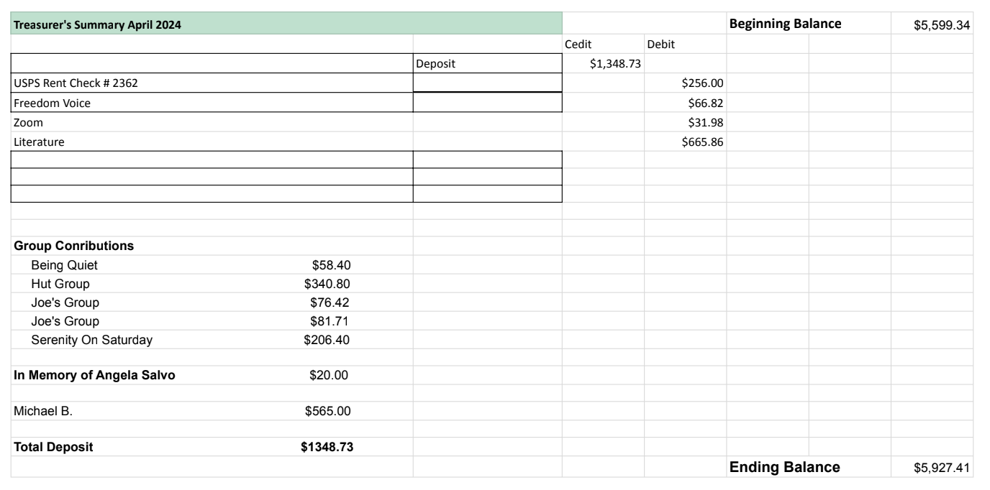

Financial Oversight Committee:
financial@aanapa.org

No meetings held during the month. IGFOC is meeting with District FOC (5/13 via Zoom) to discuss the alignment and consistency of process. All are welcome to join – please contact me if you would like the meeting information.

2.) Committee Appointees

2024-2025 |  | 2024 (2025-2026 Staggering)
Chair | Meghan T. | Secretary | Meg P.
Alt Chair | VACANT | District Liaison | Jason A.
Bday Co Chair | Jeff | Newsletter | Jean
Bday Co Chair | VACANT | H&I Liaison | Teri C.
Hotline Chair | Janet | Treasurer | Tena
Female Delegate at Large | Laura | Web Editor | Alex W.
Male Delegate at Large | Rick | Literature Chair | Mary W./Mike B (interim)
Printed Meeting Schedule Chair | Mandy B. | Events Chair | VACANT

Old Business
-In-person meeting for IG (keeping on old business to keep discussion open)
-Discuss possibility to have a meeting per quarter or semiannually in person to be available to those who cannot access zoom
-Tech workshop for Zoom “AA on the Web”

New Business
-Next Meeting Saturday, June 8, 2024, 10:00am (Officers at 9:00am)
-Next tradition reader: ?

Closing

The Responsibility Statement:

“I am Responsible. When anyone, anywhere, reaches out for help, I want the hand of A.A. always to be there. And for that: I am responsible.”

