Napa Valley Intergroup Meeting Agenda

July 12, 2024

Call To Order

A Moment of Silence followed by the Serenity Prayer

New Rep Introduction
New Intergroup Reps and Officers packets can be found on aanapa.org
https://aanapa.org/service/intergroup/welcome-new-intergroup-reps
Please provide your email and contact information to the Secretary.

Meeting Participant Introductions

Sobriety Birthdays

Review and approval of minutes

Monthly Tradition Reading from 12 Traditions Illustrated & Discussion
Reader: Alex W.
7th Tradition: Every A.A. group ought to be fully self-supporting, declining outside contributions.

7th Tradition
We have no dues or fees in A.A. We are entirely self-supporting, declining outside contributions. Visit https://www.aanapa.org and use the Venmo link or mail your contribution to NVIG, P.O Box 10948, Napa, CA 94581-2948. Venmo link for IG contributions: https://www.venmo.com/u/NapaIG-AA

Housekeeping Motions
Please wait your turn to speak and utilize the “raised hand” function to be called on to speak

Announcements

Reports:

Chair: Meghan T.
chair@aanapa.org

No submission

Alternate Chair: VACANT
altchair@aanapa.org

No submission

Secretary: Meg P.
secretary@aanapa.org

Nothing to report.

Literature Chair: Mary W.
literature@aanapa.org

Napa Intergroup Literature
Report presented June 8, 2024

JUNE 2024 LITERATURE REPORT
Michael B  Mon-Sun | 17 Hard cover 12 x 12, 3 Soft Cover 12 x 12, 2 Large Print Big Books. | 241.00
TOTAL $241.00

I placed two large orders recently for books and pamphlets so our inventory is in good shape.
Please reach out if your group has any literature needs.

While I have been convalescing from shoulder surgery, Kevin P has been doing an outstanding job, being the “books on the ground”, getting the literature orders filled. Thank you, Kevin.

The online literature order form is working well. It, as well as the Printable Literature Order form, can be found on our website - aanapa.org
Select “Resources”, Select “Literature”, select “Online Literature Order form”, or “Printable Literature Order form” if you prefer to fill out manually, take a photo with phone and email to me.

In Service,

Mary W.
literature@aanapa.org
707.260.5672

Hotline Chair: VACANT
hotline@aanapa.org

No submission

Web Editor: Alex W. (Intergroup)
Website Committee Chair: Jeff D. (District 11)
webeditor@aanapa.org

No submission

Meeting Schedule Chair: Mandy B.
meetings@aanapa.org

No submission

Newsletter Chair: Jean
newsletter@aanapa.org

No submission

Delegates at Large: Laura / Rick
delegateatlarge@aanapa.org

No submission

General Service Liaison: Jason

Unity Day was a great success, with very positive feedback and a great response to the panel discussions and the keynote speech from Erik.
Lots of excitement around the approval for the publication of Plain Language Big Book
Reminder that current panel is now coming to a close, so there will be service opportunities at the district level

Open Positions: Accessibilities Committee Chair
Upcoming Dates to remember:
a. Summer Assembly – August 10th, Campbell Community Center
b. Pacific Regional Forum – July 12th-15th- find information at https://area72aa.org/event/pacific-regional-forum-2/
c. Fall Election Assembly – November 9th – Cornerstone Fellowship of Livermore, CA

Hospitals and Institutions Liaison: Teri C.

No submission

Birthday Meeting Co-Chairs: Jeff/Alex W.
birthdaymeeting@aanapa.org

No submission

Treasurer: Christina (Tena)
treasurer@aanapa.org
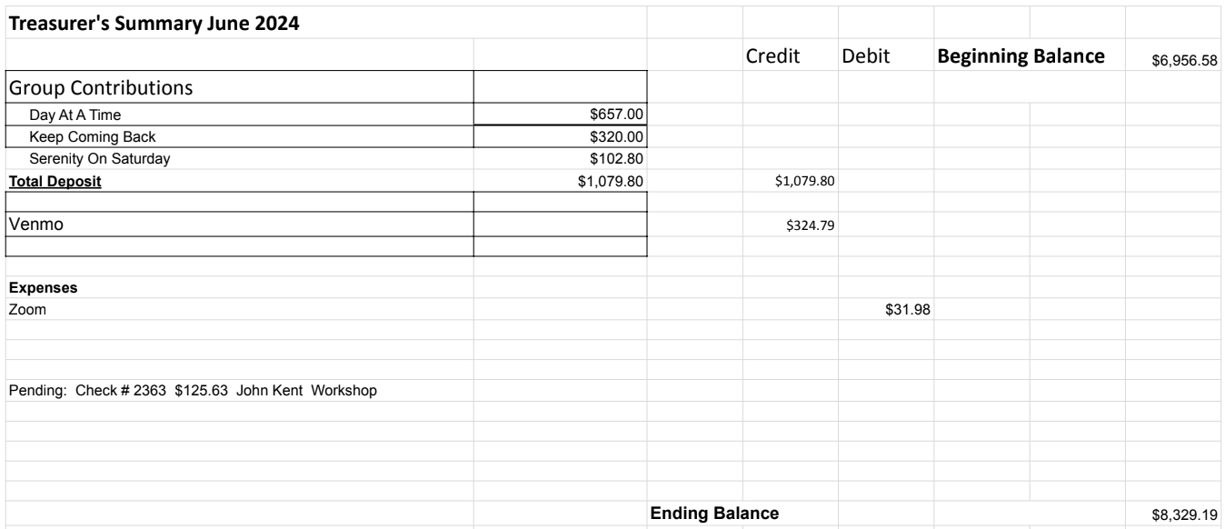

Financial Oversight Committee:
financial@aanapa.org

Nothing to report

2.) Committee Appointees

2024-2025 |  | 2024 (2025-2026 Staggering)
Chair | Meghan T. | Secretary | Meg P.
Alt Chair | VACANT | District Liaison | Jason A.
Bday Co Chair | Jeff | Newsletter | Jean
Bday Co Chair | VACANT | H&I Liaison | Teri C.
Hotline Chair | VACANT | Treasurer | Tena
Female Delegate at Large | Laura | Web Editor | Alex W.
Male Delegate at Large | Rick | Literature Chair | Mary W./Mike B (interim)
Printed Meeting Schedule Chair | Mandy B. | Events Chair | VACANT

Old Business
-In-person meeting for IG (keeping on old business to keep discussion open)
-Discuss possibility to have a meeting per quarter or semiannually in person to be available to those who cannot access zoom
-Tech workshop for Zoom “AA on the Web”

New Business
-Next Meeting Saturday, August , 2024, 10:00am (Officers at 9:00am)
-Next tradition reader: ?

Closing

The Responsibility Statement:

“I am Responsible. When anyone, anywhere, reaches out for help, I want the hand of A.A. always to be there. And for that: I am responsible.”

