Napa Valley Intergroup Meeting Agenda

June 8, 2024

TAKEBACKS

- IG reps- we encourage you to come to the Birthday meeting at the end of each month, and please encourage your groups to come as well! Please share with your group the importance of celebrating and supporting one another in these sobriety milestones. We can't wait to see you there!
- We need a Birthday Co-chair, Event Chair, and Alternate Chair. Please reach out to Meghan T. if you have any questions about these positions or would like to be of service.
- We have filled the hotline chair position! Please reach out to Travis at hotline@aanapa.org if you’re interested in being of service in answering the hotline.
- We still need groups to sign up to chair the Thanksgiving Day Alcathon and the Christmas Alcathon. Please talk to your groups and encourage them to take on this amazing service opportunity! Please reach out to Meghan T at chair@aanapa.org if your group has any questions or would like to sign up.
- The newsletter will be coming out by the end of June! Please reach out to Jean at newsletter@aanapa.org if you would like to sign up for the newsletter.

Call To Order

A Moment of Silence followed by the Serenity Prayer

New Rep Introduction
New Intergroup Reps and Officers packets can be found on aanapa.org
https://aanapa.org/service/intergroup/welcome-new-intergroup-reps
Please provide your email and contact information to the Secretary.

Meeting Participant Introductions

Sobriety Birthdays

Review and approval of minutes
Minute approved

Monthly Tradition Reading from 12 Traditions Illustrated & Discussion
Reader: Mary
6th Tradition: An A.A. group ought never endorse, finance or lend the A.A. name to any related facility or outside enterprise, lest problems of money, property and prestige divert us from our primary purpose.

7th Tradition
We have no dues or fees in A.A. We are entirely self-supporting, declining outside contributions. Visit https://www.aanapa.org and use the Venmo link or mail your contribution to NVIG, P.O Box 10948, Napa, CA 94581-2948. Venmo link for IG contributions: https://www.venmo.com/u/NapaIG-AA

Housekeeping Motions
Please wait your turn to speak and utilize the “raised hand” function to be called on to speak

Announcements

Reports:

Chair: Meghan T.
chair@aanapa.org

Alternate Chair: VACANT
altchair@aanapa.org

No submission

Secretary: Meg P.
secretary@aanapa.org

Nothing to report.

Literature Chair: Mary W.
literature@aanapa.org

Napa Intergroup Literature
Report presented June 8, 2024

MAY 2024 | Literature Report
Calistoga Gliders | 1 Large print BB, 1 Spanish BB, 1 Portable BB | 35.00
Thursday night Participation | 1 Big Book, 2 Experience, Strength and Hope, 1 12x12 soft,  1 AA Comes of Age, 1 As Bill Sees It, 1 Dr Bob and the Good Old Timers, 2 Pass It On, 2 Daily Reflections ($5.50 balance owed, paid) | 123.50
Free Thinkers | 1 Big Book, 1 Portable Big Book, $2 donation | 25.00
Silverado BB Study | 1 Big Book, 1 12x12, 1 12x12 soft cover | 33.00
No Maam | 1 AA Comes of Age, 1 Service Manual | 16.00
TOTAL $232.50

The online literature order form is working well. It, as well as the Printable Literature Order form, can be found on our website - aanapa.org
Select “Resources”, Select “Literature”, select “Online Literature Order form” or “Printable Literature Order form”

Hotline Chair: VACANT
hotline@aanapa.org

No submission

Web Editor: Alex W. (Intergroup)
Website Committee Chair: Jeff D. (District 11)
webeditor@aanapa.org

Business Meeting
- Website running and secure

Meeting Schedule Chair: Mandy B.
meetings@aanapa.org

No submission

Newsletter Chair: Jean
newsletter@aanapa.org

- The publication of our first newsletter will be toward the end of the month of June. I am waiting for a few submissions so that our newsletter will be representative of more than a couple of writers. Also, I have been a bit bogged down by work assignments that will be completed next week, leaving more time to focus on the newsletter.

- The lead article will be “Artists in Sobriety” with samples of contributors’ artwork and brief interviews/ background information on the artists’ sober journey.

- Alex W. has contributed, on behalf of the Website Committee, a wonderfully informative article about navigating the aanapa.org website.

- As we will be publishing after Unity Day, we can also include an article about Unity Day with takebacks from the service panels and delegate’s report

Delegates at Large: Laura / Rick
delegateatlarge@aanapa.org

Tues evening women’s zoom meeting can be removed from the calendars as it’s no longer active.

General Service Liaison: Jason

Unity Day is June 15. 11am-3pm @ Crosswalk. See Flyer.

Hospitals and Institutions Liaison: Teri C.

Terry M. is going to be going into surgery next month and her availability to be Area Chair is waning. Look into your heart and think about if you are available to step up for service as Area Chair.

The big news is that we participated in the “Foreign Service” Workshop. We had 11 attendees, with reasonable participation and several individuals taking contact info for further action. Joe T. (Bridging the Gap), John C. (Hospitals & Institutions) and Elisabeth B. (Public Information/Cooperation with the Professional Community) gave successful pitches, and we all agreed it went well.

Birthday Meeting Co-Chairs: Jeff/Alex W.
birthdaymeeting@aanapa.org

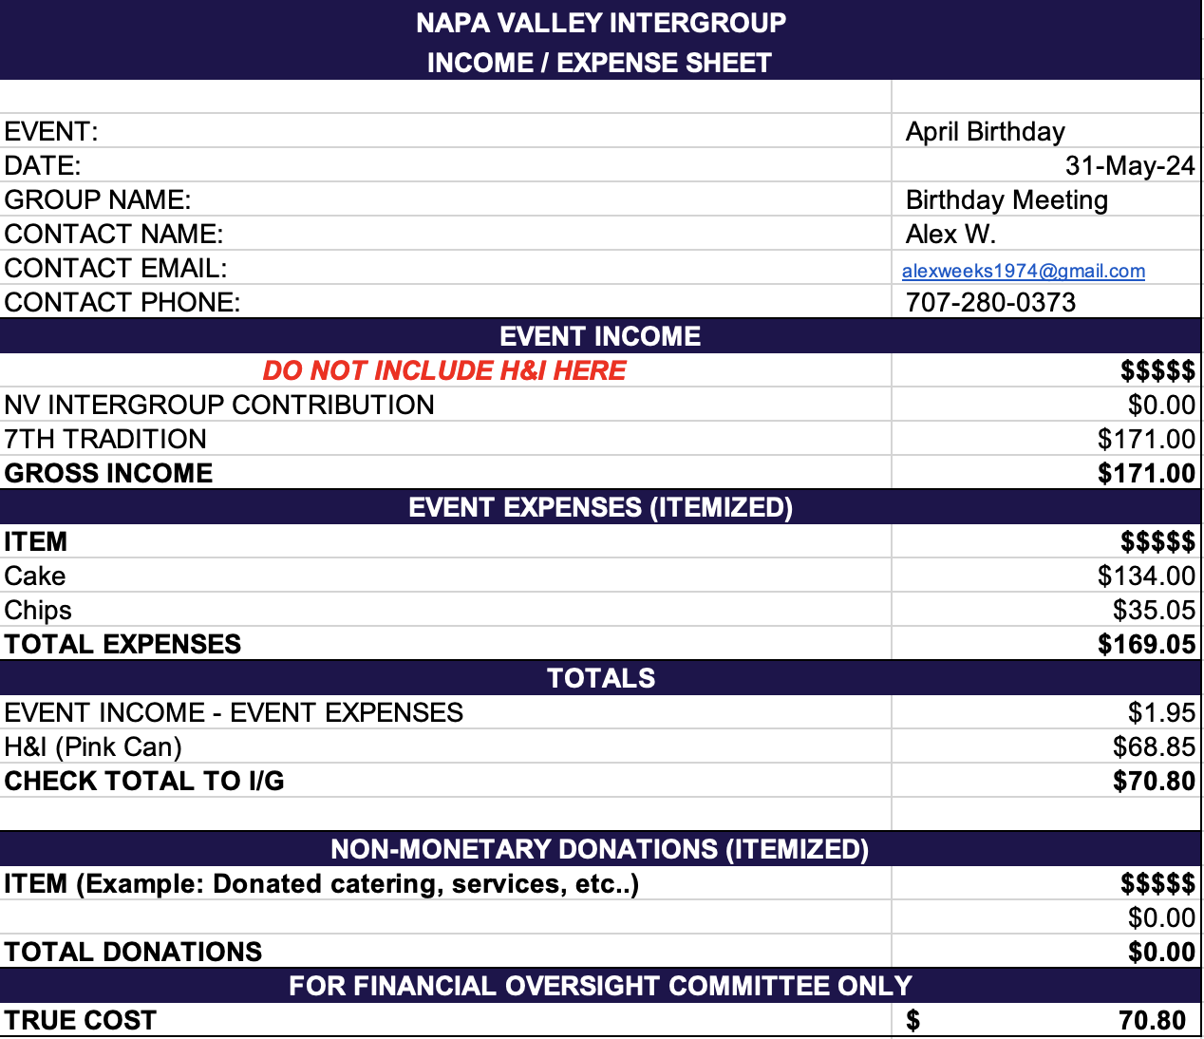

Treasurer: Christina (Tena)
treasurer@aanapa.org
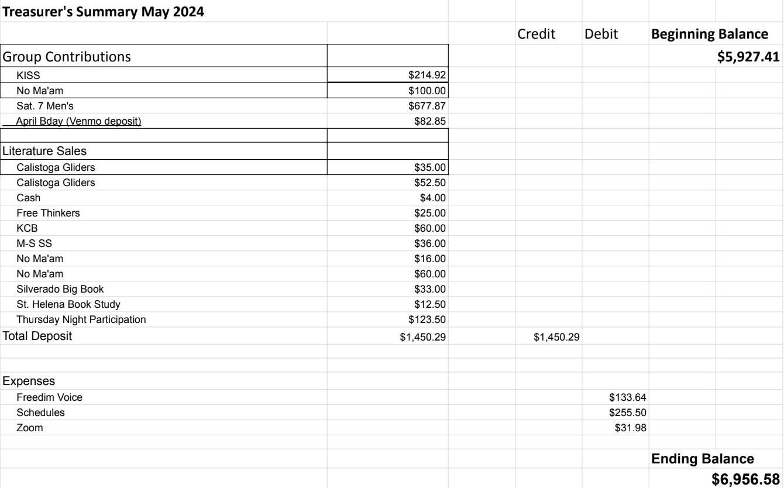

Financial Oversight Committee:
financial@aanapa.org

Meeting with District FOC did not occur. To be rescheduled at a time convenient to all IG FOC members. No meetings held.

2.) Committee Appointees

2024-2025 |  | 2024 (2025-2026 Staggering)
Chair | Meghan T. | Secretary | Meg P.
Alt Chair | VACANT | District Liaison | Jason A.
Bday Co Chair | Jeff | Newsletter | Jean
Bday Co Chair | VACANT | H&I Liaison | Teri C.
Hotline Chair | Travis | Treasurer | Tena
Female Delegate at Large | Laura | Web Editor | Alex W.
Male Delegate at Large | Rick | Literature Chair | Mary W.
Printed Meeting Schedule Chair | Mandy B. | Events Chair | VACANT

Old Business
-In-person meeting for IG (keeping on old business to keep discussion open)
-Discuss possibility to have a meeting per quarter or semiannually in person to be available to
- Anniversary Party - No Ma’am

New Business
-Next Meeting Saturday, July 13, 2024, 10:00am (Officers at 9:00am)
-Next tradition reader: Alex W.
-Intergroup Bylaws review
-Speaker Recordings
  - Speaker Tapes on our website (Audio ONLY)
  - Birthday meeting
  - Speaker decides if yes/no
  - Waiver signed

Closing

The Responsibility Statement:

“I am Responsible. When anyone, anywhere, reaches out for help, I want the hand of A.A. always to be there. And for that: I am responsible.”

