Napa Valley Intergroup Meeting Agenda

August 10, 2024

Takebacks

· Intergroup is looking for a Printed Schedule Chair. This position is integral for newcomers because you would be responsible for printing and distributing the meeting schedule pamphlets to meeting locations. This commitment will end in January, which is an excellent opportunity to get your feet wet in Intergroup. If you're interested in being of service, please talk to your meeting IG rep for more info.

· Spanish speakers are needed to assist with answering the AA Hotline. If you or someone you know is bilingual and available to be of service, please reach out to our Hotline Chair, Travis - hotline@aanapa.org

· We need your stories about what Service in AA means to you! Whether it is 500 words or a short sentence, please send over your thoughts to Jean for her to include in our following Newsletter - newsletter@aanapa.org

· Our Semi-annual in-person intergroup meeting will be held at Crosswalk Church on October 12th. There will be coffee and donuts- we hope to see you there!

Call To Order

A Moment of Silence followed by the Serenity Prayer

New Rep Introduction
New Intergroup Reps and Officers packets can be found on aanapa.org
https://aanapa.org/service/intergroup/welcome-new-intergroup-reps
Please provide your email and contact information to the Secretary.

Meeting Participant Introductions
Mike – No Ma’am/TGI Mon-Sun Group Rep
Meg – Secretary/Cross Talk meeting Rep
Jason – FOC Chair and District Liaison
Laura – Sister’s in Serenity Group Rep
Jean – Hut group Rep
Mary – Lit Chair Rep
Liz – Thurs Women’s Rep
Travis – Hotline Chair
Meghan – Chair
Alex
Jeff
Jo

Sobriety Birthdays

Review and approval of minutes
Minutes approved

Monthly Tradition Reading from 12 Traditions Illustrated & Discussion
Reader: Mike B.
8th Tradition: Alcoholics Anonymous should remain forever nonprofessional, but our service centers may employ special workers.

7th Tradition
We have no dues or fees in A.A. We are entirely self-supporting, declining outside contributions. Visit https://www.aanapa.org and use the Venmo link or mail your contribution to NVIG, P.O Box 10948, Napa, CA 94581-2948. Venmo link for IG contributions: https://www.venmo.com/u/NapaIG-AA

Housekeeping Motions
Please wait your turn to speak and utilize the “raised hand” function to be called on to speak

Announcements

Reports:

Chair: Meghan T.
chair@aanapa.org

No submission

Alternate Chair: VACANT
altchair@aanapa.org

No submission

Secretary: Meg P.
secretary@aanapa.org

Nothing to report.

Literature Chair: Mary W.
literature@aanapa.org

Napa Intergroup Literature
Report presented June 8, 2024

JULY 2024 | Literature Report
Hut Group | 6 Hard cover big books | $72.00
 | TOTAL | $72.00

The online literature order form is working well. It, as well as the Printable Literature Order form, can be found on our website - aanapa.org
Select “Resources”, Select “Literature”, select “Online Literature Order form” or “Printable Literature Order form”

In Service,

Mary W.
literature@aanapa.org
707.260.5672

Hotline Chair: Travis
hotline@aanapa.org

Good morning,

I wanted to give some insight to the AA hotline. Attached are some pics of reports generated from July 1 thru Aug 8.

The general statistics report gives a little more in-depth statistics of specificity on the total calls. There were 59 calls 20 of which were abandoned. I followed up on a few that left voicemail on the freedom-voice voicemail. Looks like there was a very short wait time to talk to a representative ranging from .1 min to .7 min. The average talk time is about 6 min per call, Ranging from a short 1 min chat to about a 17 min conversation. From the bar chart it looks like there is a spike in calls on the 10th 20th & 30th. Not sure if there is some correlation but an interesting statistic, nonetheless.

All my best,
Travis N

Web Editor: Alex W. (Intergroup)
Website Committee Chair: Jeff D. (District 11)
webeditor@aanapa.org

No submission

Meeting Schedule Chair: VACANT
meetings@aanapa.org

No submission

Newsletter Chair: Jean
newsletter@aanapa.org

Good news! The Newsletter has been published on the aanapa.org website, and I am working on getting the newsletter out to subscribers via MailChimp.

The next issue will have "Service" as a theme, and I hope to publish by late September. There will be an "Artists in Sobriety" page, which I hope to have each month, and maybe poetry if there is room.

I would love to brainstorm with the Intergroup reps regarding features on service, and solicitation of content contributions from the membership.

Yours in service.

Jean C

Delegates at Large: Laura / Rick
delegateatlarge@aanapa.org

No submission

General Service Liaison: Jason

Upcoming Dates to remember:
a. Summer Assembly – August 10th, Campbell Community Center
b. Fall Election Assembly – November 9th – Cornerstone Fellowship of Livermore, CA

Amara, DCMC for District 04/Santa Clara North – Presentation on Safety Workshop
This is a day to discuss how we can be responsible for providing safe meeting spaces so that we can better carry the message of A.A. to the alcoholic who still suffers. (see attached flyer)

Safety in A.A. Forum – District 04 Santa Clara County North (district04cnca.org)

Hospitals and Institutions Liaison: Teri C.

No submission

Birthday Meeting Co-Chairs: Jeff/Beth
birthdaymeeting@aanapa.org

No submission

Treasurer: Christina (Tena)
treasurer@aanapa.org
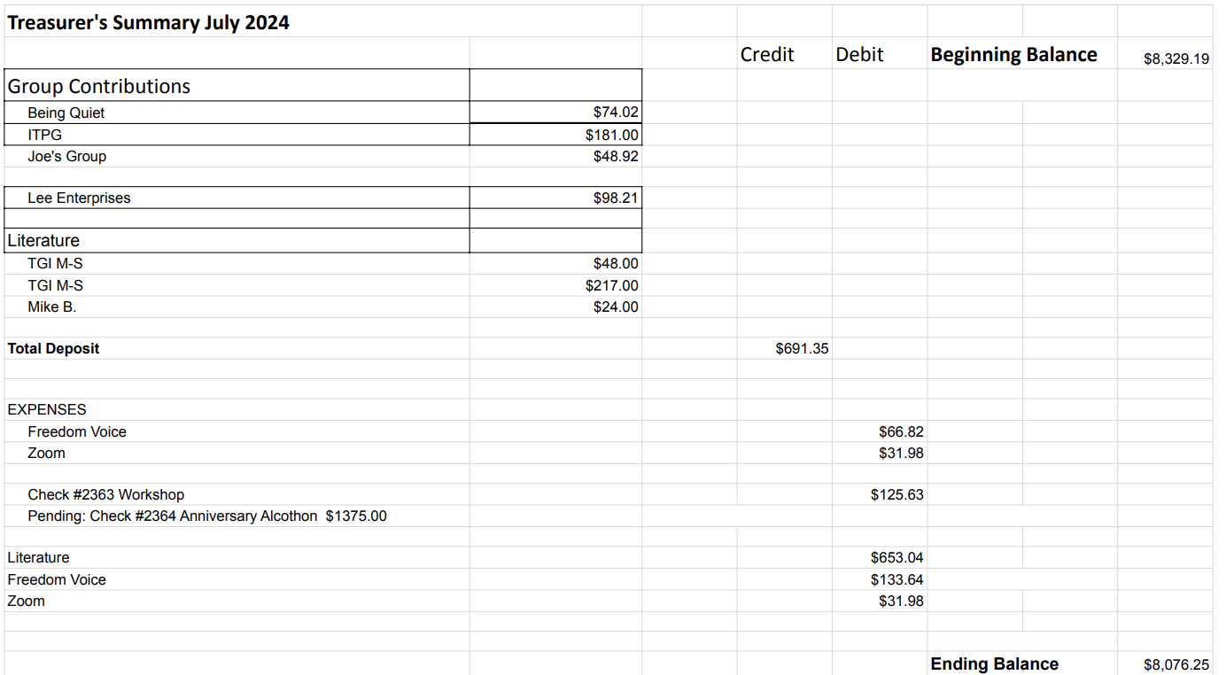

Financial Oversight Committee:
financial@aanapa.org

A question was raised related to covering the shortfall of birthday meeting costs.

2.) Committee Appointees

2024-2025 |  | 2024 (2025-2026 Staggering)
Chair | Meghan T. | Secretary | Meg P.
Alt Chair | VACANT | District Liaison | Jason A.
Bday Co Chair | Jeff | Newsletter | Jean
Bday Co Chair | Beth C. | H&I Liaison | Teri C.
Hotline Chair | Travis | Treasurer | Tena
Female Delegate at Large | Laura | Web Editor | Alex W.
Male Delegate at Large | Rick | Literature Chair | Mary W./Kevin P. (interim)
Printed Meeting Schedule Chair | VACANT | Events Chair | VACANT

Old Business
- Majority vote for first in person semiannually meeting to be held on Oct 12
- Discuss proposed locations with all pertinent information and availability to vote for
-Voted to hold the Semiannual meeting at Crosswalk on Oct 12th (next one in person the be held in April)
-Tech workshop for Zoom “AA on the Web”
-How can we increase participation in service?
-Attraction not promotion?
-Nominations?
-Speak to our groups about our experience in service

New Business
-Next Meeting Saturday, September 8, 2024, 10:00am (Officers at 9:00am)
-Next tradition reader: Jason A.

Closing

The Responsibility Statement:

“I am Responsible. When anyone, anywhere, reaches out for help, I want the hand of A.A. always to be there. And for that: I am responsible.”

