Napa Valley Intergroup Meeting Agenda

December 14, 2024

Call To Order

A Moment of Silence followed by the Serenity Prayer

New Rep Introduction
New Intergroup Reps and Officers packets can be found on aanapa.org
https://aanapa.org/service/intergroup/welcome-new-intergroup-reps
Please provide your email and contact information to the Secretary.

Meeting Participant Introductions

Sobriety Birthdays

Review and approval of minutes

Monthly Tradition Reading from 12 Traditions Illustrated & Discussion
Reader: Mary
12th Tradition: Anonymity is the spiritual foundation of all our Traditions, ever reminding us
to place principles before personalities.

7th Tradition
We have no dues or fees in A.A. We are entirely self-supporting, declining outside contributions. Visit https://www.aanapa.org and use the Venmo link or mail your contribution to NVIG, P.O Box 10948, Napa, CA 94581-2948. Venmo link for IG contributions: https://www.venmo.com/u/NapaIG-AA

Housekeeping Motions
Please wait your turn to speak and raised your hand to be called on to speak. Please silence your cell phones

Announcements

Reports:

Chair: Meghan T.
chair@aanapa.org

No submission

Alternate Chair: VACANT
altchair@aanapa.org

No submission

Secretary: Meg P.
secretary@aanapa.org

Nothing to report.

Literature Chair: Mary W.
literature@aanapa.org

Napa Intergroup Literature Report
Presented on December 14, 2024
NOVEMBER 2024 | Literature Report
Kevin P, Hut Group | BB-6 | $72.00
Colleen G, Silverado Book Study | BB-2 | 24.00
Jeff D, personal | PLBB-1 | 11.00
Cindy C, Calistoga Gliders | BB-1, PLBB-4 | 56.00
Elisabeth B, PICPC | PLBB-4 | 44.00
Colleen G, Silverado Big Book Study | PLBB-5, 12x12 (HC)-1 | 66.00
Kevin P, Hut Group | PLBB-1 | 11.00
Mike P, personal | PLBB-1, BB-1 | 23.00
Kevin P, Hut Group | BB-6 | 66.00
John K., tbd | PLBB-3 | 33.00
Adam T, Thursday Night Participation | Daily Reflections-2, Exp, Strength and Hope- 2, Came to Believe-1, As Bill Sees It (SC)-1, Pass it On-1 | 66.00
Tobias L, No Ma’am | BB-6, As Bill Sees It (HC)-6 | 138.00
Cindy C, 12x12 Book Study | PLBB-2, 12x12 (HC)- 1 | 33.00
Keith E, Wheel of Sobriety | PLBB-11 | 11.00*
Alex W., Freethinkers | PLBB-1 | 11.00
Cynthia C, Daily Reflections | PLBB-5 | 55.00
Geoff M, Sunrise Group | PLBB-5 | 55.00
Michael B, Personal | PLBB-1 | 11.00
TOTAL |  | $786.00
*$11.00 collected, but not yet deposited

The online literature order form is up and running. It, as well as the Printable Literature Order form, can be found on our website - aanapa.org
Select “Resources”, Select “Literature”, select “Online Literature Order form” or “Printable Literature Order form”
Unfortunately, Plain Language Big Book is currently out of stock. When I am able to order, we will update the literature order form to reflect availability.

It appears there are still many members unaware that literature can be ordered online, or even how to go about ordering literature from Intergroup. Reps please announce at meetings you attend.
Thanks.

In Service,
Mary W.
literature@aanapa.org

Hotline Chair: Travis
hotline@aanapa.org

No submission

Web Editor: Alex W. (Intergroup)
Website Committee Chair: Alex W. (District 11)
webeditor@aanapa.org

No submission

Meeting Schedule Chair: Kevin P.
meetings@aanapa.org

No submission

Newsletter Chair: Jean
newsletter@aanapa.org

No submission

Delegates at Large: Laura / Rick
delegateatlarge@aanapa.org

No submission

General Service Liaison: Jason

No submission

Hospitals and Institutions Liaison: VACANT

No submission

Birthday Meeting Co-Chairs: Jeff/Beth
birthdaymeeting@aanapa.org

No submission

Treasurer: Christina (Tena)
treasurer@aanapa.org
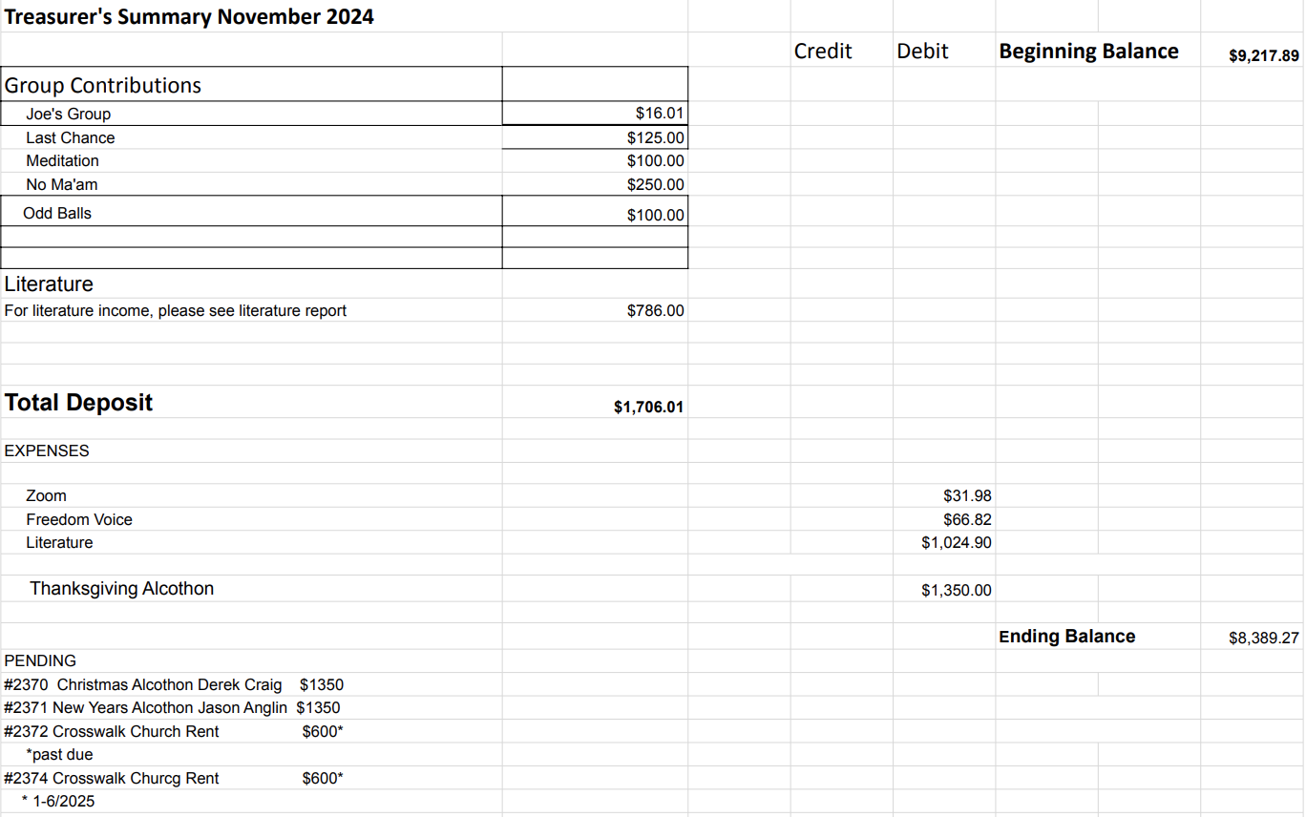

Financial Oversight Committee:
financial@aanapa.org

No submission

2.) Committee Appointees

2024-2025 |  | 2024 (2025-2026 Staggering)
Chair | Meghan T. | Secretary | Meg P.
Alt Chair | VACANT | District Liaison | Jason A.
Bday Co Chair | Jeff | Newsletter | Jean
Bday Co Chair | Beth C. | H&I Liaison | VACANT
Hotline Chair | Travis | Treasurer | Tena
Female Delegate at Large | Laura | Web Editor | Alex W.
Male Delegate at Large | Rick | Literature Chair | Mary W./Kevin P. (interim)
Printed Meeting Schedule Chair | Kevin P. | Events Chair | VACANT
*In December elections will be held*

Old Business
-Spanish speaking liaison to their district?‬
-Alcathon updates‬
-Cleaning the storage container‬
-Jan 2025 will be the beginning of quarterly in person‬
‬ -Will in person meetings be hybrid?‬

New Business
-Next Meeting Saturday, December 14, 2024, 10:00am (Officers at 9:00am)
-Next tradition reader: ?

Closing

The Responsibility Statement:

“I am Responsible. When anyone, anywhere, reaches out for help, I want the hand of A.A. always to be there. And for that: I am responsible.”

