Napa Valley Intergroup Meeting Minutes & Takebacks

December 14, 2024

Takebacks
• several positions still need to be filled. Please reach out to Meghan (chair@aanapa.org) if you are interested in being of service in the following:
o Recording Secretary
o Alternate Chair
o Meeting Schedule Chair
• The financial oversight committee needs to be reinvigorated! They will work with our treasurer to budget for the upcoming year. All positions are open. If you are interested in these vital roles, please get in touch with Meghan (chair@aanapa.org) and Alex W. (treasurer@aanapa.org).
• The January meeting at Crosswalk Church will be held in person on Saturday, January 11, 2025, at 10 a.m. (the officer meeting will be at 9 a.m.). It will NOT be hybrid, so please come in person, grab a donut, and join the fun! Please be sure to let any incoming IG reps know this in advance!

Call To Order

A Moment of Silence followed by the Serenity Prayer

New Rep Introduction
New Intergroup Reps and Officers packets can be found on aanapa.org
https://aanapa.org/service/intergroup/welcome-new-intergroup-reps
Please provide your email and contact information to the Secretary.

Meeting Participant Introductions
Alex W.
Kevin P.
Jean
Tena
Mike
Meg
Laura
John
Heidi
Mary
Zane
Jason
Jo
Meghan

Sobriety Birthdays
Jason – 3 years

Review and approval of minutes
Correction on Literature report – will replace on minutes/takebacks
Minutes approved

Monthly Tradition Reading from 12 Traditions Illustrated & Discussion
Reader: Mary
12th Tradition: Anonymity is the spiritual foundation of all our Traditions, ever reminding us
to place principles before personalities.

7th Tradition
We have no dues or fees in A.A. We are entirely self-supporting, declining outside contributions. Visit https://www.aanapa.org and use the Venmo link or mail your contribution to NVIG, P.O Box 10948, Napa, CA 94581-2948. Venmo link for IG contributions: https://www.venmo.com/u/NapaIG-AA

Housekeeping Motions
Please wait your turn to speak and raised your hand to be called on to speak. Please silence your cell phones

Announcements

Reports:

Chair: Meghan T.
chair@aanapa.org

No submission

Alternate Chair: VACANT
altchair@aanapa.org

No submission

Secretary: Meg P.
secretary@aanapa.org

Nothing to report.

Literature Chair: Mary W.
literature@aanapa.org

Napa Intergroup Literature Report
Presented on December 14, 2024
NOVEMBER 2024 | Literature Report
Kevin P, Hut Group | BB-6 | $72.00
Colleen G, Silverado Book Study | BB-2 | 24.00
Jeff D, personal | PLBB-1 | 11.00
Cindy C, Calistoga Gliders | BB-1, PLBB-4 | 56.00
Elisabeth B, PICPC | PLBB-4 | 44.00
Colleen G, Silverado Big Book Study | PLBB-5, 12x12 (HC)-1 | 66.00
Kevin P, Hut Group | PLBB-1 | 11.00
Mike P, personal | PLBB-1, BB-1 | 23.00
Kevin P, Hut Group | BB-6 | 66.00
John K., tbd | PLBB-3 | 33.00
Adam T, Thursday Night Participation | Daily Reflections-2, Exp, Strength and Hope- 2, Came to Believe-1, As Bill Sees It (SC)-1, Pass it On-1 | 66.00
Tobias L, No Ma’am | BB-6, As Bill Sees It (HC)-6 | 138.00
Cindy C, 12x12 Book Study | PLBB-2, 12x12 (HC)- 1 | 33.00
Keith E, Wheel of Sobriety | PLBB-11 | 11.00*
Alex W., Freethinkers | PLBB-1 | 11.00
Cynthia C, Daily Reflections | PLBB-5 | 55.00
Geoff M, Sunrise Group | PLBB-5 | 55.00
Michael B, Personal | PLBB-1 | 11.00
TOTAL |  | $786.00
*$11.00 collected, but not yet deposited

The online literature order form is up and running. It, as well as the Printable Literature Order form, can be found on our website - aanapa.org
Select “Resources”, Select “Literature”, select “Online Literature Order form” or “Printable Literature Order form”
Unfortunately, Plain Language Big Book is currently out of stock. When I am able to order, we will update the literature order form to reflect availability.

It appears there are still many members unaware that literature can be ordered online, or even how to go about ordering literature from Intergroup. Reps please announce at meetings you attend.
Thanks.

In Service,
Mary W.
literature@aanapa.org

Hotline Chair: Travis
hotline@aanapa.org

No submission

Web Editor: Alex W. (Intergroup)
Website Committee Chair: Alex W. (District 11)
webeditor@aanapa.org

No submission

Meeting Schedule Chair: Kevin P.
meetings@aanapa.org

No submission

Newsletter Chair: Jean
newsletter@aanapa.org

No submission

Delegates at Large: Laura / Rick
delegateatlarge@aanapa.org

No submission

General Service Liaison: Jason

No submission

Hospitals and Institutions Liaison: VACANT

No submission

Birthday Meeting Co-Chairs: Jeff/Beth
birthdaymeeting@aanapa.org

No submission

Treasurer: Christina (Tena)
treasurer@aanapa.org
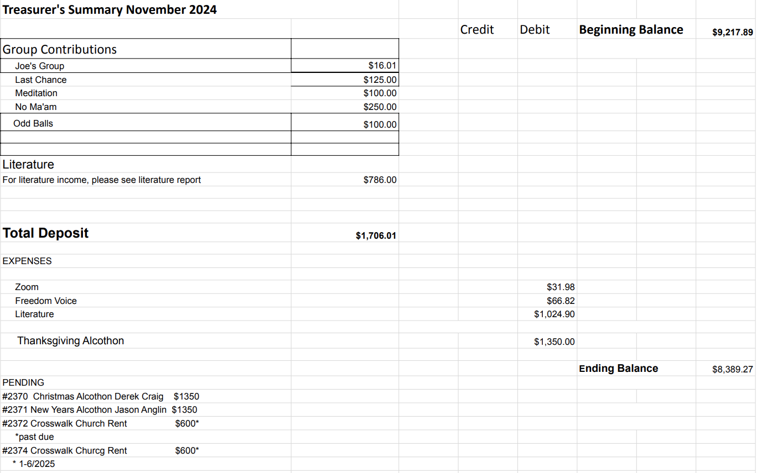

Financial Oversight Committee:
financial@aanapa.org

Needs to be reinvigorated, working with our treasurer to budget the upcoming year. All positions are open.

2.) Committee Appointees

2024-2025 |  | 2024 (2025-2026 Staggering)
Chair | Meghan T. | Secretary | VACANT
Alt Chair | VACANT | District Liaison | John S.
Bday Co Chair | Jeff | Newsletter | Jean
Bday Co Chair | Beth C. | H&I Liaison | Heidi
Hotline Chair | Travis | Treasurer | Alex W.
Female Delegate at Large | Laura | Web Editor | Zane
Male Delegate at Large | Rick | Literature Chair | Kevin P.
Printed Meeting Schedule Chair | VACANT | Events Chair | Laura K.

Old Business
-Spanish speaking liaison to their district?‬‬ Still looking‬
-Alcathon updates‬‬‬
-Cleaning the storage container‬‬‬
-Jan 2025 will be the beginning of quarterly in person‬‬‬
‬ -Will in person meetings be hybrid?‬ - Jan will not be hybrid
‬‬
New Business
-Next Meeting Saturday, January 11, 2025, 10:00am (Officers at 9:00am)
-Next tradition reader: Kevin P

Closing

The Responsibility Statement:

“I am Responsible. When anyone, anywhere, reaches out for help, I want the hand of A.A. always to be there. And for that: I am responsible.”

