**Napa Valley Intergroup Meeting Agenda**

January 11, 2025

**Call To Order**

**A Moment of Silence followed by the Serenity Prayer**

**New Rep Introduction**

New Intergroup Reps and Officers packets can be found on aanapa.org

<https://aanapa.org/service/intergroup/welcome-new-intergroup-reps>

Please provide your email and contact information to the Secretary.

**Meeting Participant Introductions**

**Sobriety Birthdays**

**Review and approval of minutes**

**Monthly Tradition Reading from 12 Traditions Illustrated & Discussion**

Reader: Kevin P.

1st Tradition: Our common welfare should come first; personal recovery depends upon A.A. unity.

**7th Tradition**

We have no dues or fees in A.A. We are entirely self-supporting, declining outside contributions. Visit https://www.aanapa.org and use the Venmo link or mail your contribution to NVIG, P.O Box 10948, Napa, CA 94581-2948. Venmo link for IG contributions: <https://www.venmo.com/u/NapaIG-AA>

**Housekeeping Motions**

Please wait your turn to speak and raised your hand to be called on to speak. Please silence your cell phones

**Announcements**

**Reports:**

**Chair: Meghan T.**

[chair@aanapa.org](mailto:%20chair@aanapa.org?subject=Intergroup)

Reminder that we are doing quarterly in-person meetings. In person meeting seems to be growing, we should continue the conversation about in person meetings.

Alt Chair role is still open. We need this role filled.

**Alternate Chair: VACANT**

[altchair@aanapa.org](mailto:altchair@aanapa.org?subject=Intergroup)

No submission

**Secretary: Vacant**

[secretary@aanapa.org](mailto:secretary@aanapa.org?subject=Intergroup)

Nothing to report.

**Literature Chair: Kevin P.**

[literature@aanapa.org](mailto:literature@aanapa.org?subject=Intergroup)

**Napa Intergroup Literature Report**

**Presented on**  No submission during transition.

The online literature order form is up and running. It, as well as the Printable Literature Order form, can be found on our website - aanapa.org

Select “Resources”, Select “Literature”, select “Online Literature Order form” or “Printable Literature Order form”

Unfortunately, Plain Language Big Book is currently out of stock. When I am able to order, we will update the literature order form to reflect availability.

It appears there are still many members unaware that literature can be ordered online, or even how to go about ordering literature from Intergroup. Reps please announce at meetings you attend.

Thanks.

In Service,

Kevin P.

[literature@aanapa.org](mailto:literature@aanapa.org)

**Hotline Chair: Travis**

[hotline@aanapa.org](mailto:hotline@aanapa.org%20?subject=Intergroup)

No Submission

**Web Editor: Zane M. (Intergroup)**

**Website Committee Chair: Alex W.**

[webeditor@aanapa.org](mailto:webeditor@aanapa.org%20?subject=Intergroup)

Business Meeting

1. Website running and secure
2. Potential issues with website Search Engine Optimization
   1. Alex has reported that when using Safari on iPhone our website does not appear to come up in the results under Google.
   2. Zane is investigating and determining ways to improve our SEO and will have a report for the February meeting on findings

Zane M

Web Admin, Intergroup

Derek C

Web Admin, District 11

**Meeting Schedule Chair: VACANT**

[meetings@aanapa.org](mailto:meetings@aanapa.org%20?subject=Intergroup)

No submission

**Newsletter Chair: Jean**

[newsletter@aanapa.org](mailto:newsletter@aanapa.org%20?subject=Intergroup)

No submission

**Delegates at Large: Laura / Rick**

[delegateatlarge@aanapa.org](mailto:%20delegateatlarge@aanapa.org%20?subject=Intergroup)

No submission

**General Service Liaison: John**

No submission

**Hospitals and Institutions Liaison: Heidi**

No submission

**Birthday Meeting Co-Chairs: Jeff/Beth**

[birthdaymeeting@aanapa.org](mailto:birthdaymeeting@aanapa.org?subject=Intergroup)

**Treasurer: Alex W.**

[treasurer@aanapa.org](mailto:treasurer@aanapa.org?subject=Intergroup)

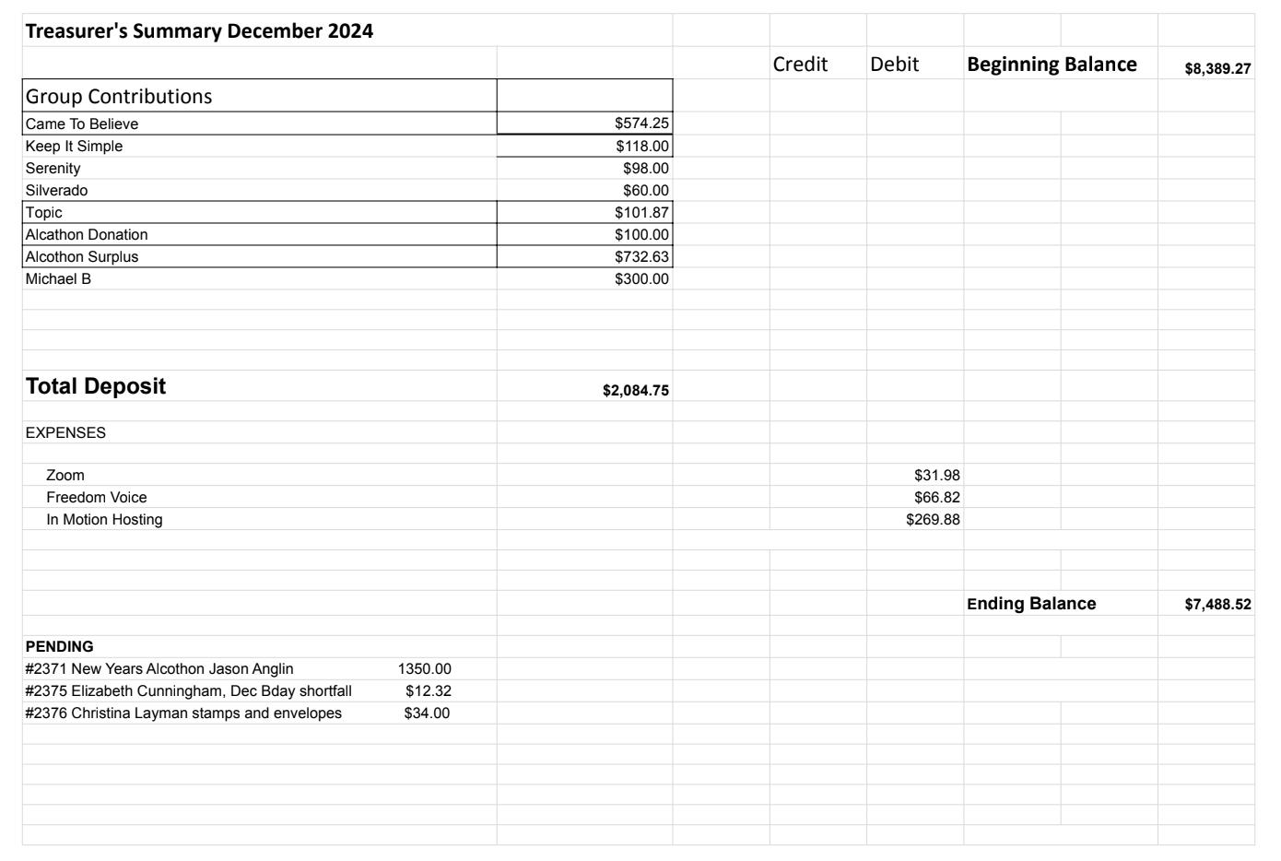

**Financial Oversight Committee:**

[financial@aanapa.org](mailto:financial@aanapa.org?subject=Intergroup)

No submission

**Committee Appointees**

| **2024-2025** | | **2024 (2025-2026 Staggering)** | |
| --- | --- | --- | --- |
| **Chair** | Meghan T. | **Secretary** | Meg P. |
| **Alt Chair** | VACANT | **District Liaison** | Jason A. |
| **Bday Co Chair** | Jeff | **Newsletter** | Jean |
| **Bday Co Chair** | Beth C. | **H&I Liaison** | VACANT |
| **Hotline Chair** | Travis | **Treasurer** | Tena |
| **Female Delegate at Large** | Laura | **Web Editor** | Alex W. |
| **Male Delegate at Large** | Rick | **Literature Chair** | Mary W./Kevin P. (interim) |
| **Printed Meeting Schedule Chair** | Kevin P. | **Events Chair** | VACANT |

*In December elections will be held*

**Old Business**

-Spanish speaking liaison to their district?‬

-Alcathon updates‬

-Cleaning the storage container‬

**New Business**

-Next tradition reader: Jessica

-Intergroup tri-fold

**Closing**

**The Responsibility Statement:**

*“I am Responsible. When anyone, anywhere, reaches out for help, I want the hand of A.A. always to be there. And for that: I am responsible.”*