**Napa Valley Intergroup Meeting Takebacks and Minutes**

January 11, 2025

**Takebacks:**

* Several positions still need to be filled. Please reach out to Meghan (chair@aanapa.org) if you are interested in being of service in the following:
  + Recording Secretary
  + Alternate Chair
  + Meeting Schedule Chair
* H&I looking for volunteers!
  + Looking for new Napa State Hospital Coordinator
    - Requires 2 year sobriety & 1 year H&I experience.
  + Need Volunteers for Cresswood in Vallejo
  + Need Volunteers for Napa State Hospital
    - 6 month sobriety requirement & valid CA Driver’s License
  + Next H&I Meeting Feb 7, 6:45PM at Sea Scouts (First friday of the month)
* Newsletter
  + Latest newsletter was published in December 2024.
  + Looking for submissions for the next newsletter. Theme will be the first 3 steps and traditions. Can be anything from 5-500 words, about the theme or anything you like.
  + Also looking for submissions in the form of artwork, poetry, and more.
* New Plain Language Big Books being ordered. Should be available soon.

**Call To Order**

**A Moment of Silence followed by the Serenity Prayer**

**New Rep Introduction**

New Intergroup Reps and Officers packets can be found on aanapa.org

<https://aanapa.org/service/intergroup/welcome-new-intergroup-reps>

Please provide your email and contact information to the Secretary.

**Meeting Participant Introductions**

**Sobriety Birthdays**

**Review and approval of minutes**

**Monthly Tradition Reading from 12 Traditions Illustrated & Discussion**

Reader: Kevin P.

1st Tradition: Our common welfare should come first; personal recovery depends upon A.A. unity.

**7th Tradition**

We have no dues or fees in A.A. We are entirely self-supporting, declining outside contributions. Visit https://www.aanapa.org and use the Venmo link or mail your contribution to NVIG, P.O Box 10948, Napa, CA 94581-2948. Venmo link for IG contributions: <https://www.venmo.com/u/NapaIG-AA>

$10.58 Collected

**Housekeeping Motions**

Please wait your turn to speak and raised your hand to be called on to speak. Please silence your cell phones

**Announcements**

**Reports:**

**Chair: Meghan T.**

[chair@aanapa.org](mailto:%20chair@aanapa.org?subject=Intergroup)

Reminder that we are doing quarterly in-person meetings. In person meeting seems to be growing, we should continue the conversation about in person meetings.

Alt Chair role is still open. We need this role filled.

**Alternate Chair: VACANT**

[altchair@aanapa.org](mailto:altchair@aanapa.org?subject=Intergroup)

No submission

**Secretary: Vacant**

[secretary@aanapa.org](mailto:secretary@aanapa.org?subject=Intergroup)

Nothing to report.

**Literature Chair: Kevin P.**

[literature@aanapa.org](mailto:literature@aanapa.org?subject=Intergroup)

**Napa Intergroup Literature Report** No submission during transition.

The online literature order form is up and running. It, as well as the Printable Literature Order form, can be found on our website - aanapa.org

Select “Resources”, Select “Literature”, select “Online Literature Order form” or “Printable Literature Order form”

Unfortunately, Plain Language Big Book is currently out of stock. When I am able to order, we will update the literature order form to reflect availability.

It appears there are still many members unaware that literature can be ordered online, or even how to go about ordering literature from Intergroup. Reps please announce at meetings you attend.

Thanks.

In Service,

Kevin P.

[literature@aanapa.org](mailto:literature@aanapa.org)

**Hotline Chair: Travis**

[hotline@aanapa.org](mailto:hotline@aanapa.org%20?subject=Intergroup)

No submission

Jane mentioned signing up.

Question about how many calls we get?

Question about how many people are signed up?

**Web Editor: Zane M. (Intergroup)**

**Website Committee Chair: Alex W.**

[webeditor@aanapa.org](mailto:webeditor@aanapa.org%20?subject=Intergroup)

Business Meeting

1. Website running and secure
2. Potential issues with website Search Engine Optimization
   1. Alex has reported that when using Safari on iPhone our website does not appear to come up in the results under Google.
   2. Zane is investigating and determining ways to improve our SEO and will have a report for the February meeting on findings

Zane M - Web Admin, Intergroup

Derek C - Web Admin, District 11

**Meeting Schedule Chair: VACANT**

[meetings@aanapa.org](mailto:meetings@aanapa.org%20?subject=Intergroup)

No submission

Print Schedules can be ordered from the Online Literature Order Form

**Newsletter Chair: Jean**

[newsletter@aanapa.org](mailto:newsletter@aanapa.org%20?subject=Intergroup)

No submission

4th quarter 2024 Newsletter published on the website under resources.

Q1 2025 newsletter being worked on. Theme will be 1,2,3. First 3 steps and traditions.

Needs submissions, anything from 5-500 works. Can be related to the theme or not. Also looking for artwork, poetry, and anything else you’d like to submit.

Needs new email platform to distribute.

**Delegates at Large: Laura / Rick**

[delegateatlarge@aanapa.org](mailto:%20delegateatlarge@aanapa.org%20?subject=Intergroup)

No submission

**General Service Liaison: John**

No submission

Need Bridging the Gap role

Interdistrict workshop in Keylsyville on the 21st.

Changes proposed to Plain Language Big Book

**Hospitals and Institutions Liaison: Heidi**

No submission

Promoting H&I procedure manual

Looking for new Napa State Hospital Coordinator

Requires 2 year sobriety & 1 year H&I experience.

D11 January 4th meeting, looking for Bridging the Gap Liaison

Meetings going into Cresswood. Needs Volunteers.

Crisis stabilization unit asking for meetings

Vallejo Detox has 5 meetings per week.

Napa State Hospital needs volutneers

6 months sobriety & an Valid CA Driver’s license.

Next meeting Feb 7th at Sea Scouts.

Women’s jail still having issues bringing meetings in, the women don’t want them.

**Birthday Meeting Co-Chairs: Jeff/Beth**

[birthdaymeeting@aanapa.org](mailto:birthdaymeeting@aanapa.org?subject=Intergroup)

| **NAPA VALLEY INTERGROUP** | |
| --- | --- |
| **INCOME / EXPENSE SHEET** | |
|  |  |
| EVENT: | Dec B-day meeting |
| DATE: | Dec 27 2024 |
| GROUP NAME: | AA Birthday |
| CONTACT NAME: | Beth |
| CONTACT EMAIL: | bananapez2@yahoo.com |
| CONTACT PHONE: | 707-953-0483 |
| **EVENT INCOME** | |
| ***DO NOT INCLUDE H&I HERE*** | **$$$$$** |
| NV INTERGROUP CONTRIBUTION | $0.00 |
| 7TH TRADITION | $106.75 |
| **GROSS INCOME** | **$106.75** |
| **EVENT EXPENSES (ITEMIZED)** | |
| **ITEM** | **$$$$$** |
| Cake | $80.98 |
| Coffee | $15.00 |
| Coffee Cups | $10.76 |
| Plates | $37.33 |
| **TOTAL EXPENSES** | **$144.07** |
| **TOTALS** | |
| EVENT INCOME - EVENT EXPENSES | -$37.32 |
| H&I (Pink Can) | $25.00 |
| **CHECK TOTAL TO I/G** | **-$12.32** |
|  |  |
| **NON-MONETARY DONATIONS (ITEMIZED)** | |
| **ITEM (Example: Donated catering, services, etc..)** | **$$$$$** |
| [INSERT DETAILS] | $0.00 |
| **TOTAL DONATIONS** | **$0.00** |
| **FOR FINANCIAL OVERSIGHT COMMITTEE ONLY** | |
| **TRUE COST** | **$ (12.32)** |

**Treasurer: Alex W.**

[treasurer@aanapa.org](mailto:treasurer@aanapa.org?subject=Intergroup)

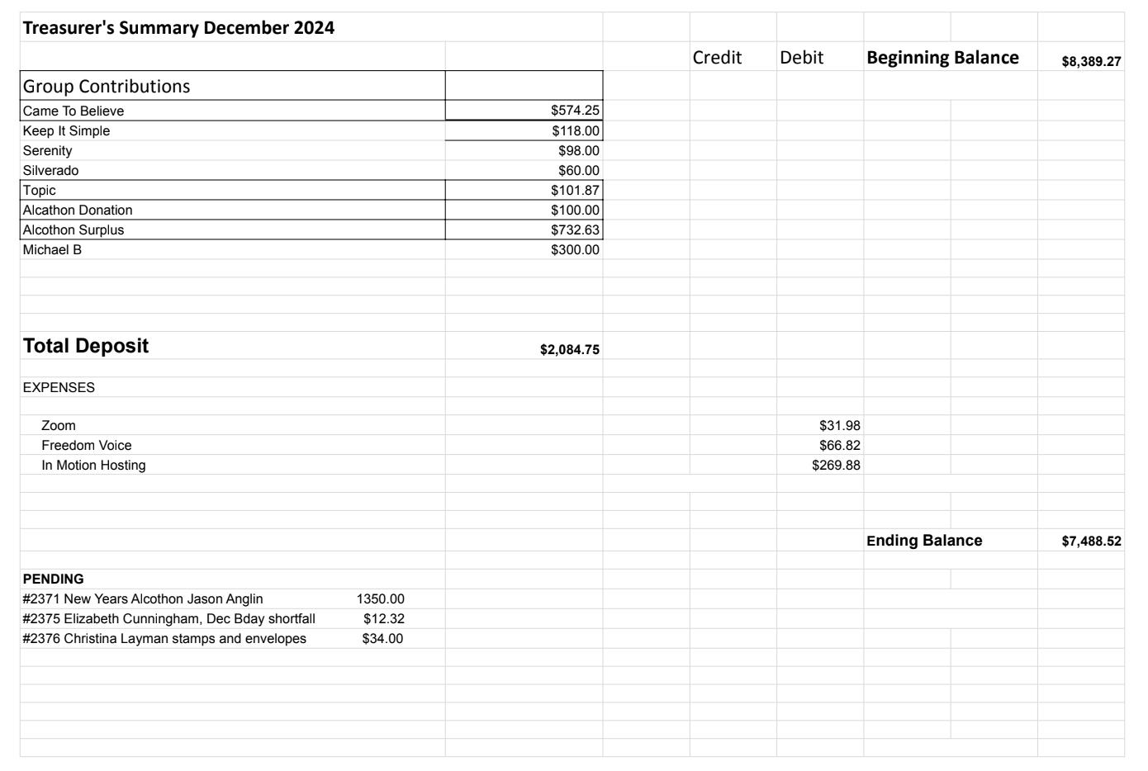

**Financial Oversight Committee:**

[financial@aanapa.org](mailto:financial@aanapa.org?subject=Intergroup)

No submission

**Committee Appointees**

| **2024-2025** | | **2024 (2025-2026 Staggering)** | |
| --- | --- | --- | --- |
| **Chair** | Meghan T. | **Secretary** | VACANT |
| **Alt Chair** | VACANT | **District Liaison** | VACANT |
| **Bday Co Chair** | Jeff | **Newsletter** | Jean |
| **Bday Co Chair** | Beth C. | **H&I Liaison** | Heidi |
| **Hotline Chair** | Travis | **Treasurer** | Alex W. |
| **Female Delegate at Large** | Laura | **Web Editor** | Zane M. |
| **Male Delegate at Large** | Rick | **Literature Chair** | Mary W./Kevin P. (interim) |
| **Printed Meeting Schedule Chair** | Glenn | **Events Chair** | Laura K. |

*In December elections will be held*

**Old Business**

-Spanish speaking liaison to their district?‬

-Alcathon updates‬ -

- Christmas Alcathon went good.

- Some issues with New Years, body wasn’t available onsite

-Cleaning the storage container‬

**New Business**

-Next tradition reader: Jessica

-CTB Meeting - Used to be hybrid. Offering equipment to Intergroup to use for hybrid or offer up to a group (or district) that needs it. IG to continue discussion in Feb.

-Intergroup Trifold - Do we update it? - Megan T., Alex W., Jean, Jo to update and present in Feb.

- Newsletter - Pay for email distribution service. Research being done.

- Non-Profit - Alex doing research

-FOC - Should this become ad-hoc or stay standing? Discuss next month

- District - 2 proposals

- Buy Storage shed from NRRC

-Moved to Old Business and approved purchase of shipping container

- District hosting CNCA assembly in October 2025. Asking if we want to co-host

- This would be a Birthday meeting with potluck before, and dancing after.

- Accelerated and approved.

**Closing**

**The Responsibility Statement:**

*“I am Responsible. When anyone, anywhere, reaches out for help, I want the hand of A.A. always to be there. And for that: I am responsible.”*