Take Back to Groups

- SAVE THE DATE: October 31 Anniversary, General Services Meeting, Birthday, and Halloween “Monster Bash”
- Hotline is looking for Spanish speakers. Please contact Travis N. hotline@aanapa.org
- Intergroup Newsletter submission deadline is September 15, 2025. Send your submission to newsletter@aanapa.org
- Intergroup has Open Positions: Alternate Chair, District Liaison, Tech to run Intergroup Hybrid Meetings, Spanish Speaking Representative
- Send Group meeting updates to: webeditor@aanapa.org
- Intergroup is looking for groups to host the Alcathons. Contact Laura K if you are interested. events@aanapa.org
-------------------------------------------------------------------------------------------------
CALL TO ORDER
Moment of Silence & Serenity Prayer
New Rep Introduction: Cindy from Gliders Group
Meeting Participant Introductions:
Meghen – Chair | Craig W. – Literature Chair
Alex W. – Treasurer / As Bill Sees It | Jane C. – At Large / Free Thinkers Group
Zane M. – Web Editor / Never Too Young | Cindy C. – UpValley Rep. / Gliders Group
Travis N. – Hotline Chair | Jean C. – Newsletter Chair
Gene M. – Men’s Sat. Stag | Jo M. – Veterans Home Group Rep.
Brian D. – No Ma’am Group | Laura K. – Events Chair
Mark V. - Secretary | Michelle P. – Serenity on Saturday Group

Sobriety Birthdays: Group congratulated Michelle P. for 37 years of sobriety.

Review and approval of July Intergroup minutes.
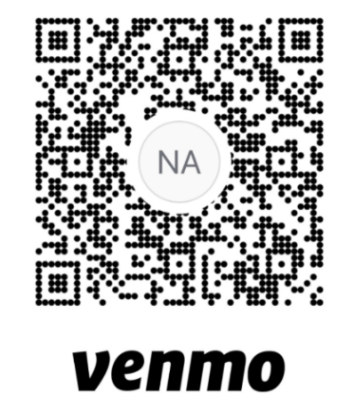
Monthly Tradition Reading from 12 Traditions: Tradition 8 (Zane M.)
7th Tradition: We have no dues or fees in A.A. We are entirely self-supporting, declining outside contributions. Please mail contributions to NVIG, P.O Box 10948, Napa, CA 94581-2948. Venmo link for IG contributions: https://www.venmo.com/u/NapaIG-AA @NapaIG-AA

ANNOUNCEMENTS
A new women's group, "Sisters in Sobriety," starting Wednesdays at 6:30 PM at the
Inter-Group will co-host a combined anniversary party and Area Assembly dinner on October 31st (Halloween). ​The event will be held at Crosswalk Church; the Area Assembly meeting is at Expo Fairgrounds in Chardonnay Hall.
District is voting whether to co-fund the event. If they match the funding, the group agreed to split the 7th Tradition contributions from the event.
OFFICER REPORTS
Alternate Chair: The position is vacant.

Literature Chair: Craig W.
Printed schedule order form is available on aanapa.org under the Resources section.
​Members needing new schedules can email them to meetings@aanapa.org.
​
Newsletter Chair: Jean newsletter@aanapa.org
October 1 is the target date for next publication. Theme for the next newsletter is “Finding your authentic voice / Authenticity in AA.” We request submissions of visual arts and photography from fellowship members. Contributions and submissions can be sent to newsletter@aanapa.org. Deadline for next newsletter submissions is September 15.
Sign up for the AA Napa Newsletter: https://aanapa.org/service/intergroup/newsletters
Reviewed Newsletter “Pass It On” steps with IG Board.

Hotline Chair: Travis hotline@aanapa.org
Travis reported progress has been made on the Spanish-speaking hotline. Ten men and one woman signed up to answer calls. Some bugs need to be worked out with the Grasshopper phone system.
- Total hangups :14
- Men: 22 calls
- Women: 7 total calls
- Pick up 100% for July
- Aug 0/4 0% all went to vm
Numbers and Extensions | Total | Message | Hangup | Answered
English Women | 7
English Men | 22 |  | 14
Spanish Women | 0 | 0 | 0 | 0
Spanish Men | 0 | 0 | 0 | 0

Web Editor: Zane M. (Intergroup) and Derek C. (Web Admin, District 11)
Meeting change for Tuesday Heritage Arts. Web committee meeting was postponed. Everyone is welcome to email schedule changes.

Meeting Schedule Chair: Glen G. meetings@aanapa.org No report.

Delegates at Large: Laura / Rick delegateatlarge@aanapa.org No report.

District Liaison: Position is vacant.

Hospitals and Institutions Liaison: No report.

Birthday Meeting Co-Chairs: birthdaymeeting@aanapa.org no report.

Treasurer: Alex W. treasurer@aanapa.org
The billing issue with the printed schedule chair has been resolved. The correct email address for invoices has been confirmed and is now being used
Bank account needs to be moved.
Group is looking for a meeting space less than $80 per month.
Last birthday meeting had a loss of $61 due to the need to restock on chips. Group was cash-positive last month due to other contributions.
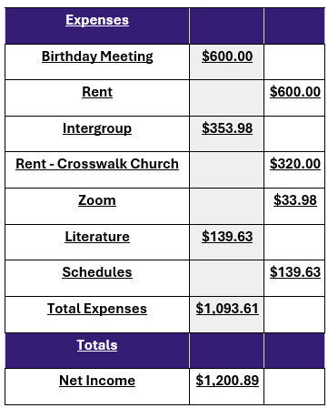
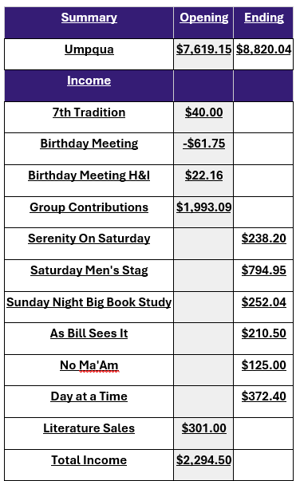

Committee Appointees *In December elections will be held*
2024-2025 |  | 2024 (2025-2026 Staggering)
Chair | Meghan T. | Secretary | Mark V.
Alt Chair | VACANT | District Liaison | VACANT
Birthday Chair | Carl K. | Newsletter | Jean
Birthday Treasurer | Beth C. | H&I Liaison | Heidi
Hotline Chair | Travis | Treasurer | Alex W.
Female Delegate at Large | VACANT | Web Editor | Zane M.
Male Delegate at Large | VACANT | Literature Chair | Craig W.
Print Meeting Schedule Chair | Glenn G. | Events Chair | Laura K

OLD BUSINESS
Bylaws subcommittee formed (Megan, Alex, Zane, Travis, Mark, Laura) to review and update Bylaws, as they haven't been revised in several years. ​The committee will discuss, among other issues, whether to formalize the Tech Chair, Spanish-Speaking Liaison, and Up Valley Delegate roles:
Spanish-speaking Liaison: This position is being formalized within the bylaws.
Tech Chair (for Zoom/Hybrid meetings): This position is being formalized within the bylaws. This role is crucial for enabling hybrid meetings, and the group acknowledges that the lack of a volunteer is preventing Zoom from being offered. The website will be updated to reflect that Zoom is on pause due to the need for a volunteer.
Up Valley Delegate at Large position discussed, moved, and approved to expand outreach.

NEW BUSINESS
Carl was nominated and voted as the new Birthday Meeting Chair. He has over 38 years of sobriety and a willingness to serve.

Closing
The Responsibility Statement: “I am Responsible. When anyone, anywhere, reaches out for help, I want the hand of A.A. always to be there. And for that: I am responsible.”

