INTERGROUP BUSINESS MEETING
March 11, 2023
Agenda

Call To Order
A Moment of Silence followed by the Serenity Prayer

New Rep Introduction:
New Intergroup Reps and Officers packets can be found on aanapa.org
https://aanapa.org/service/intergroup/welcome-new-intergroup-reps
Please provide your email and contact information to the Secretary.

Meeting Participant Introductions:

Sobriety Birthdays:

Review and approval of minutes

Minutes are approved unless there are any objections.

Monthly Tradition Reading from 12 Traditions Illustrated & Discussion

Reader: Nell – Tradition 3: The only requirement for AA membership is a desire to stop drinking.

7th Tradition

We have no dues or fees in A.A. We are entirely self-supporting, declining outside contributions. Visit https://www.aanapa.org and use the Venmo link or mail your contribution to NVIG, P.O Box 10948, Napa, CA 94581-2948
Venmo link for IG contributions: https://www.venmo.com/u/NapaIG-AA

Housekeeping Motions

These are procedural motions and pass if there are no objections. If the motion does not pass it will move to new business.

REPORTS

Chair: Frank F. chair@aanapa.org

Greetings,
All of us who serve as officers of Napa Valley Intergroup, once again find ourselves extremely grateful to all who serve as Intergroup Representatives. You are the messengers of all that’s going on within our realm. Without your sincere efforts, IG would find itself challenged to engage our growing fellowship as robustly as we currently do. Please keep spreading the news and bringing to the attention of others what it is we all do together.
Many Thanks,
Frank

Alternate Chair: Ann E. altchair@aanapa.org

Secretary: Patty B. secretary@aanapa.org

Please provide current contact information such as your email address and the best phone number at which you can be reached.

Literature Chair: Mary W. literature@aanapa.org

Please refer to the “New Business” section for additional item of interest.
Michael B. | 5 Big Books, Check #2008 | $47.50
Gordon R. | 4 Big Books, 2 12x12 Check #1749 | $55.00
Alex W. | 2 Big Books, 2 12x12, 2 Daily Reflections (paid with cash) | $56.00
 | Total | $158.50
The literature order form is available as shown below on our website - aanapa.org
Select “Resources”, Select “Literature”, select “Printable Literature Order form”
The URL is: https://aanapa.org/wp-content/uploads/Literature-form-.pd
Please use it to check prices and submit with any order.

Hotline Chair: Erik H. hotline@aanapa.org

Male Line: 6 Calls
Female Line: 6 Calls
General Extension: 12 Calls
Most calls were short lasting less than a minute. There was 2 calls lasting longer then 5 minutes, one of which had a 15 minute duration.

Web Editor/Ad Hoc Website Committee: Alex. - Jeff D. webeditor@aanapa.org

AA Napa Valley Web Committee Report March 2023 Business Meeting
Literature: Draft Online Order Form Ready for testing
Volunteer Sign Up Sheet is ready for testing

Zoom
  - 30 meetings using Zoom - Auditing them all
  - 20 Audited
    - 16 OK
    - 4 Errors
      - 4 Didn’t Open
        - 6PM Tuesday
        - 7:30 Tuesday
        - 7:30 Wednesday (South Napa)
        - 7:30 Friday
      - 1 Not using (Fixed)
        - 7PM Thursday (No longer using - fixed)

Update Calendar Business Meetings - Done: 9
Reaching out to other service entities for volunteers to web committee
  - Met w/ H&I - Jeff working
  - PI/CPC - Alex Working with them
  - Will meet w/NAPYPAA - Alex

Alex W: Web Admin, Intergroup
Jeff D: Web Admin, District 11

Meeting Schedule Chair: Jo M. meetings@aanapa.org

Printed schedules were printed and paid for. They are in circulation and can be found at Crosswalk Church and Sea Scouts and Frank has more. We need someone to take on the position of printed schedule chair to help coordinate with the website on a new format from the web to print and continue distributing.

Newsletter Chair: Catherine F. newsletter@aanapa.org

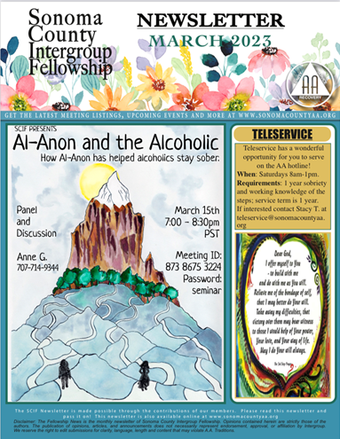
Delegates at Large: Katie Z. / Bill C. delegateatlarge@aanapa.org

February/March Meetings Attended
Sunday Hut Group - 26 Feb
Monday DAAT - 27 Feb - Cynthia C is the IG rep
Wednesday KCB - 1 Mar
Friday beginners mtg - 3 Ma

General Service Liaison: Jo M.

District Liaison position is still open.
This month’s report is about the group consciences that will be held by the General Service Representatives (GSRs) from the groups on Agenda Topics for this year’s General Service Conference in NY.
This is the way that every member of AA has input, through groups, districts, areas and delegates to the General Service Conference where decisions are made for AA as a whole. These topics are in every realm that we operate collectively, from literature, to our presence in social media, to corrections/Hospitals & Institutions, to policies and procedures, and more. This is how we protect AA, change AA, and keep our World Service headquarters informed about our collective group conscience.
SHOW UP FOR YOUR GROUP’S MEETINGS ON THE TOPICS! Individual ideas are welcomed by our delegate, too. See the Area Website: CNCA06.org
Open positions at District:
- Recording Secretary
- Intergroup Liaison
- NAPYPAA Liaison
- Archives Chair
- NEW POSITION—Accessibilities Chair
All are welcome to attend our District meetings held today at 1:00, but normally the first Saturday of each month at 10am. Zoom 860 5600 2397 pw 060455

Hospitals and Institutions Liaison: John C. john@curnutt.org

H&I welcomes anyone to join us at our monthly business meeting 6:45 pm on the first Friday of the month at the Sea Scout Building 402 Riverside Drive Napa, CA 94559. Learn about the workings of H&I and how to get involved.

Did you know that there are facilities that you can attend without filling out clearance paperwork, make a commitment or even share?

Currently Area 51 brings 26 meetings a week and literature to the Women’s Jail, Men’s Jail, Men’s Jail Spanish, California Medical Facility, Crestwood Behavior Center Vallejo, Crestwood Behavior Center Angwin, National Vallejo, CenterPoint, Napa South Shelter, Napa State Hospital Spanish, Napa State Hospital English, Queen of the Valley Hospital, SHAMIA house and Vallejo Detox.
You can learn more about H&I by going to http://www.handinorcal.org or by contacting John Curnutt 707-477-0422 john@curnutt.org

Summary
Our return into the facilities continues to be herky-jerky we are hoping to gather some more even momentum in 2023. Currently Jails and State Hospital are still offline.

Finance
Attached is the February 2023 H&I Financial Statement. While we had positive cash flow of $3845 for the month, GrapeVine/LaVina failed to send us our bi-monthly invoices of approximately $13,000, which would have made the actual cash flow for the month around -$9000 and the YTD cash flow around -$20,000. This will normalize next month when the invoices are received and paid. Our financial condition remains "sound", as we continue to draw down on our cash reserves.

The below analysis indicates our contributions were slightly higher than last year and our expenses were over twice as high as last year, due to extremely low literature orders during the first two months of 2022. All in all, we're headed in the right direction.

Feb, 2023 | contributions | Lit expense | Total expense
YTD comparison to LY | +7.7% | +102.7% | +86.8%
YTD comparison to Budget | -3.0% | -14.4% | -17.6%
Overall financial condition: | SOUND

Feb, 2023 Last Month Contributions Year to date Contributions
Area 51, Napa $722.25 $2,200.15
Open Positions
Area Chair: We are still seeking a candidate for Chair of Area 51. Please reach out to your contacts. Do they have five years of sobriety? Can they organize information? Can they work with others? Have they done H&I or had contact with institutions dealing with alcohol? If being a coordinator of coordinator is in your skill set The Chair of Area 51 H&I might be the perfect service commitment.

Intergroup Liaison
Men’s Jail Coordinator

Online Contributions
Make credit card contributions online and get an immediate receipt: www.handinorcal.org/contribute Please make sure to write on contribution checks AREA 51. This allows H&I to track donations by the Napa area.

H&I business meeting is back to in person meetings at the Sea Scouts.
Next meeting on April 7th in person Sea Scouts 6:45pm.

Financial Oversight Committee: financial@aanapa.org

We will take up the forming of a newly established committee in April, 2023

Birthday Meeting Chair: Meghan T. & Heather B. birthdaymeeting@aanapa.org

February 24, 2023
7th Tradition: $170.25
H&I: $45.34
Total Income: $215.59
Total Expenses: $117.63 ($34.00 Cake – $16.99 Coffee Supplies – $66.64 AA Chips)
Net Income: $97.96

Treasurer: Christina (Tena) treasurer@aanapa.org

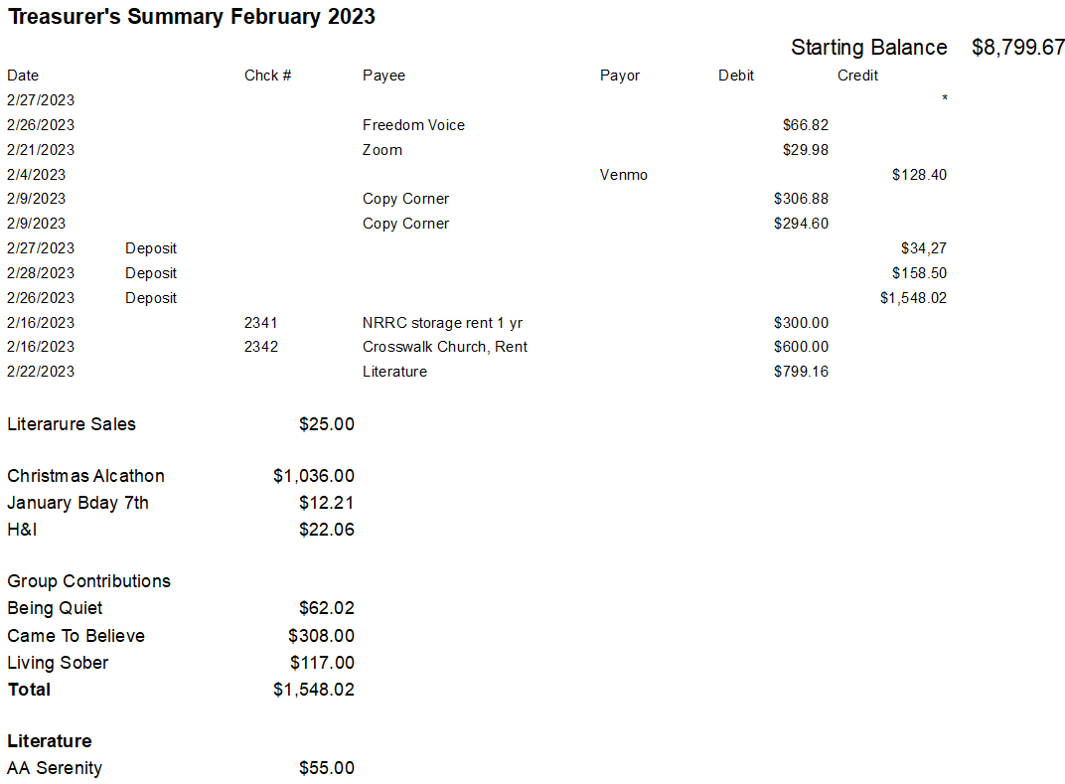

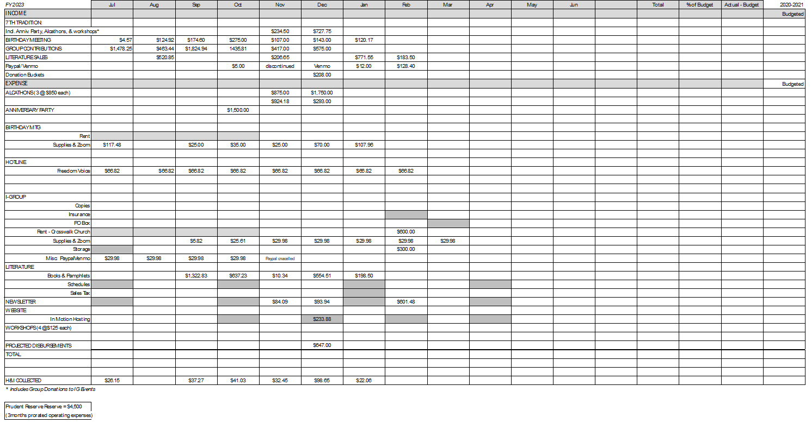

New Business: Intergroup Officer discussion on charging groups for AA Pamphlets beginning April 1, 2023

Old Business: Napa Valley AA Summer Picnic. This was voted in at last meeting.
Tracey P. to provide committee request for additional budget assistance.

Events Committee Chair position was voted in at last meeting. Discussion as to when we might begin to open voting for interested candidates.
Anniversary Party Report received on March 3, 2023

Open Positions: NAPYPAA Liaison – H& I Rep – District Liaison – Printed Schedules

Closing:

The Responsibility Statement:

“I am Responsible. When anyone, anywhere, reaches out for help, I want the hand of A.A. always to be there. And for that: I am responsible.”

