INTERGROUP BUSINESS MEETING November 12, 2022
Minutes

Bring Back to Your Group
- The Saturday morning Serenity on Saturday Women’s meeting is hosting the Thanksgiving Alcathon.
  - It will be held from 7am to 8pm at the 7th Day Adventist Church on G Street right off Jefferson.
  - Signup sheets for committees, including clean-up, and secretary / chair are circulating.
- TGIF – M-S 5:30 meetings along with Saturday Morning Men’s Stag are hosting the Christmas Alcathon.
- Joe’s Group in St Helena is hosting the New Year’s Alcathon.
- Hotline needs volunteers. Contact Erik H if interested or email hotline@aanapa.org
- There are many IG service positions that will be coming up for rotation starting in January Please contact Frank F. if you are interested email chair@aanapa.org.
- November newsletter is posted and highlights the Alcathons and tips on how to stay sober during the holiday season.
- Updated printed schedules are available.
- Check out the new online meeting schedule format to be posted on www.aanapa.org

Call To Order

A Moment of Silence followed by the Serenity Prayer

New Rep Introduction:

New Intergroup Reps and Officers packets can be found on aanapa.org.
Please provide contact information to the Secretary.

Meeting Participant Introductions:

Alex Weeks joined who is part of the Ad Hoc Website Committee

Sobriety Birthdays:

Frank – 6 years Nov 3
Rick – 6 years Nov 26
Congratulations!

Review and approval of minutes

Minutes approved

Monthly Tradition Reading from 12 Traditions Illustrated & Discussion

Reader: Teri Tradition 11

Our public relations policy is based on attraction rather than promotion; we need always maintain personal anonymity at the level of press, radio, and films.

Discussion:
- Maintaining anonymity on social media is challenging. We still see big personalities break their anonymity.
- With that said, Bill W. stressed that it is important that “…we need to be known to each other…”
- It is important that we know how to contact each other when needed.

John B. agreed to review Tradition 12 next month.

7th Tradition

We have no dues or fees in A.A. We are entirely self-supporting, declining outside contributions. Visit https://www.aanapa.org and use the Venmo link or mail your contribution to NVIG, P.O Box 10948, Napa, CA 94581-2948

Venmo link for IG contributions: https://www.venmo.com/u/NapaIG-AA

Housekeeping Motions

No housekeeping motions

Reports

Chair: Frank F. chair@aanapa.org

It is once again time to engage in the Spirit of Rotation for certain Service Commitments for the upcoming IG cycle. Please refer to our “New Business” section for available positions to be voted upon.
Due to our bustling business load, I have elected to reschedule a presentation offered up from our siblings at CNCA Accessibilities. Co-Chair of California Northern Coastal Area 06. Claudia G. will present next month on how we might help with their plight to better assist with Deaf and Hard of Hearing mtgs.
The AA in Napa 78th Birthday Anniversary Party was a smashing success. We thank Jonave and those in Napypaa who assisted in making this such a successful event.
Our rapidly approaching Holiday Alcathons will be hosted by the groups listed below.
Thanksgiving = SOS Saturday Women’s Group
Christmas = Saturday Men’s Stag and Thank God It’s (Sea Scout 5:30)
New Year’s = Joes Group
Alternate Chair: Open Position altchair@aanapa.org

Secretary: Ann E. secretary@aanapa.org

- Please submit your reports before Friday at noon preceeding.
- If that is not possible, the report will be included in the meeting minutes.

Literature Chair: Shaela A. literature@aanapa.org

September 2022
Kevin P. | 10 - BB // check #1700 | $95.00
Elisabeth B. | 5 - Daily Reflections // check #180 | $51.25
Maureen D. | 3 - BB, 1 - 12x12, 1- Pass it on, 2- Dailys // check #461 | $60.40
Michael B. | 7 - BB, 3 - 12x12 // check (sent to PO Box) | $91.25
 | Total | $297.90

- An order was placed for BB, 12 x 12, and pamphlets for a total of $744.66. Big print BB are on back order.
- The NEW, REVISED literature order form is available as shown on our website: http://www.aanapa.org/service/resources/group-resources/literature

Hotline Chair: Erik H. hotline@aanapa.org

- Male Line: 15 calls
- Female Line: 4 calls
- General Line: 10 calls
- Most calls were short lasting less than a minute.
- There was 1 call lasting longer than 5 minutes.

Web Editor/Ad Hoc Website Committee: Patty B. - Jeff D. webeditor@aanapa.org

- Jeff D. and Alex W. presented the proposed revisions to the web-based meeting schedule (with real-time demonstration). This type of e-schedule is already implemented in many other districts.
- It is also being presented to our District Committee.
- The “behind the scenes” logic makes the e-schedule user friendly.
- Monthly meetings such as the IG and GSR will be listed on a separate page therefore will require one more click to access.
- The ability to printout schedules from this site is forthcoming, but they are not currently a priority.
- If the IG Committee approves, a beta site will be added to www.aanapa.org next month.
  - The IG committee approved unanimously.

Meeting Schedule Chair: Jo M. meetings@aanapa.org

Printed Schedules: The latest schedules have been printed, distributed, and posted at aanapa.org.

Newsletter Chair: Catherine F. newsletter@aanapa.org

See copy of Thanksgiving Alcathon flyer at end of minutes

Delegates at Large: Katie Z. and John B. delegateatlarge@aanapa.org
​​
Delegates at Large attended seven meetings in the past month:
- Rule 62
- Cottage Group
- Wednesday Downtown Group
- Women Gone Mild
- One Zoom at a Time
- Keeping It Simple
- Living Sober

General Service Liaison: Jo M.

- District doesn’t meet until after this month’s Intergroup meeting, so please go to www.aanapa.org for information.
- Fall Assembly happened and was Great! It was long because people made themselves available for service positions. We had many votes to get to 2/3rds vote. They went to the hat for a few positions (third legacy).
- District elections are happening this month, like Intergroup. There may be continuing opportunities for service, so please come to meetings to know what’s going on and perhaps make yourself available to serve.
- New addresses for donations from groups or individuals to:
  - California Northern Coastal Area 06: (cnca06.org) to 1390 N. McDowell Blvd, Suite G-339, Petaluma, CA 94954
  - General Service Office: P. O. Box 2407, James A Farley Station, NY, NY 10116-2407.
- Please check registration details for your group, all groups with the website at www.aanapa.org and our Registrar at www.registrar@aanapa.org
- Beginners meeting needs new coordinators and volunteer secretaries for 6-week commitments to get speakers. The meeting needs support from people with sobriety time as well as beginners. It’s hybrid, so please attend when you can.
- Concepts Study is every Wednesday evening at 5:30 pm on Zoom through November. Please go to www.aanapa.org for the Zoom connection info.
- Check www.aanapa.org for an update on the Service Manual Study that has been on the third Sunday of each month.

Hospitals and Institutions Liaison: John C. john@curnutt.org

H&I welcomes anyone to join us at our monthly business meeting 6:45 pm on the first Friday of the month at the Sea Scout Building, 402 Riverside Drive Napa, CA 94559. Learn about the workings of H&I and how to get involved. There are facilities that you can attend without filling out clearance paperwork, make a commitment or even share.

Currently Area 51 brings 26 meetings a week and literature to the Women’s Jail, Men’s Jail, Men’s Jail Spanish, California Medical Facility, Crestwood Behavior Center Vallejo, Crestwood Behavior Center Angwin, National Vallejo, CenterPoint, Napa South Shelter, Napa State Hospital Spanish, Napa State Hospital English, Queen of the Valley Hospital, SHAMIA house and Vallejo Detox. You can learn more about H&I by going to http://www.handinorcal.org or by contacting John Curnutt 707-477 – 0422 www.john@curnutt.org

Summary:

- The return into the facilities continues to be herky-jerky we are hoping to gather some more momentum in Q4. Currently Jails and State Hospital are still offline.
- We have elected a new Chair for Napa Area 51 – Lily B.
- It If you have 6 months of sobriety and want to share the message your service is needed.

Finance:
- Our finances continue to normalize, with numbers well above last year and getting closer to budget every month.
- Literature orders were good again last month, so we're continuing to get our life-saving message out to members in the facilities we serve!
- We had net NEGATIVE INCOME of over $18,000 this month, but our financial condition is still sound as we had budgeted for negative income this year to reduce our cash reserves.
- Napa Area 51 Contributions: October $1031.19; YTD $9,993.03
- Open Positions: Intergroup Liaison; Men’s Jail Coordinator; Napa South Shelter Coordinator
- Online Contributions: Notice: New sticker on pink cans - Make credit card contributions online and get an immediate receipt: www.handinorcal.org/contribute
- Please make sure to write on contribution checks AREA 51. This allows H&I to track donations by the Napa area.
- H&I business meeting is back to in person meetings at the Sea Scouts.
- Next meeting on December 2nd in person Sea Scouts 6:45pm.

Financial Oversight Committee: Erik S. financial@aanapa.org

- Eric S. has come to the end of his commitment. He is happy to help in any transition moving forward.
- We will take up the forming of a newly established committee at the outset of 2023.

Birthday Meeting Chair: Meghan T. & Heather B. birthdaymeeting@aanapa.org

- November’s birthday meeting will be the Friday immediately following Thanksgiving.
- We continue to have nice attendance and positions are filled (Frank is filling in on sound and lights).
- Dana is doing a great job managing the literature. She is very excited about being in service for the Birthday meeting!
- See below October’s income / expense sheet.
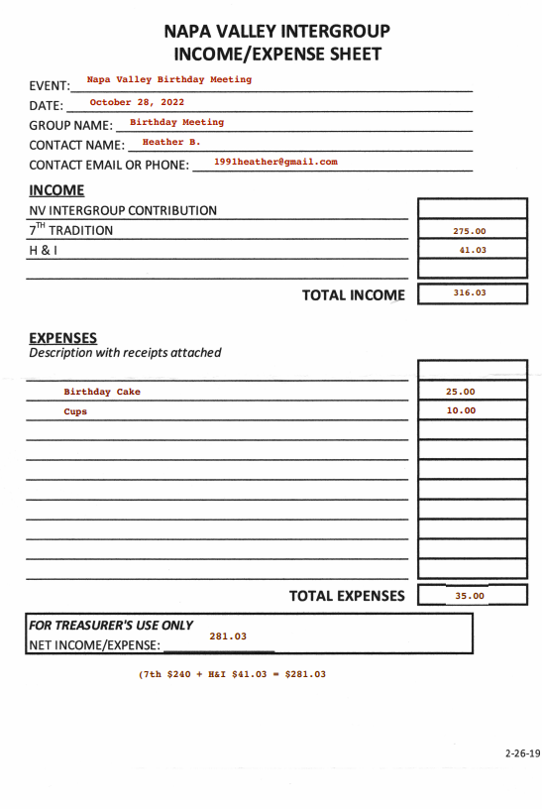

Treasurer: Christina (Tena) treasurer@aanapa.org

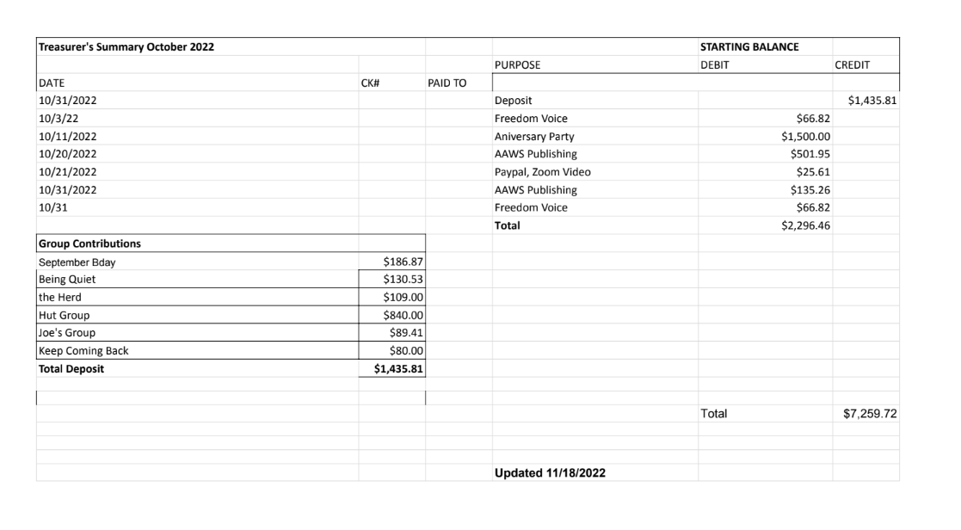
Old Business: none

New Business:

- Based on our Bylaws, we hold Service Commitment Elections in November.
- We have several open positions, beginning January 2023, including:
- Alternate-Chair
- Literature Chair
- Secretary
- Treasure
- Printed Schedule Chair
- Delegates at Large

- The committee voted to leave position elections open through January 2023 as we navigate the holidays and support the three forthcoming Alcathons.

Thanksgiving Alcathon:
- Will be held from 7am to 8pm at the 7th Day Adventist Church on G. Street, off of Jefferson.
- Food will be provided all day.
- Sign up lists to be on committees, and to secretary / chair a meeting are circulating.
- We will pay close attention to securing volunteers to be on the clean-up committee.

NAPYPAA Liaison: Jonave

No report submitted

Closing: The Responsibility Statement

“I am Responsible. When anyone, anywhere, reaches out for help, I want the hand of A.A. always to be there. And for that: I am responsible.”

Meeting adjourned at 11:50 am

