Napa Valley Intergroup Meeting Agenda
April 8, 2023
Call To Order
A Moment of Silence followed by the Serenity Prayer

New Rep Introduction
New Intergroup Reps and Officers packets can be found on aanapa.org
https://aanapa.org/service/intergroup/welcome-new-intergroup-reps
Please provide your email and contact information to the Secretary.

Meeting Participant Introductions

Sobriety Birthdays

Review and approval of minutes
Minutes are approved unless there are any objections.

Monthly Tradition Reading from 12 Traditions Illustrated & Discussion
Reader: Alex W. – Tradition 4: Each group should be autonomous except in matters affecting other groups or A.A. as a whole.

7th Tradition
We have no dues or fees in A.A. We are entirely self-supporting, declining outside contributions. Visit https://www.aanapa.org and use the Venmo link or mail your contribution to NVIG, P.O Box 10948, Napa, CA 94581-2948 . Venmo link for IG contributions: https://www.venmo.com/u/NapaIG-AA

Housekeeping Motions

These are procedural motions and pass if there are no objections. If the motion does not pass it will move to new business.

REPORTS

Chair: Frank F. chair@aanapa.org

Greetings Sisters and Brothers,
I attended several meetings between our last business meeting and this one. The rooms are bustling with eager new-comers and those who have been around for extended periods of time. It occurred to me that we have not sponsored any workshops since the outset of the pandemic.
Two workshops which seem to be extremely beneficial for all of us are Mindful Meditation and Sponsorship. I am bringing forth the suggestion to the IG Officers and if in favor, will bring to the reps for further consideration.

Thank to everyone for the wonderful Spirit of Service exhibited throughout our fellowship.

Alternate Chair: Ann E. altchair@aanapa.org

Nothing to report.

Secretary: Patty B. secretary@aanapa.org

Please continue to send updated contact information to secretary@aanapa.org for Intergroup Reps.

Literature Chair: Mary W. literature@aanapa.org

Large literature order of books and pamphlets placed on March 28 - Total Cost: $992.37

March 2023
Mike B | 5-12x12 - Check #2016 | $44.50
Haley P | 1 As Bill Sees it (will submit payment next week) | $9.00
John M | 3-BB, 2 Living Sober, 3 Daily Reflections - Check #760 | $69.25
Tannya V | 5-BB, 1 portable BB, 1 large print BB, 2-12x12 soft, 1- 12x12 large, 1-As Bill Sees It Soft,1= As Bill Sees It Large, 1- Daily Reflections, 2-Came to Believe, 1-Came to Believe large, 2-Living Sober, 1-Living Sober large print | $152.50
Kevin P | 10-BB, 1-BBlarge, 4-12x12 hard, 4-12x12 large, 5-As Bill Sees It, 1-ABSI soft, 3-Daily Reflections, 3 Daily Reflections large print | $292.40
Tom H | Balance owed from previous purchase | $30.00
 | Total | $597.65

General Service price increase went into effect on April 3, 2023. Books will increase about 20% and pamphlets 30%.

We will be discussing the possibility of charging groups for the pamphlets. With the price increase, they will now be between 10 cents and 55 cents each, with the majority costing between 20 and 35 each.

The literature order form is available as shown below on our website - aanapa.org
We are working to update it to reflect new costs.

Select “Resources”, Select “Literature”, select “Printable Literature Order form”
Interestingly, if you use app (smart phone or tablet) this link takes you to General Service (aa.org).
If you want to order through intergroup and avoid shipping costs, use a computer to download and print the order form or contact me directly at literature@aanapa.org. It is helpful to have completed order form with contact information when submitting order.

Hotline Chair: Erik H. hotline@aanapa.org
Male Line: 11 Call
Female Line:5 Calls
General Extension: 20 Calls
Most calls were short lasting less than a minute. There were 4 calls lasting longer than 1 minute including 1 over 7 minutes.

Web Editor: Alex W. webeditor@aanapa.org
Website Committee Chair: Jeff D.

- Literature
  - Draft Online Order Form Testing
  - Identified software bug, awaiting fix
  - Need to update pricing per the increase
- Volunteer Sign Up Sheet
  - Testing Started
  - Signups for AA Summer BBQ
- Zoom
  - 30 meetings using Zoom - Auditing them all
  - 20 Audited
    - 16 OK
    - 4 Errors
      - 4 Didn’t Open
        - 6PM Tuesday
        - 7:30 Tuesday
        - 7:30 Wednesday (South Napa) - REMOVED
        - 7:30 Friday
      - 1 Not using (Fixed)
        - 7PM Thursday (No longer using - fixed)
- Reaching out to other service entities for volunteers to web committee
  - Met w/ H&I - Jeff working
  - PI/CPC - Updated their page
  - Will meet w/NAPYPAA - Connected with new Rep - Starting engagement
- Meeting Schedule
  - Met with programmer. Gave prerequisites for tri-fold schedule.

Meeting Schedule Chair: Jo M. meetings@aanapa.org

Printed schedules have been done for a while. It’ll be time for another. If we can inspire anyone to take on this position to work with the web committee, it should be relatively easy and I’d be glad to assist. With our new website, we have spoken about printing straight from the web info, so the format will be different, a few folded pages, probably not print so many, and maybe print a general Intergroup trifold for all that we do and especially the web address, hotline number, and space for people to write phone numbers for newcomers.

Newsletter Chair: Catherine F. newsletter@aanapa.org

No Submission.

Delegates at Large: Katie Z. / John B. delegateatlarge@aanapa.org

Both our delegates were called upon to fulfill heavier than normal professional obligations, thus unable to attend and or report back on meeting visits. This should normalize in coming weeks.

General Service Liaison: Jo M.

District will have its meeting this afternoon, but the pre-conference assembly happened last weekend for all the 23 districts in our Area to give our group conscience results to our delegate. Eric L., our Area Delegate is on his way to the General Service Conference now. They’ll be discussing and deciding on this year’s agenda topics. District needs contact people — preferably General Service Representatives (GSRs) — for info from the General Service Office in New York. Please let me, Jo Moore, (707) 318-8168 know of your group’s GSR or contact person contact info for unity and connection.

Hospitals and Institutions Liaison: John C. john@curnutt.org

H&I welcomes anyone to join us at our monthly business meeting 6:45 pm on the first Friday of the month IN-PERSON at the Sea Scout Building 402 Riverside Drive Napa, CA 94559. Learn about the workings of H&I and how to get involved. Next meeting on April 7th in person Sea Scouts 6:45pm.

Did you know that there are facilities that you can attend without filling out clearance paperwork, make a commitment or even share?

You can learn more about H&I by going to http://www.handinorcal.org or by contacting John Curnutt 707-477-0422 john@curnutt.org

- Area Chair: We are still seeking a candidate for Chair of Area 51. Please reach out to your contacts. Do they have five years of sobriety? Can they organize information? Can they work with others? Have they done H&I or had contact with institutions dealing with alcohol? If being a coordinator of coordinator is in your skill set The Chair of Area 51 H&I might be the perfect service commitment.
- Intergroup Liaison
- Men’s Jail Coordinator

Online Contributions
Make credit card contributions online and get an immediate receipt: www.handinorcal.org/contribute

Financial Oversight Committee: financial@aanapa.org

Open service positions available for IG to vote in.

Birthday Meeting Chair: Meghan T. & Heather B. birthdaymeeting@aanapa.org

March 31, 2023
7th Tradition: $190.10 - H&I: $36.37
Total Income: $226.47
Total Expenses: $70.75 - Cake $25, Coffee $35.77, Creamer $9.98
Net Income: $70.75

Treasurer: Christina (Tena) treasurer@aanapa.org

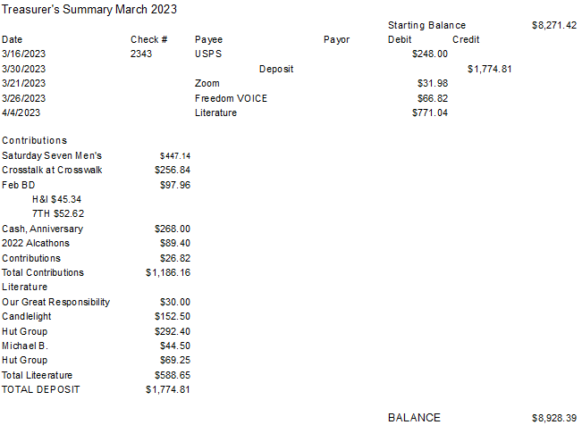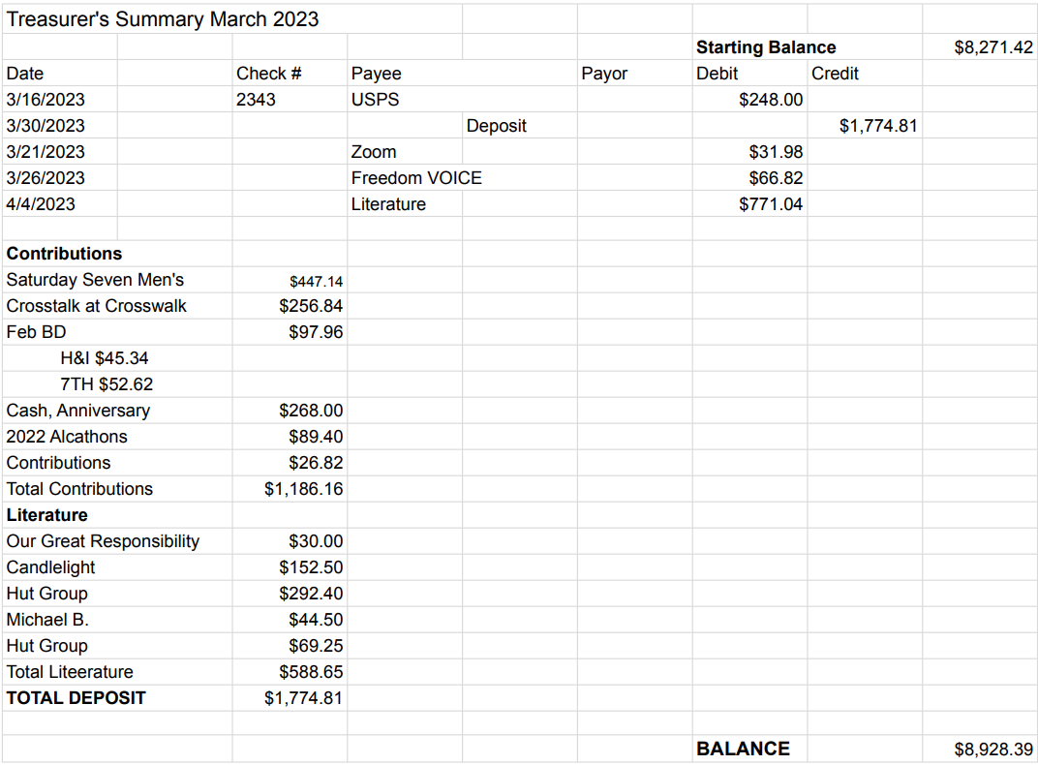

New Business

Motion to begin assembling the Intergroup Financial Oversite Committee

Old Business

- Tracey P. to provide fact sheet produced at first committee meeting.
- Events Committee Chair position was voted in at last meeting. Discussion as to when we might begin to open voting for interested candidates.
- Anniversary Party Report received on March 3, 2023

Open Positions

Available Service Commitments 2023:
- NAPYPAA Liaison
- H&I Rep available
- District Liaison
- Printed schedules Chair
- NVIG Events Committee Chair

Announcements

Next Meeting Saturday, May 13, 2023

Closing

The Responsibility Statement:

“I am Responsible. When anyone, anywhere, reaches out for help, I want the hand of A.A. always to be there. And for that: I am responsible.”

