Napa Valley Intergroup Meeting Agenda
May 13, 2023
Call To Order
A Moment of Silence followed by the Serenity Prayer

New Rep Introduction
New Intergroup Reps and Officers packets can be found on aanapa.org
https://aanapa.org/service/intergroup/welcome-new-intergroup-reps
Please provide your email and contact information to the Secretary.

Meeting Participant Introductions

Sobriety Birthdays

Review and approval of minutes
Minutes are approved unless there are any objections.

Monthly Tradition Reading from 12 Traditions Illustrated & Discussion
Reader: Nell Z. – Tradition 5: Each group has but one primary purpose…to carry its message to the alcoholic who still suffers.

7th Tradition
We have no dues or fees in A.A. We are entirely self-supporting, declining outside contributions. Visit https://www.aanapa.org and use the Venmo link or mail your contribution to NVIG, P.O Box 10948, Napa, CA 94581-2948 . Venmo link for IG contributions: https://www.venmo.com/u/NapaIG-AA

Housekeeping Motions

These are procedural motions and pass if there are no objections. If the motion does not pass it will move to new business.

REPORTS

Chair: Frank F. chair@aanapa.org

Greetings Trusted Servants,
I am humbled to serve as your Chair. This engagement has proven to be such the investment in my personal program of recovery. The extreme admiration we hold for all who serve our beloved fellowship is beyond words.
No matter the commitment you have, your service is seen, felt and appreciated by many. The Officers of Intergroup have rallied to support me personally while I’ve tended to personal matters on the home-front. This sort of extreme support epitomizes the power of the Unity of The Fellowship. The reps and those serving as secretaries are doing a wonderful job as well. Reaching out when low on supplies, directing newcomers to the literature rack so they can begin to get names of people to reach out to. Coffee makers brewing beans not hops…. It goes on and on. This Spirit of Services and reciprocity - It’s amazing to witness… You all - Are Amazing to watch.

Thanks You…..ff

Alternate Chair: Ann E. altchair@aanapa.org

Nothing to report.

Secretary: Patty B. secretary@aanapa.org

Please continue to send updated contact information to secretary@aanapa.org for Intergroup Reps.

Literature Chair: Mary W. literature@aanapa.org

April 2023
Jennifer | 2 BB, 2 BB large print, 2 12x12 (HC), 2 12x12 large print,  1 Daily Reflection large print, 1 Service Manual  Paid cash $72.00, will send balance $16.20 | $88.20
Elisabeth B | 10 Service Manual/Concepts. Balance due $35.50 | $35.50
 | Total | $123.70

The literature order form is available as shown below on our website - aanapa.org
Select “Resources”, Select “Literature”, select “Printable Literature Order form”
It is helpful to have completed order form with contact information when submitting order.
Email to: literature@aanapa.org

Alex W has finished the online order form and it has been beta tested with positive reviews.
He will demonstrate it at the May intergroup meeting. It is ready to be put on our website after group review. We will still offer the option of a literature order form that can be printed out. A new one with updated prices has been prepared and will be put up when group gives go ahead. (Should new prices go into effect immediately or after next order? All books in our current inventory were bought under old pricing)

Over the last two months, there has been some discussion regarding charging for pamphlets. Some members have asked about costs of pamphlets to Intergroup. As best as I can tell, from reviewing old orders, Intergroup spent:
2021 $160.85
2022 $291.60
2023 $168.00 (to date)

Hotline Chair: Erik H. hotline@aanapa.org
Male Line: 18 Call
Female Line: 11 Calls
General Extension: 18 Calls
Most calls were short lasting less than a minute. There were 3 calls lasting longer than 10 minutes including 1 over 15 minutes.

Web Editor: Alex W. webeditor@aanapa.org
Website Committee Chair: Jeff D.

- Literature
  - Online Order Form Tested
  - Ready to deploy
  - New PDF Signup Order Form Created
- Volunteer Sign Up Sheet
  - Testing Started
  - Sign Ups for AA Summer BBQ
- Zoom
  - 30 meetings using Zoom - Auditing them all
  - 20 Audited
    - 16 OK
    - 5 Errors
      - 2 Didn’t Open
        - 6PM Tuesday
        - 7:30 Friday
      - 3 Not using (Fixed)
        - 7:30PM Tuesday
        - 7PM Thursday (No longer using - fixed)
        - 7:30 Wednesday (South Napa) - REMOVED
- Reaching out to other service entities for volunteers to web committee
  - Met w/ H&I - Jeff working
  - PI/CPC - Updated their page
  - Will meet w/NAPYPAA - Connected with new Rep - Starting engagement
- Meeting Schedule
  - Met with programmer. Gave prerequisites for tri-fold schedule.
  - Programmer started work. Will be meeting to review progress.

Meeting Schedule Chair: Jo M. meetings@aanapa.org

Printed schedules have been done for a while. It’ll be time for another. If we can inspire anyone to take on this position to work with the web committee, it should be relatively easy and I’d be glad to assist. With our new website, we have spoken about printing straight from the web info, so the format will be different, a few folded pages, probably not print so many, and maybe print a general Intergroup trifold for all that we do and especially the web address, hotline number, and space for people to write phone numbers for newcomers.

Newsletter Chair: Catherine F. newsletter@aanapa.org

No Submission.

Delegates at Large: Katie Z. / Bill C. delegateatlarge@aanapa.org

Wheel of Sobriety – April 10, 2023
Big Book Step Study Meeting – April 17, 2023 7:30pm

General Service Liaison: Jo M.

District will have its meeting this afternoon, but the pre-conference assembly happened last weekend for all the 23 districts in our Area to give our group conscience results to our delegate. Eric L., our Area Delegate is on his way to the General Service Conference now. They’ll be discussing and deciding on this year’s agenda topics. District needs contact people — preferably General Service Representatives (GSRs) — for info from the General Service Office in New York. Please let me, Jo Moore, (707) 318-8168 know of your group’s GSR or contact person contact info for unity and connection.

Hospitals and Institutions Liaison: John C. john@curnutt.org

No new report.

H&I welcomes anyone to join us at our monthly business meeting 6:45 pm on the first Friday of the month IN-PERSON at the Sea Scout Building 402 Riverside Drive Napa, CA 94559. Learn about the workings of H&I and how to get involved. Next meeting on April 7th in person Sea Scouts 6:45pm.

Did you know that there are facilities that you can attend without filling out clearance paperwork, make a commitment or even share?

You can learn more about H&I by going to http://www.handinorcal.org or by contacting John Curnutt 707-477-0422 john@curnutt.org

Online Contributions
Make credit card contributions online and get an immediate receipt: www.handinorcal.org/contribute

Financial Oversight Committee: financial@aanapa.org

Open service positions available for IG to vote in.

Birthday Meeting Chair: Meghan T. & Heather B. birthdaymeeting@aanapa.org

April 28, 2023
7th Tradition: $164.84 - H&I: $21.21
Total Income: $186.05
Total Expenses: $95.69 - Cake $25, AA Medallions $70.69
Net Income: $90.36

Treasurer: Christina (Tena) treasurer@aanapa.org

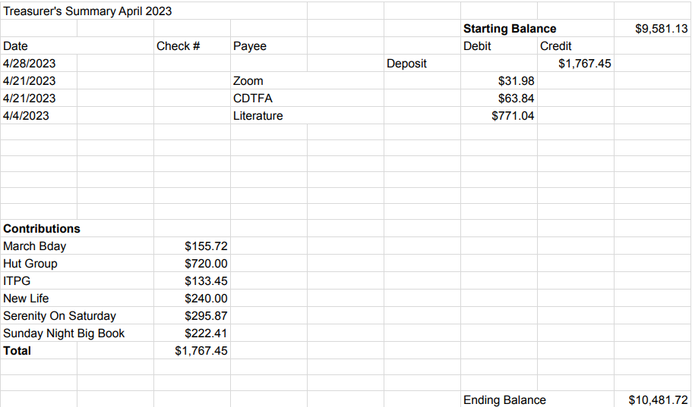

New Business

None Submitted

Old Business

- Budgetary discussion regarding Intergroup assistance for the Summer Picnic
- Intergroup Financial Oversite Committee Assembly

Open Positions

Available Service Commitments 2023:
- H&I Liaison(s) available
- District Liaison
- Printed schedules Chair
- NVIG Events Committee Chair
- Financial Oversight Committee

Announcements

Next Meeting Saturday, June 10, 2023 10:00am (Officers at 9:00am)

Closing

The Responsibility Statement:

“I am Responsible. When anyone, anywhere, reaches out for help, I want the hand of A.A. always to be there. And for that: I am responsible.”

