Napa Valley Intergroup Meeting Agenda
June 10, 2023
Call To Order
A Moment of Silence followed by the Serenity Prayer

New Rep Introduction
New Intergroup Reps and Officers packets can be found on aanapa.org
https://aanapa.org/service/intergroup/welcome-new-intergroup-reps
Please provide your email and contact information to the Secretary.

Meeting Participant Introductions

Sobriety Birthdays

Review and approval of minutes
Minutes are approved unless there are any objections.

Monthly Tradition Reading from 12 Traditions Illustrated & Discussion
Reader: Derek – Tradition 6: An A.A. group ought never endorse, finance or lend the A.A> name to any related facility or outside enterprise, lest problems of money, property and prestige divert us from our primary purpose.

7th Tradition
We have no dues or fees in A.A. We are entirely self-supporting, declining outside contributions. Visit https://www.aanapa.org and use the Venmo link or mail your contribution to NVIG, P.O Box 10948, Napa, CA 94581-2948 . Venmo link for IG contributions: https://www.venmo.com/u/NapaIG-AA

Housekeeping Motions

These are procedural motions and pass if there are no objections. If the motion does not pass it will move to new business.

REPORTS

Chair: Frank F. chair@aanapa.org

Greetings All -
Ongoing thanks to all who serve as Officers and Reps of Napa Valley Intergroup. It’s summer already, and with it comes a certain exuberance and good vibes. I’ve seen it in meetings and it’s real nice. For some, summer may bring about sudden urges or a sudden thirstiness which equates to disaster, as we’ve seen countless times. We can anticipate additional calls to the Hotline, members not showing up at the usual meetings and or not returning calls. Let's all try to remember how it was for us, during the heat of the summer months, when we were new to this or not so new even.

If our Hotline Chair needs additional assistance, may the unity of the fellowship show itself by rising to the occasion. If we notice folks we are accustomed to seeing suddenly not showing up, let's reach out. If we can offer rides in air condition vehicles to get our brothers and sisters to the rooms, so may it happen.

These are just a few ways we might be of good service to others. Your continued support in passing the word on matters as such, is absolutely priceless.
-Frank F.

Alternate Chair: Ann E. altchair@aanapa.org

Nothing to report.

Secretary: Patty B. secretary@aanapa.org

Please continue to send updated contact information to secretary@aanapa.org for Intergroup Reps.

Literature Chair: Mary W. literature@aanapa.org

MAY 2023
John B. | 2 BB, 1 Daily Reflection | $29.25
Mike B. | 5 12x12 hard cover | $44.50
JD K. | 1 AA Comes of Age | $9.50
Alex W. | 4 BB, 3 12x12, 2 Living Sober, 2 Came to believe | $105.00
Alex W. | 1 AA Comes of Age | $12.00
 | Total | $200.25

The online literature order form is up and running. It, as well as the Printable Literature Order form, can be found on our website - aanapa.org. Select “Resources”, Select “Literature”, select “Online Literature Order form” or “Printable Literature Order form.” Both order forms have been updated to reflect the new prices.

Hotline Chair: Erik H. hotline@aanapa.org
Male Line: 46 Calls
Female Line: 13 Calls
General Extension: 36 Calls
Most calls were short lasting less than a minute. There were 3 calls lasting longer than 1 minute including 1 over 14 minutes.

Web Editor: Alex W. webeditor@aanapa.org
Website Committee Chair: Jeff D.

Pending – will be updated by the end of the night.

Meeting Schedule Chair: Jo M. meetings@aanapa.org

A new printing has been done of Summer 2023 schedules! I failed to ask for a specific color, so we got what we got… Please make sure your group has schedules. You can check at Crosswalk, Sea Scouts and with Frank to get more. The website continues to work on a way to print from the on-line meeting schedule, but there is not a direct process to something easy like our old trifold. This service position is open to someone who cares that we have printed schedules and would work with Alex, our web guy, and I’d be a help as well.

Newsletter Chair: Catherine F. newsletter@aanapa.org

No Submission.

Delegates at Large: Katie Z. / Bill C. delegateatlarge@aanapa.org

Brother Bill is currently deployed & Sister Katie has been called upon to fulfill heavier than normal professional obligations, (and deserved vacation), thus unable to attend many and/or report back on meeting visits. This should normalize in coming weeks.
Hut Group – 12:15pm
Friday Night Candlelight – 8:00pm
One Zoom at a Time – 8:00pm

General Service Liaison: Jo M.

Unity Day – June 17th, 11am-3pm, Crosswalk Church
• Please contact Duncan if you can be of service working on the set up and/or clean-up crew.
• Please announce and pass around the Unity Day Potluck Sign-Up sheet. Send completed sign-up sheets to Laura @ baylaurel49@gmail.com.
Beginners Meeting – Every Friday at 5:45pm at the Crosswalk Church. The meeting is hybrid. The meeting continues to need support. Please announce at meetings.
Open District 11 Service Positions (please announce at meetings):
Secretary, Intergroup Liaison, NAPYPAA Liaison, Accessibilities Chair

District continues to investigate venues for hybrid meeting. A subcommittee has been formed.
The following are items that our Area (23 Districts of No Cal Coastal Area) have been discussing and group feedback is invited:
- NEW BUSINESS: The Conference Literature committee consider producing literature combining Twelve Steps and Twelve Traditions with the Twelve Concepts for World Service. – Presented by District 14 at the Area Committee Meeting 10/22/22
- OLD BUSINESS: That the phrase “cómo nosotros los concebimos” (as we conceive it) on Step Three of the Third Edition of the Big Book in Spanish be corrected in future editions to; “como nosotros lo entendimos” (as we understood him), the correct translation from the English version of the Big Book. - Presented by District 20 at the Area Committee Meeting 11/27/21

Hospitals and Institutions Liaison: John C. john@curnutt.org

No new report.

H&I welcomes anyone to join us at our monthly business meeting 6:45 pm on the first Friday of the month IN-PERSON at the Sea Scout Building 402 Riverside Drive Napa, CA 94559. Learn about the workings of H&I and how to get involved.Did you know that there are facilities that you can attend without filling out clearance paperwork, make a commitment or even share? You can learn more about H&I by going to http://www.handinorcal.org or by contacting John Curnutt 707-477-0422 john@curnutt.org

Financial Oversight Committee: financial@aanapa.org

Open service positions available for IG to vote in.

Birthday Meeting Chair: Meghan T. & Heather B. birthdaymeeting@aanapa.org

May 26, 2023
7th Tradition: $95.50 - H&I: $0.00
Total Income: $95.50
Total Expenses: $25.00 - Cake $25.00
Net Income: $70.50

Treasurer: Christina (Tena) treasurer@aanapa.org

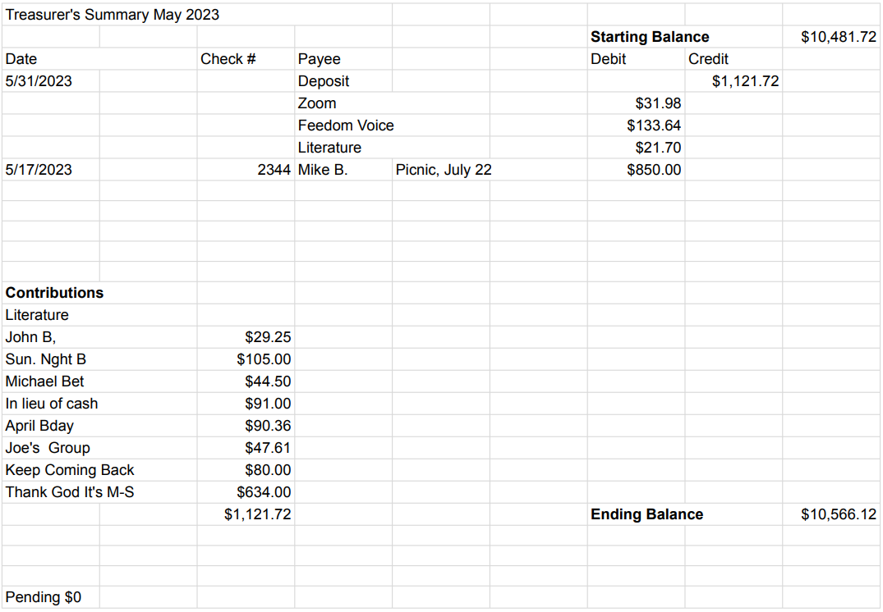

New Business

- Returning to in-person Intergroup meetings

Old Business

- Budgetary discussion regarding Intergroup assistance for the Summer Picnic
- Intergroup Financial Oversite Committee Assembly

Open Positions

Available Service Commitments 2023:
- H&I Liaison(s) available
- District Liaison
- Printed schedules Chair
- NVIG Events Committee Chair
- Financial Oversight Committee

Announcements

Next Meeting Saturday, July 8, 2023 10:00am (Officers at 9:00am)

Closing

The Responsibility Statement:

“I am Responsible. When anyone, anywhere, reaches out for help, I want the hand of A.A. always to be there. And for that: I am responsible.”

