Napa Valley Intergroup Meeting Agenda
July 8, 2023
Call To Order
A Moment of Silence followed by the Serenity Prayer

New Rep Introduction
New Intergroup Reps and Officers packets can be found on aanapa.org
https://aanapa.org/service/intergroup/welcome-new-intergroup-reps
Please provide your email and contact information to the Secretary.

Meeting Participant Introductions

Sobriety Birthdays

Review and approval of minutes
Minutes are approved unless there are any objections.

Monthly Tradition Reading from 12 Traditions Illustrated & Discussion
Reader: Patty – Tradition 7: Every A.A. group ought to be fully self-supporting, declining outside contributions.

7th Tradition
We have no dues or fees in A.A. We are entirely self-supporting, declining outside contributions. Visit https://www.aanapa.org and use the Venmo link or mail your contribution to NVIG, P.O Box 10948, Napa, CA 94581-2948 . Venmo link for IG contributions: https://www.venmo.com/u/NapaIG-AA

Housekeeping Motions

These are procedural motions and pass if there are no objections. If the motion does not pass it will move to new business.

REPORTS

Chair: Frank F. chair@aanapa.org

Summer Greetings to all of our Sober Sisters and Brothers,
I believe we can all agree that the integrity of the information we provide to those seeking meetings within the Napa Valley is paramount to our plight. In order for us to reflect current and accurate meeting information on both our Website and within our Printed Schedules we require your assistance. The NVIG Officers are requesting that each group and or meeting body put forth the contact information of a regularly attending individual who can be responsible for consistent virtual/hybrid dial in numbers.
We’ve had situations wherein the zoom numbers and passwords have either changed or the meeting has gone back to "in person only" and nobody has communicated the change back to IG. In such cases we have struggled to establish rapid contact regarding the changes and the suffering alcoholic has to seek help by some other means. So, we are asking all you wonderful IG Reps to talk to your groups regarding this issue and to take the suggested action so as to help resolve this concerning issue.
On a happier note: We are so looking forward to the Summer Picnic! We are up to about 20-25 baskets for raffle. There will be tons of kids activities, free burgers and dogs and sides….. oh and desserts. Chicken Kevin’s truck will be there for any food purchases! If that weren’t enough, there will also be 3 legged races and corn hole and a Meeting Table to include Topic Cards.
Hope to see you there!
Many Thanks,
Frank

Alternate Chair: Ann E. altchair@aanapa.org

Nothing to report.

Secretary: Patty B. secretary@aanapa.org

Please continue to send updated contact information to secretary@aanapa.org for Intergroup Reps.

Literature Chair: Mary W. literature@aanapa.org

JUNE 2023
Big Books | 2
Big Book – large print | 1
Daily Reflection | 1
Daily Reflection – large print | 1
Living Sober | 1
Twelve by Twelve – large print | 2
Receipts | 64.00
Balance due on order | 25.00

Just a reminder – online Literature form is up and running. Find it at aanapa.org, resources, literature.

Hotline Chair: Erik H. hotline@aanapa.org
Male Line: 22 Calls
Female Line: 10 Calls
General Extension: 23 Calls
Most calls were short lasting less than a minute. There were 6 calls lasting longer than 2 minutes including 1 over 31 minutes.

Web Editor: Alex W. (Intergroup) webeditor@aanapa.org
Website Committee Chair: Jeff D. (District 11)

1) Print Schedule
a. Nothing. Programmer too busy.
b. Looking for a new programmer.
2) Volunteer Sign Up Sheet
a. Testing Started
b. Sign Ups for AA Summer BBQ
3) Zoom
a. Sunday 6pm Women’s meeting didn’t open
4) ADA Compliance
a. Working to ensure our website is ADA Compliant
5) Website security Funding Request

Meeting Schedule Chair: Jo M. meetings@aanapa.org

The schedules are printed and available from Frank, The Crosswalk Church, and Sea Scouts.
Please continue to send meeting changes to reportmeetingchange@aanapa.org or go to the website and “Contact Us” in the drop down menu, then “Who would you like to Contact?” Scroll to “Report Meeting Change”.

The position of Printed schedules chairperson is an open position and I would be happy to help in the pass it on, though the website is working on a new format for the printing directly from the website. If people want and will use printed schedules, this is a relatively easy service position to keep printed schedules happening.

Newsletter Chair: Catherine F. newsletter@aanapa.org

No Submission.

Delegates at Large: Katie Z. / Bill C. delegateatlarge@aanapa.org

Brother Bill is currently deployed.

Sunday Night Big Book Study – 7:30pm
Cottage Group – 7:30pm
CrossTalk at Crosswalk – 7:30pm
Thank God it’s (Sunday) – 5:30pm

General Service Liaison: Jo M.

This position is also open and is a particularly fun service position of simply listening to both groups and sharing info back and forth.

This month’s news from District includes:
-The report of our Financial Oversight Committee meeting and formulating recommendations that they will present, and the District will vote on
-Request for support for our Hybrid Beginners’ meeting every Friday at 5:45 at Crosswalk and Zoom
-Our appreciation for Derek taking on the NAPYPAA Liaison position for District!
-Discussion and further investigation into starting our hybrid format for District, still looking for places
-Open Positions for very important service (2 years of sobriety “requirement”):
1. Recording Secretary
2. Archives Chair
3. Intergroup Liaison
4. Accessibilities Chair

There are also lots of events happening, which can all be found on our website: aanapa.org
Upcoming Events:
Summer Assembly – The “fun” assembly with more fellowship and less business Saturday August 12, 2023
Redwood Acres Fairground3750 Harris St., Eureka, CA 95503
ZOOM: 632 553 607 password 1935
Beginners Meeting – every Friday at 5:45pm at Crosswalk Church. Looking for Meeting Secretaries (6-week commitment)
Please continue to announce at your meetings. Hybrid.
Zoom Meeting ID: 868 9882 8555 Password: 013 485
Napa Summer Picnic – Intergroup organized
July 22nd, 11-3:00 at Kennedy Park in Napa
Go to www.aanapa.org/event/2023-summer- picnic To sign up and volunteer
12 Concepts: Women in Service Workshops
Monthly via Zoom, July – December
Registration info at www.dailywomensmeeting.com
Unity Day in Alameda
In case you missed our delegate speak
July 16, 2023 12:30-4
Beresford Rec Center 2720 Alameda de las Pulgas Alameda, CA Check www.cnca.org for more info
ICYPAA International Conference of Young People in AA
September 1-4, Marriott Marquis, 780 MissionSt, SF, CA Please go to www.icypaa.org for more info and to register
Other events and registration contacts:
26th National AA Archives Workshop, September 7-10, Sudbury, Ontario, CANADA www.naaaw.org or archivist@area84aa.org
Bridging the Gap Workshop Weekend
Houston,TX, 9/8-10/2023, contact: LauraS (612)3098385 or coordinator@btgww.com
8th Annual Hispanic Women’s Workshop - Hybrid
Saturday 12/9/23, Westminster Presbyterian Church, 1757 N. Lake Ave. Pasadena, CA 91104 Zoom: 891 3842 5577 passcode: area05
National AA Technology Workshop – Hybrid
September 8-10, Shenandoah University, Winchester, VA. https://naatw.org

Hospitals and Institutions Liaison: John C. john@curnutt.org

No new report. – Are we still refraining from passing the pink can?

H&I welcomes anyone to join us at our monthly business meeting 6:45 pm on the first Friday of the month IN-PERSON at the Sea Scout Building 402 Riverside Drive Napa, CA 94559. Learn about the workings of H&I and how to get involved. Did you know that there are facilities that you can attend without filling out clearance paperwork, make a commitment or even share? You can learn more about H&I by going to http://www.handinorcal.org or by contacting John Curnutt 707-477-0422 john@curnutt.org

Financial Oversight Committee: financial@aanapa.org

No Submission.

Birthday Meeting Co-Chairs: Meghan T. & Heather B. birthdaymeeting@aanapa.org

June 30, 2023
7th Tradition: $156.09 - H&I: $0.00
Total Income: $156.09
Total Expenses: $25.00 - Cake $25.00
Net Income: $131.09

Treasurer: Christina (Tena) treasurer@aanapa.org

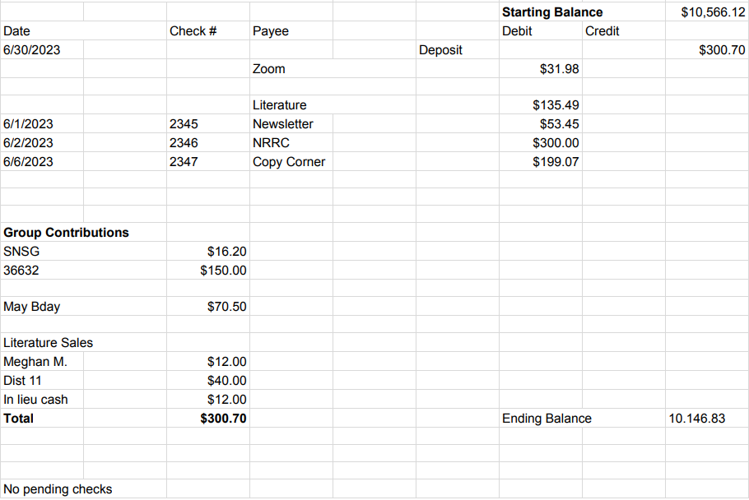

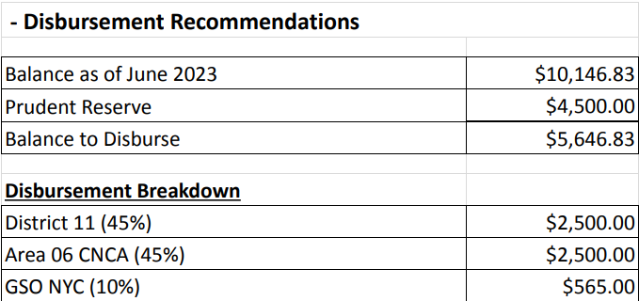

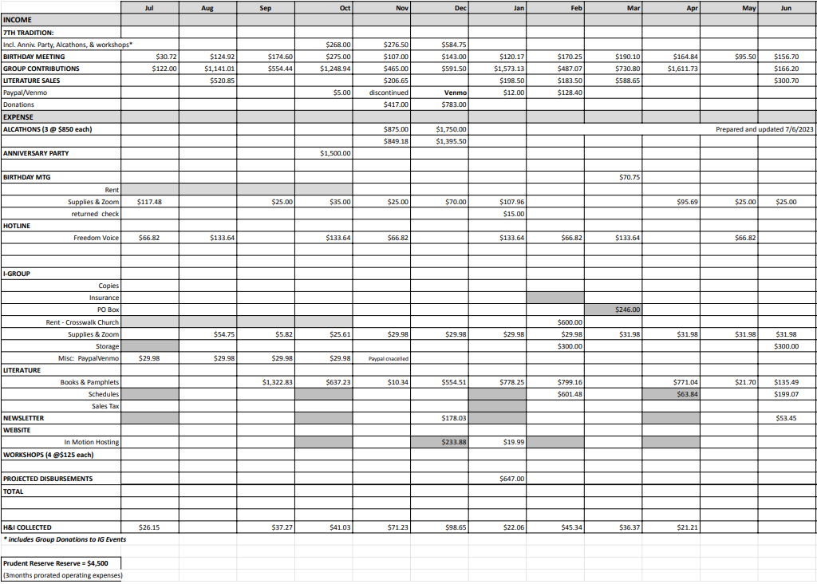

New Business

- September Meditation Workshop – Alex W & Edward T. (Sample Agenda below)
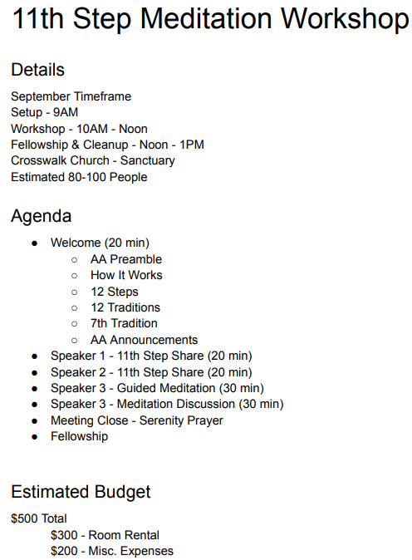

Old Business

- Proposition of an AA event at the Methodist Church
  - After a brief introduction of this item last month, it was determined that it will be discussed for formal proposal at the July NVIG meeting.
Open Positions

Available Service Commitments 2023:
- H&I Liaison(s) available
- District Liaison
- Printed schedules Chair
- NVIG Events Committee Chair

Announcements

Next Meeting Saturday, August 12, 2023 10:00am (Officers at 9:00am)

Closing

The Responsibility Statement:

“I am Responsible. When anyone, anywhere, reaches out for help, I want the hand of A.A. always to be there. And for that: I am responsible.”

