**Napa Valley Intergroup Meeting Agenda**

**August 12, 2023**

**Call To Order**

A Moment of Silence followed by the ***Serenity Prayer***

**New Rep Introduction**

New Intergroup Reps and Officers packets can be found on aanapa.org

<https://aanapa.org/service/intergroup/welcome-new-intergroup-reps>

Please provide your email and contact information to the Secretary.

**Meeting Participant Introductions**

**Sobriety Birthdays**

**Review and approval of minutes**

Minutes are approved unless there are any objections.

**Monthly Tradition Reading from 12 Traditions Illustrated & Discussion**

Reader: Jay B. – ***Tradition 8:*** ***Alcoholics Anonymous should remain forever nonprofessional, but our service centers may employ special workers.***

**7th Tradition**

We have no dues or fees in A.A. We are entirely self-supporting, declining outside contributions. Visit <https://www.aanapa.org> and use the Venmo link or mail your contribution to NVIG, P.O Box 10948, Napa, CA 94581-2948 . Venmo link for IG contributions: <https://www.venmo.com/u/NapaIG-AA>

**Housekeeping Motions**

These are procedural motions and pass if there are no objections. If the motion does not pass it will move to new business.

**REPORTS**

**Chair:**  Frank F. [chair@aanapa.org](mailto:chair@aanapa.org)

Greetings to All,

It’s never too early to begin the subtle and steady planning for our upcoming Alcathons. This year we have a newly introduced Special Events Coordinator to serve as our point person to best assist in just that. Our sober sister Joy has graciously volunteered for this valued service commitment. You’ll soon begin to hear her speak at meetings as to our need to find groups willing to sponsor these events. The aim is to fill these open slots as early as we can so as to provide smooth sailing into the Alcathon Season.

On another note: Dear IG Reps and Secretaries, please get word of any deviation to your meeting location, time, format and zoom accessibility to [meetings@aanapa.org](mailto:meetings@aanapa.org) so we can keep the printed and web-based schedules accurate to the very best of our ability.

Warmest Thanks

Frank F.

Chair NVIG

707-478-2886

**Alternate Chair:**  Ann E. [altchair@aanapa.org](mailto:altchair@aanapa.org)

Nothing to report.

**Secretary:**  Patty B. [secretary@aanapa.org](mailto:secretary@aanapa.org)

Please continue to send updated contact information to [secretary@aanapa.org](mailto:secretary@aanapa.org) for Intergroup Reps.

**Literature Chair:**  Mary W. [literature@aanapa.org](mailto:literature@aanapa.org)

|  |  |  |
| --- | --- | --- |
| July 2023 | Literature Report |  |
| Dave M  Men’s Stag | 2 BB, | 24.00 |
| Mike B | 5 BB, 10 Living Sober | 120.00 |
| Elisabeth B,  Sun nite BB study | 3Big Books, large print | 36.00 |
| Holly M. Thursday  Topic Discussion | 1 As Bill Sees It Soft cover, 2 Daily Reflections | 36.00 |
| Donation |  | 1.00 |

TOTAL $217.00

The online literature order form is up and running. It, as well as the Printable Literature Order form, can be found on our website - aanapa.org. Select “Resources”, Select “Literature”, select “Online Literature Order form” or “Printable Literature Order form”. Both order forms have been updated to reflect the new prices.

**Hotline Chair:** Erik H. [hotline@aanapa.org](mailto:hotline@aanapa.org)

I conducted some tests on the hotline and verified the issue that was being reported by some volunteers. Calls were ringing one time and then dropping. The caller would then be directed to voicemail instead of being connected with a volunteer. Some calls were getting answered making it difficult to diagnose. I spent some time talking to support with Freedom VOICE, our provider, and the issue appears to be resolved. I will continue to test periodically and monitor performance in the coming months.

There were 30 calls seeking to speak to a man,  5 calls seeking to speak to a woman and  23 calls to the general extension. Most calls were short lasting less than a minute, likely not connected. There were 5 call lasting longer than 5 minutes including 1 over 45 minutes.

Male Line: 30 Calls

Female Line: 5 Calls

General Extension: 23 Calls

Most calls were short lasting less than a minute, likely not connected.

There were 5 calls lasting longer than 5 minutes including 1 over 45 minutes.

Erik H. will be unable to attend.

**Web Editor:** Alex W. (Intergroup) [webeditor@aanapa.org](mailto:webeditor@aanapa.org) Website Committee Chair: Jeff D. (District 11)

No Report Submitted.

**Meeting Schedule Chair**: Jo M. [meetings@aanapa.org](mailto:meetings@aanapa.org)

Printed schedules had another printing of a relatively small batch for Summer. This position is open—that of Printed Schedule Chari or Coordinator. Alex and the web maestros continue to work on a schedule download from the web to print form, so this position of printed chair would be even easier, soon. Please contact Frank or check Crosswalk and Sea Scouts for printed schedules.

**Newsletter Chair:** Catherine F. [newsletter@aanapa.org](mailto:newsletter@aanapa.org)

No Submission.

**Delegates at Large:**  Katie Z. / Bill C.         [delegateatlarge@aanapa.org](mailto:delegateatlarge@aanapa.org)  

Thursday Night – 8:00

Brother Bill is currently deployed.

Katie will be unable to attend.

**General Service Liaison:** Jo M.

District Liaison position is still open. I missed the meeting this month and the report back is not yet on aanapa.org, but it will be soon. Look under “Service” in the sidebar menu and District 11, District Reports, then DBM Report Backs (District Meeting Meeting—DBM).  
There are service positions open! 2 years of sobriety and you need not be a General Service Representative (GSR).

**Upcoming Events:**

**Summer Assembly –** The “fun” assembly with more fellowship and less business Saturday August 12, 2023  
Redwood Acres Fairground3750 Harris St., Eureka, CA 95503  
ZOOM: 632 553 607 password 1935

**Beginners Meeting** – every Friday at 5:45pm at Crosswalk Church. Looking for Meeting Secretaries (6-week commitment)  
Please continue to announce at your meetings. Hybrid.  
Zoom Meeting ID: 868 9882 8555 Password: 013 485

**12 Concepts: Women in Service Workshops**

Monthly via Zoom, July – December  
Registration info at [www.dailywomensmeeting.com](http://www.dailywomensmeeting.com)

**ICYPAA International Conference of Young People in AA**

September 1-4, Marriott Marquis, 780 MissionSt, SF, CA Please go to [www.icypaa.org](http://www.icypaa.org) for more info and to register

**Other events and registration contacts:  
26th National AA Archives Workshop,** September 7-10, Sudbury, Ontario, CANADA [www.naaaw.org](http://www.naaaw.org) or [archivist@area84aa.org](mailto:archivist@area84aa.org)

**Bridging the Gap Workshop Weekend**

Houston,TX, 9/8-10/2023, contact: LauraS (612)3098385 or [coordinator@btgww.com](mailto:coordinator@btgww.com)

**8th Annual Hispanic Women’s Workshop - Hybrid**

Saturday 12/9/23, Westminster Presbyterian Church, 1757 N. Lake Ave. Pasadena, CA 91104 Zoom: 891 3842 5577 passcode: area05

**National AA Technology Workshop – Hybrid**

September 8-10, Shenandoah University, Winchester, VA. <https://naatw.org>

**Hospitals and Institutions Liaison:**  VACANT

H&I welcomes anyone to join us at our monthly business meeting 6:45 pm on the first Friday of the month at the Sea Scout Building 402 Riverside Drive Napa, CA 94559. Learn about the workings of H&I and how to get involved. Did you know that there are facilities that you can attend without filling out clearance paperwork, make a commitment or even share?  Currently Area 51 brings 26 meetings a week and literature to the Women’s Jail, Men’s Jail, Men’s Jail Spanish, California Medical Facility, Crestwood Behavior Center Vallejo, Crestwood Behavior Center Angwin, National Vallejo, Napa South Shelter, Napa State Hospital Spanish, Napa State Hospital English, Queen of the Valley Hospital, SHAMIA house and Vallejo Detox.  You can learn more about H&I by going to <http://www.handinorcal.org> or by contacting John Curnutt 707-477-0422  [john@curnutt.org](mailto:john@curnutt.org)

**The Big News**

The New Napa Jail Applications have been turned it to start the lengthy onboarding volunteer clearance process.  Thank you to all those who have volunteered to go back into the County Jail once it opens.

**Financials July 2023**

This month was a reversal of last month's performance, with the highest contributions so far this year and the lowest literature orders. Our monthly cash flow was positive $19,005, reducing our cumulative losses for the year to <$61,197.98>.  The Finance Committee will meet after the August numbers are out, at which time we'll prepare our 2024 budget and make a recommendation on the metric we'll use to determine our recommended cash reserves of six month's expenses. Our financial condition remains 'neutral', since our negative cash flow now exceeds our budgeted amount by almost $30,000.

Napa - July $345 - YTD $5960

NorCal - July $51684 - YTD $265,722

NorCal

Cash in Prudent Reserve = $ 154,961.86

Cash in Operating Acct = $ 149,789.47

Total Cash on Hand = $ 304,751.33

**Open Positions**

This month focus on Crestwood Behavior Center Angwin

Crestwood Center is a Mental Health Rehabilitation Center located in Angwin, amidst the beautiful hills of the Napa Valley.  The facility provides a versatile array of classes for clients to participate in during their recovery program and encourages active participation in treatment planning from the moment of admission.

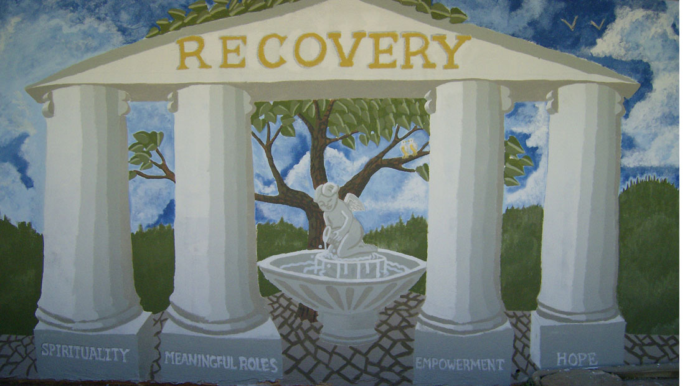

The facility also exemplifies Crestwood’s commitment to providing mental health clients with the kind of care that puts them on the road to recovery. All clients at this center, regardless of their treatment focus or their specific program details, are eligible to participate in the Wellness Recovery Action Plan (WRAP) program, a self-help recovery system designed to decrease symptoms, increase personal responsibility and improve their quality of life.

Crestwood Center at Napa Valley takes a trauma-informed approach to care. Understanding the trauma a person has experienced and the impact it has on their lives and behavior, and understanding the vulnerabilities or triggers are essential to helping a client reach their recovery potential. The understanding of a client’s experiences strengthens and helps to build a rapport with them. It also builds a trust and understanding which enables us to intervene successfully and help us to develop approaches that do not exacerbate or re-traumatize them. This trauma informed approach facilitates the clients healing and recovery process as well as empowers them.

*“To the world we may be one person, but to one person we may be the world.” -Unknown*

*From Coordinator Jim*

Thus far. the H&I participants are myself, Catherine F. and Kelly G.  (Kathy and I go in weekly, Kelly joins us on the first Sunday of each month.)

We continue to read the stories in the Big Book. The patients seem to enjoy this the most and are beginning to contribute significant shares after the reading. Attendance varies between 6 and 12-15 patients.

Please announce at the business meeting that we would welcome anyone willing to join this effort is more than welcome. Once a month would be ideal.  I’d be pleased to meet and conduct the meeting with them even on a trial basis.

Feel free to contact [john@curnutt.org](mailto:john@curnutt.org) for more information to volunteer.

**For Discussion and Further Thought:  Should our group pass the pink can?**

Due to the pandemic and closed facilities NorCal H&I has built up a large prudent reserve around $300K. Note that H&I distributed $342K in literature for 2022 and is expecting to increase distribution with rising costs and more institutional meetings going live.  The past has taught us that it is hard to re-start passing the pink can once it has stopped.  It is up to your group to pass the pink can or not. H&I has no opinion on this.

**Online Contributions**

Make credit card contributions online and get an immediate receipt: [www.handinorcal.org/contribute](http://www.handinorcal.org/contribute) Please make sure to write on contribution checks AREA 51.  This allows H&I to track donations by the Napa area.

H&I business meeting is back to in person meetings at the Sea Scouts.

Next meeting on September 1st in person Sea Scouts 6:45pm.

**Financial Oversight Committee:**       [financial@aanapa.org](mailto:financial@aanapa.org)

No Submission.

**Birthday Meeting Co-Chairs:** Meghan T. & Heather B.   [birthdaymeeting@aanapa.org](mailto:birthdaymeeting@aanapa.org)

No submission.

July 28,, 2023

7th Tradition: $ - H&I: $0.00

Total Income: $

Total Expenses: $25.00 - Cake $25.00

Net Income: $

**Treasurer:** Christina (Tena) [treasurer@aanapa.org](mailto:treasurer@aanapa.org)

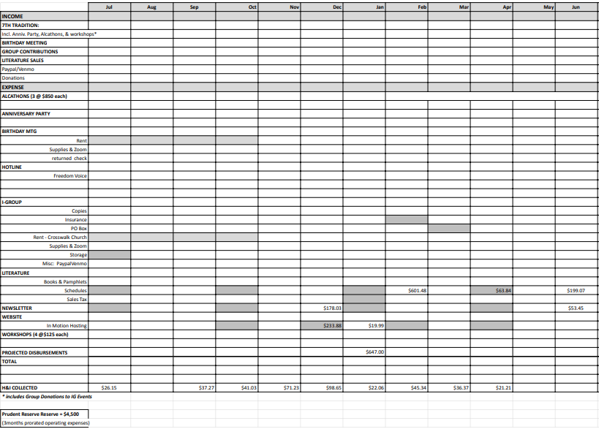

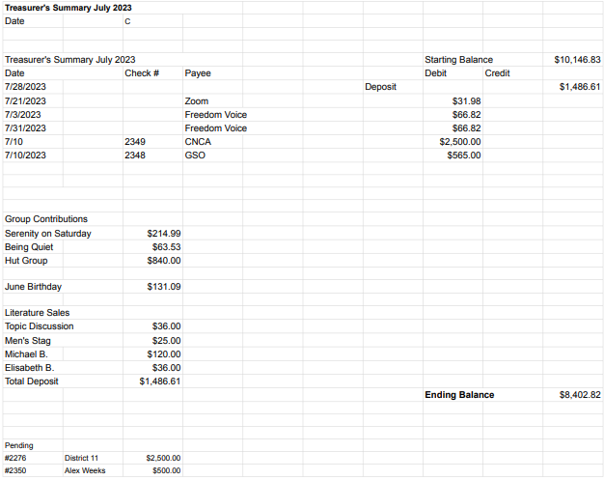

**New Business**

No submission

**Old Business**

Mike B. to debrief results for the AA BBQ

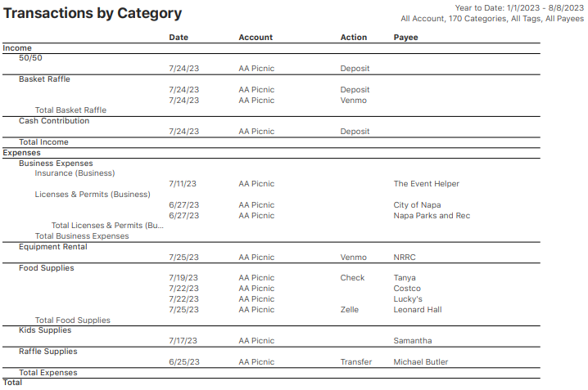

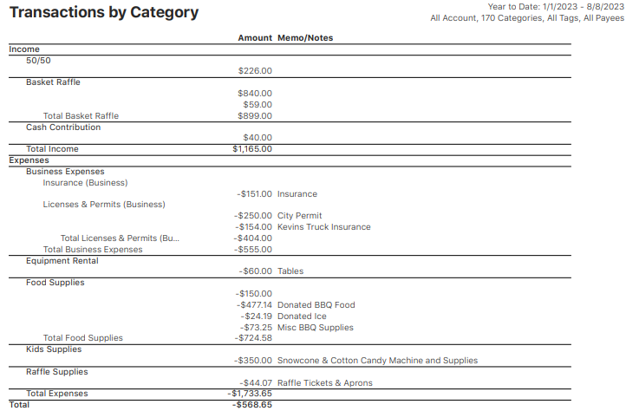

**Open Positions**

Available Service Commitments 2023:

* H&I Liaison(s) available
* District Liaison
* Printed Schedules Chair

**Announcements**

**Next Meeting** **Saturday, September 9, 2023 10:00am (Officers at 9:00am)**

**Closing**

The Responsibility Statement:

***“I am Responsible. When anyone, anywhere, reaches out for help, I want the hand of A.A. always to be there. And for that: I am responsible.”***