Napa Valley Intergroup Meeting Agenda

December 9, 2023
Call To Order

A Moment of Silence followed by the Serenity Prayer

New Rep Introduction
New Intergroup Reps and Officers packets can be found on aanapa.org
https://aanapa.org/service/intergroup/welcome-new-intergroup-reps
Please provide your email and contact information to the Secretary.

Meeting Participant Introductions

Sobriety Birthdays

Review and approval of minutes
Minutes are approved unless there are any objections.

Monthly Tradition Reading from 12 Traditions Illustrated & Discussion
Reader: Michael B. – Tradition 12: Anonymity is the spiritual foundation of all our Traditions, ever reminding us to place principles before personalities.

7th Tradition
We have no dues or fees in A.A. We are entirely self-supporting, declining outside contributions. Visit https://www.aanapa.org and use the Venmo link or mail your contribution to NVIG, P.O Box 10948, Napa, CA 94581-2948 . Venmo link for IG contributions: https://www.venmo.com/u/NapaIG-AA

Housekeeping Motions

These are procedural motions and pass if there are no objections. If the motion does not pass it will move to new business.

REPORTS

Chair: Frank F. chair@aanapa.org

Warm Holiday Greetings,

A note of sincere gratitude to all of the trusted servants who’ve served Napa Valley Intergroup alongside me over the last two years. The Intergroup Reps and Officers who’ve engaged in service over the span of my tenure as Chair, have displayed passion and reverence at every turn. Giving of themselves, to others, and doing so as freely as the great gift of sobriety was given to them, has truly been something to marvel at. I hope to see you all at our upcoming Alcathons, wherein, we'll have the amazing opportunity to celebrate the holidays via the great gift of fellowship. I would also like to further encourage continued service engagement from everyone comprising our beloved Napa AA Fellowship.

Thank you for allowing me the opportunity to serve you!

Happy Holiday Wishes to All

Frank F.
ffradella@me.com
Mobile: (707) 478-2886

Alternate Chair: Ann E. altchair@aanapa.org

Nothing to report.

Secretary: Patty B. secretary@aanapa.org

The Secretary Position is open to complete 1 year of a two-year term.

Literature Chair: Mary W. literature@aanapa.org

Pending

Hotline Chair: Erik H. hotline@aanapa.org

Male Line: 21 Calls
Female Line: 4 Calls
General Extension: 24 Calls
Most calls were short lasting less than 2 minutes.
There were 3 calls lasting longer than 5 minutes including 1 which was nearly 10 minutes long.

Stability of the hotline has improved with fewer missed calls and voicemails.

Web Editor: Alex W. (Intergroup) webeditor@aanapa.org Website Committee Chair: Jeff D. (District 11)

- ADA Compliance
  - Working to ensure our website is ADA Compliant – Ongoing
- Assisted Treasurer with new Income/Expense XLS
- Started organizing old media for upload to AA Google Drive

Meeting Schedule Chair: Mandy B. meetings@aanapa.org

Pending

Newsletter Chair: VACANT newsletter@aanapa.org

No Submission.

Delegates at Large: Katie Z. / Bill C. (John B. – Interim) delegateatlarge@aanapa.org

One Zoom at a Time (Wednesday) – 8:00 PM
Cottage Group (Sunday) – 7:30 PM
Sharing Meeting (Saturday) – 7:30 PM
Thank God it’s (Wednesday) – 5:30 PM

General Service Liaison: Jo M.

-The Fall inventory was done last month and a committee will be reviewing it;
-District is moving forward to decide on a venue for the in person portion of its hybrid meeting;
-The budget continues to be worked on;
-We got a recording secretary! Thank You, Derek!
-A proposal was approved for our district to hold an Agenda Topics Workshop this winter, hopefully in Napa and Up Valley;
-Elections will be held and positions are open to serve our district. Please join us;

Upcoming Dates to remember:
a. Inter-District Workshop – January 13th, 2024, Benicia Senior Center, Benicia, CA
b. Agenda Topic Workshop - Feb 17th, 2024, Bethlehem Lutheran Church, Sta Rosa
c. PRAASA – March 1-3, 2024, Mariott, San Francisco; http://praasa.org
d. Unity Day – June 15th, 2024, Crosswalk Church

Hospitals and Institutions Liaison: VACANT

H&I welcomes anyone to join us at our monthly business meeting 6:45 pm on the first Friday of the month at the Sea Scout Building 402 Riverside Drive Napa, CA 94559. Learn about the workings of H&I and how to get involved. Did you know that there are facilities that you can attend without filling out clearance paperwork, make a commitment or even share? Currently Area 51 brings 26 meetings a week and literature to the Women’s Jail, Men’s Jail, Men’s Jail Spanish, California Medical Facility, Crestwood Behavior Center Vallejo, Crestwood Behavior Center Angwin, National Vallejo, Napa South Shelter, Napa State Hospital Spanish, Napa State Hospital English, Queen of the Valley Hospital, and Vallejo Detox. You can learn more about H&I by going to http://www.handinorcal.org or by contacting John Curnutt 707-477-0422 john@curnutt.org

Financials As of 11/5: Napa Area 51 Contributed: OCTOBER $634. YTD: $7,091

Archway Recovery Services has been awarded the contract to take over the Napa County Drug and Alcohol recovery programs. https://www.recoveryatarchway.com/ Estimated start date in Napa is Mid-January. H&I is reaching out to see if Archway would like a weekly meeting brought into the facility.

ABOUT ARCHWAY RECOVERY SERVICES: Substance Use Disorder Treatment & Rehabilitation Programs Since 1995. Founded in 1995 and incorporated in 2002, we have helped many on the journey to recovery. We have expanded our recovery services with detox, residential, outpatient, and sober living facilities in both Solano and Napa Counties.

Napa Jail is still closed to H&I Volunteers.

Open Position: Crestwood Behavior Center Angwin

Make credit card contributions online and get an immediate receipt: www.handinorcal.org/contribute Please make sure to write on contribution checks AREA 51. This allows H&I to track donations by the Napa area.

H&I business meeting is back to in person meetings at the Sea Scouts. Next meeting on January 5th at 6:45pm.

Financial Oversight Committee: financial@aanapa.org

The Intergroup Financial Oversight Committee (IFOC) met once during November.

The outcome of this meeting as a result of an ad-hoc request received for guidance on funding workshops was a recommendation as follows:

The financial oversite committee recommends that IG establish a workshop approval process whereby the Overview and detailed budget be presented to the Chair of IG for consideration. These requests that have appropriate merit will be put to the IG group conscience. On a case-by-case basis IG will approve or request additional clarifications, which will be considered with a view to overall IG budget.

Should IG require additional guidance from the IFOC – please provide to the IFOC the context and a detailed request for the type of guidance requested.
Birthday Meeting Co-Chairs: Meghan T. & Heather B. birthdaymeeting@aanapa.org

November 24, 2023
7th Tradition: $82.10
H&I: $23.00
Total Income: $105.10
Total Expenses: $118.69 - Cake $25.00, Refreshment supplies $46.00, AA Medallions $15.00, AA Medallions $32.69
Net Income: $ -13.59

Treasurer: Christina (Tena) treasurer@aanapa.org

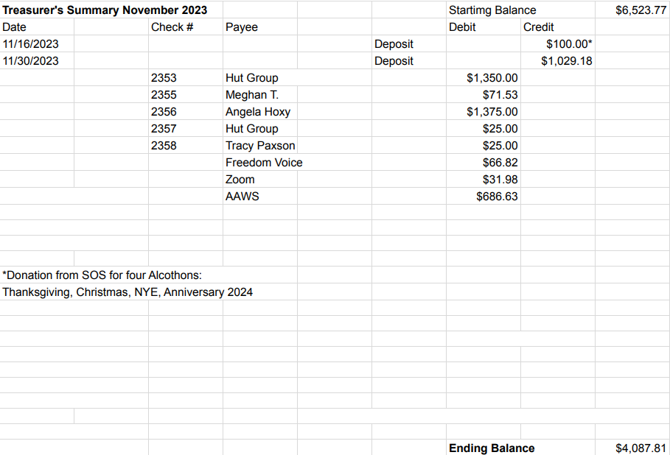

New Business

None.

Old Business

1.) “Sponsorship Workshop” Proposal
2.) Alcathon updates

Open Positions – Voting for open positions

2024-2025  2-yr commitment  2-yr Sobriety | 2024  1-yr commitment  2-yr sobriety | Filled positions through end of 2024
Chair | Secretary | Treasurer
Alternate Chair | District Liaison | Web Editor
Birthday Co-Chair | Newsletter | Literature Chair
Birthday Co-Chair | H&I Liaison
Hotline Chair | Male Delegate at Large
Meeting Schedule Chair
Female Delegate at Large
General Service Liaison

Announcements

Next Meeting Saturday, January 13, 2024 10:00am (Officers at 9:00am)

Closing
The Responsibility Statement:

“I am Responsible. When anyone, anywhere, reaches out for help, I want the hand of A.A. always to be there. And for that: I am responsible.”

