Napa Valley Intergroup Meeting Minutes
March 11, 2023

TAKE BACKS:

- AA BBQ is coming back! More info to come—join us at the next NVIG meeting to see how you can participate and serve
- Please verify that all meeting information is correct on the website for any meetings you attend or represent at all times and send revisions to reportmeetingchanges@aanapa.org
- SHOW UP FOR YOUR GROUP’S MEETINGS ON THE AGENDA TOPICS! Individual ideas are welcomed by our delegate, too. See the Area Website: CNCA06.org
- Hotline needs volunteers. Contact Erik H. if interested or email hotline@aanapa.org
- Report website issues to webeditor@aanapa.org
- Literature Order form changes on aanapa.org for easier ordering
- Available NVIG Service Commitments 2023: NAPYPAA Liaison, H&I Rep, District Liaison, Printed Schedules Chair, NVIG Events Committee Chair
- Beginners Meeting – Every Friday at 5:45pm at the Crosswalk Church. The meeting is hybrid and continues to need support.

Call To Order – 10:00 a.m.

A Moment of Silence followed by the Serenity Prayer

New Rep Introduction

Welcome! New Intergroup Reps and Officers packets can be found on www.aanapa.org; Please provide contact information to the Secretary.

Meeting Participant Introductions – 15 in attendance

Sobriety Birthdays

Nell Z – 11 years!

Review and approval of minutes

Minutes approved as submitted.

Monthly Tradition Reading from 12 Traditions Illustrated & Discussion

Reader: Nell – Tradition 3

The only requirement for AA membership is a desire to stop drinking.

Discussion:
- Nell Z read Tradition 3
- Nell Z & Michael B contributed to the discussion regarding the foresight the founders had on including heavy drinkers and not excluding alcoholics that were not “quite ready”
- Alex W will read Tradition 4 at April 2023 NVIG meeting.

7th Tradition

We have no dues or fees in A.A. We are entirely self-supporting, declining outside contributions. Visit https://www.aanapa.org and use the Venmo link or mail your contribution to NVIG, P.O Box 10948, Napa, CA 94581-2948

Venmo link for IG contributions: https://www.venmo.com/u/NapaIG-AA

Housekeeping Motions

No housekeeping motions

REPORTS

Chair: Frank F. chair@aanapa.org

Greetings,
All of us who serve as officers of Napa Valley Intergroup, once again find ourselves extremely grateful to all who serve as Intergroup Representatives. You are the messengers of all that’s going on within our realm. Without your sincere efforts, IG would find itself challenged to engage our growing fellowship as robustly as we currently do. Please keep spreading the news and bringing to the attention of others what it is we all do together.
Many Thanks,
Frank

Alternate Chair: Ann E. altchair@aanapa.org

Nothing to report.

Secretary: Patty B. secretary@aanapa.org

Thank you for your patience during transition and sincere apologies for the February minutes delivery issue last month. Please continue to send updated contact information to secretary@aanapa.org for Intergroup Reps.

Literature Chair: Mary W. literature@aanapa.org

Mary W. announced at the Officer’s meeting that there will be a 30% increase for pamphlets and would like to discuss passing the costs to the groups during new business. Also, draft online order forms are being developed with the Alex W – Web Editor.

FEBRUARY 2023
Michael B. | 5 – Big Books // Check #2008 | $47.50
Gordon R. | 4 – BB, 2 12x12 // Check #1749 | $55.00
Alex W. | 2 – BB, 2 12x12, 2 Daily Reflections (paid w/Cash) | $56.00
 | Total | $158.50

The literature order form is available as shown below on our website – aanapa.org: Select “Resources”, Select “Literature”, select “Printable Literature Order form”

The URL is: https://aanapa.org/wp-content/uploads/Literature-form-.pd
Please use it to check prices and submit with any order

Discussion:
- Clarification was requested regarding:
  - Costs for printing
  - Funds for pamphlets
  - Amount NVIG spends on pamphlets

Hotline Chair: Erik H. hotline@aanapa.org

- Male Line: 6 Calls
- Female Line: 6 Calls
- General Extension: 12 Calls
- Most calls were short lasting less than a minute. There were 2 calls lasting longer than 5 minutes, one of which had a 15-minute duration.

Web Editor: Alex W. webeditor@aanapa.org
Ad Hoc Website Committee Chair: Jeff D.

- AA Napa Valley Web Committee Report March 2023 Business Meeting
- Literature: Draft Online Order Form Ready for testing
- Volunteer Sign Up Sheet is ready for testing
- Zoom
  - 30 meetings using Zoom - Auditing them all
  - 20 Audited
    - 16 OK
    - 4 Errors
      - 4 Didn’t Open
        - 6PM Tuesday
        - 7:30 Tuesday
        - 7:30 Wednesday (South Napa)
        - 7:30 Friday
      - 1 Not using (Fixed)
        - 7PM Thursday (No longer using - fixed)
- Update Calendar Business Meetings - Done: 9
- Reaching out to other service entities for volunteers to web committee
a. Met w/ H&I - Jeff working
b. PI/CPC - Alex Working with them
c. Will meet w/NAPYPAA - Alex

Discussion:
- Updated Order Form
  - Will include new prices, once determined
- Volunteer sign up
- Mailbox log-in credentials for NVIG officers (mailbox capacity)
- Trifold clarification – Alex is working with other software development fellows that are joining the web committee to explore options compatible with our website

Meeting Schedule Chair: Jo M. meetings@aanapa.org

Printed schedules were printed and paid for. They are in circulation and can be found at Crosswalk Church and Sea Scouts and Frank has more. We need someone to take on the position of printed schedule chair to help coordinate with the website on a new format from the web to print and continue distributing.

Newsletter Chair: Catherine F. newsletter@aanapa.org

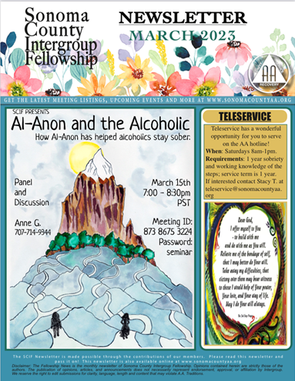

Delegates at Large: Katie Z. and John B. delegateatlarge@aanapa.org

- February/March Meetings Attended:
  - Sunday Hut Group – 26 Feb
  - Monday DAAT – 27 Feb - Cynthia C is the IG rep
  - Wednesday KCB – 1 Mar
  - Friday beginners mtg – 3 Mar
  - Monday Rule 62 – Friday
  - Thank God its Sunday
  - New Life Women’s Group – Thursday

General Service Liaison: Jo M.

District Liaison position is still open.
This month’s report is about the group consciences that will be held by the General Service Representatives (GSRs) from the groups on Agenda Topics for this year’s General Service Conference in NY.
This is the way that every member of AA has input, through groups, districts, areas and delegates to the General Service Conference where decisions are made for AA as a whole. These topics are in every realm that we operate collectively, from literature, to our presence in social media, to corrections/Hospitals & Institutions, to policies and procedures, and more. This is how we protect AA, change AA, and keep our World Service headquarters informed about our collective group conscience.
SHOW UP FOR YOUR GROUP’S MEETINGS ON THE TOPICS! Individual ideas are welcomed by our delegate, too. See the Area Website: CNCA06.org
Open positions at District:
- Recording Secretary
- Intergroup Liaison
- NAPYPAA Liaison
- Archives Chair
- NEW POSITION—Accessibilities Chair
All are welcome to attend our District meetings held today at 1:00, but normally the first Saturday of each month at 10am. Zoom 860 5600 2397 pw 060455

Hospitals and Institutions Liaison: John C. john@curnutt.org

H&I welcomes anyone to join us at our monthly business meeting 6:45 pm on the first Friday of the month IN-PERSON at the Sea Scout Building 402 Riverside Drive Napa, CA 94559. Learn about the workings of H&I and how to get involved. Next meeting on April 7th in person Sea Scouts 6:45pm.

Did you know that there are facilities that you can attend without filling out clearance paperwork, make a commitment or even share?

Currently Area 51 brings 26 meetings a week and literature to the Women’s Jail, Men’s Jail, Men’s Jail Spanish, California Medical Facility, Crestwood Behavior Center Vallejo, Crestwood Behavior Center Angwin, National Vallejo, CenterPoint, Napa South Shelter, Napa State Hospital Spanish, Napa State Hospital English, Queen of the Valley Hospital, SHAMIA house and Vallejo Detox.

You can learn more about H&I by going to http://www.handinorcal.org or by contacting John Curnutt 707-477-0422 john@curnutt.org
Summary
Our return into the facilities continues to be herky-jerky we are hoping to gather some more even momentum in 2023. Currently Jails and State Hospital are still offline.

Finance
Attached is the February 2023 H&I Financial Statement. While we had positive cash flow of $3845 for the month, GrapeVine/LaVina failed to send us our bi-monthly invoices of approximately $13,000, which would have made the actual cash flow for the month around -$9000 and the YTD cash flow around -$20,000. This will normalize next month when the invoices are received and paid. Our financial condition remains "sound", as we continue to draw down on our cash reserves.

The below analysis indicates our contributions were slightly higher than last year and our expenses were over twice as high as last year, due to extremely low literature orders during the first two months of 2022. All in all, we're headed in the right direction.

Feb, 2023 | contributions | Lit expense | Total expense
YTD comparison to LY | +7.7% | +102.7% | +86.8%
YTD comparison to Budget | -3.0% | -14.4% | -17.6%
Overall financial condition: | SOUND

Feb, 2023 Last Month Contributions Year to date Contributions
Area 51, Napa $722.25 $2,200.15
Open Positions
- Area Chair: We are still seeking a candidate for Chair of Area 51. Please reach out to your contacts. Do they have five years of sobriety? Can they organize information? Can they work with others? Have they done H&I or had contact with institutions dealing with alcohol? If being a coordinator of coordinator is in your skill set The Chair of Area 51 H&I might be the perfect service commitment.
- Intergroup Liaison
- Men’s Jail Coordinator

Online Contributions
Make credit card contributions online and get an immediate receipt: www.handinorcal.org/contribute Please make sure to write on contribution checks AREA 51. This allows H&I to track donations by the Napa area.
Financial Oversight Committee: Erik S. financial@aanapa.org

We will take up the forming of a newly established committee in “New Business” at the April 2023

Birthday Meeting Co-Chairs birthdaymeeting@aanapa.org
Meghan T. & Heather B.

February 24, 2023
7th Tradition: $170.25
H&I: $45.34
Total Income: $215.59
Total Expenses: $117.63 ($34.00 Cake – $16.99 Coffee Supplies – $66.64 AA Chips)
Net Income: $97.96

Treasurer: Christina (Tena) treasurer@aanapa.org

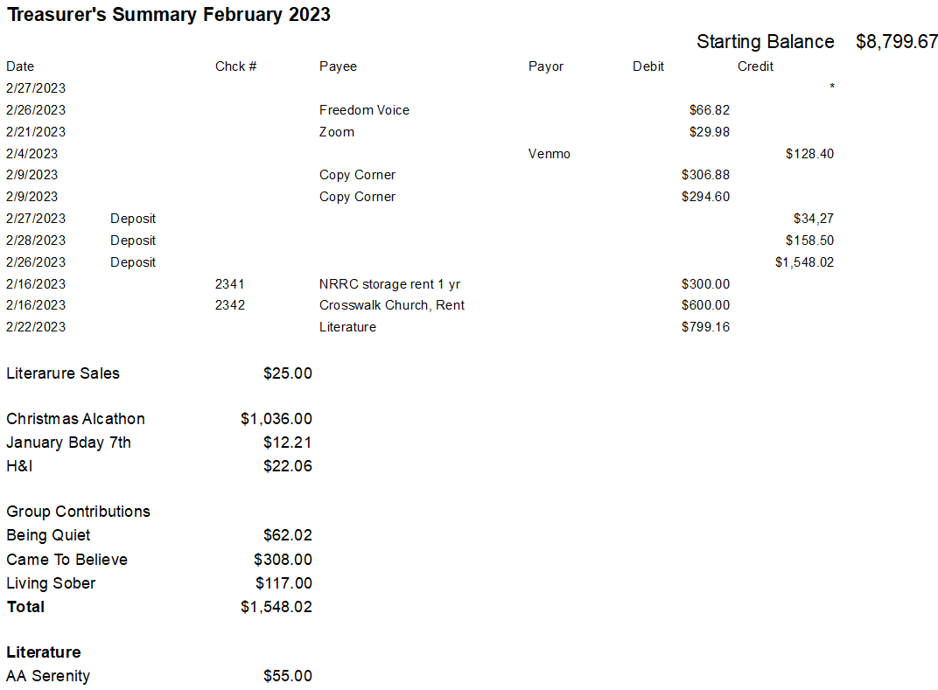
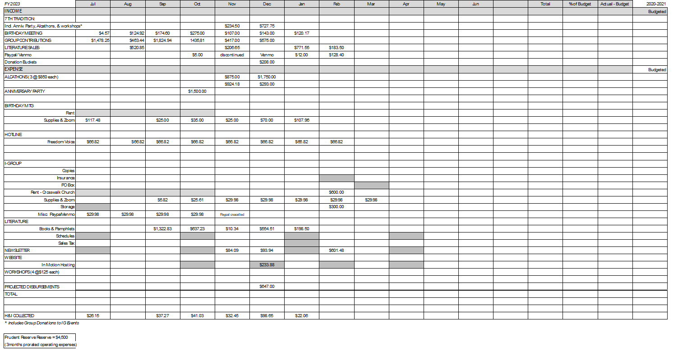

Discussion:

- Clarification was requested regarding:
  - Prudent Reserve Uses
  - Violations of the 7th tradition at alcathons

New Business:

- Intergroup Officer discussion on charging groups for AA Pamphlets beginning April 1, 2023 due to 30% cost increase in production
- Will include the Financial Oversight Committee at the April meeting

Old Business:

- Napa Valley AA Summer Picnic. This was voted in at last meeting. Tracey P. to provide committee request for additional budget assistance.
- Events Committee Chair position was voted in at last meeting. Discussion as to when we might begin to open voting for interested candidates.
- Anniversary Party Report received on March 3, 2023

Open Positions:

Available Service Commitments 2023:
- NAPYPAA Liaison
- H&I Rep available
- District Liaison
- Printed schedules Chair
- NVIG Events Committee Chair

Announcements: Confirmation pending: Shelley L. is the new female rep for H&I.

Next Meeting: Saturday, April 8,2023

Closing: - 11:21 a.m.

The Responsibility Statement

“I am Responsible. When anyone, anywhere, reaches out for help, I want the hand of A.A. always to be there. And for that: I am responsible.”

