Napa Valley Intergroup Meeting Minutes
April 8, 2023

TAKE BACKS:

- AA BBQ is happening July 2023! FOOD, FELLOWSHIP and GAMES for kids and kids at heart! More info when the Flyer is published this month!
- Now looking to form our Financial Oversight Committee! If you have a passion for number crunching, are interest in learning, or just want to be involved in making budgetary suggestions, please join us at the May Intergroup meeting where our Financial Oversight Committee will be selected. (2-year commitment, 2-year sobriety requirement)
- Please verify that all meeting information is correct on the website for any meetings you attend or represent at all times and send revisions to reportmeetingchanges@aanapa.org
- Hotline needs volunteers. Contact Erik H. if interested or email hotline@aanapa.org
- Report website issues to webeditor@aanapa.org
- Literature Order form changes on aanapa.org for easier ordering
- Available NVIG Service Commitments 2023: H&I Rep, District Liaison, Printed Schedules Chair, NVIG Events Committee Chair, Financial Oversight Committee
- Beginners Meeting – Every Friday at 5:45pm at the Crosswalk Church. The meeting is hybrid and continues to need support.

Call To Order – 10:00 a.m.

A Moment of Silence followed by the Serenity Prayer

New Rep Introduction – None present
(New Intergroup Reps and Officers packets can be found on www.aanapa.org; Please provide contact information to the Secretary.)

Meeting Participant Introductions – 19 in attendance

Sobriety Birthdays – Alex W.: 1 year on April 16 & Meghan T.: 4 years on April 24!

Review and approval of minutes – Minutes approved as submitted.

Monthly Tradition Reading from 12 Traditions Illustrated & Discussion

Reader: Siohban – Tradition 4

Each group should be autonomous except in matters affecting other groups or A.A. as a whole.

- Siohban read Tradition 4
- Jay, Ann E, John B, Frank and Nell shared their experiences regarding the disparity of this tradition in different regions of the world.
- Nell Z will read Tradition 5 at May 2023 NVIG meeting.

7th Tradition

We have no dues or fees in A.A. We are entirely self-supporting, declining outside contributions. Visit https://www.aanapa.org and use the Venmo link or mail your contribution to NVIG, P.O Box 10948, Napa, CA 94581-2948

Venmo link for IG contributions: https://www.venmo.com/u/NapaIG-AA

Housekeeping Motions

No housekeeping motions

REPORTS

Chair: Frank F. chair@aanapa.org

Greetings Sisters and Brothers,
I attended several meetings between our last business meeting and this one. The rooms are bustling with eager new-comers and those who have been around for extended periods of time. It occurred to me that we have not sponsored any workshops since the outset of the pandemic.
Two workshops which seem to be extremely beneficial for all of us are Mindful Meditation and Sponsorship. I am bringing forth the suggestion to the IG Officers and if in favor, will bring to the reps for further consideration.
Thank to everyone for the wonderful Spirit of Service exhibited throughout our fellowship.

Alternate Chair: Ann E. altchair@aanapa.org

Ann expressed gratitude for NVIG’s grace at her first run as Chair in March.

Secretary: Patty B. secretary@aanapa.org

Patty encouraged everyone to refer new NVIG reps to her so she can assist with onboarding.

Please continue to send updated contact information to secretary@aanapa.org for Intergroup Reps.

Literature Chair: Mary W. literature@aanapa.org

Large literature order of books and pamphlets placed on March 28 - Total Cost: $992.37

March 2023
Mike B | 5-12x12 - Check #2016 | $44.50
Haley P | 1 As Bill Sees it (will submit payment next week) | $9.00
John M | 3-BB, 2 Living Sober, 3 Daily Reflections - Check #760 | $69.25
Tannya V | 5-BB, 1 portable BB, 1 large print BB, 2-12x12 soft, 1- 12x12 large, 1-As Bill Sees It Soft,1= As Bill Sees It Large, 1- Daily Reflections, 2-Came to Believe, 1-Came to Believe large, 2-Living Sober, 1-Living Sober large print | $152.50
Kevin P | 10-BB, 1-BBlarge, 4-12x12 hard, 4-12x12 large, 5-As Bill Sees It, 1-ABSI soft, 3-Daily Reflections, 3 Daily Reflections large print | $292.40
Tom H | Balance owed from previous purchase | $30.00
 | Total | $597.65

General Service price increase went into effect on April 3, 2023. Books will increase about 20% and pamphlets 30%.

We will be discussing the possibility of charging groups for the pamphlets. With the price increase, they will now be between 10 cents and 55 cents each, with the majority costing between 20 and 35 each.

The literature order form is available as shown below on our website – aanapa.org:

We are working to update it to reflect new costs.

Select “Resources”, Select “Literature”, select “Printable Literature Order form”
Interestingly, if you use app (smart phone or tablet) this link takes you to General Service (aa.org). (Alex W, Web Editor will look into this.)
If you want to order through intergroup and avoid shipping costs, use a computer to download and print the order form or contact me directly at literature@aanapa.org. It is helpful to have completed order form with contact information when submitting order.

Hotline Chair: Erik H. hotline@aanapa.org

Male Line: 11 Call
Female Line:5 Calls
General Extension: 20 Calls
Most calls were short lasting less than a minute. There were 4 calls lasting longer than 1 minute including 1 over 7 minutes.

There were some Spanish speaker calls outsourced to Spanish speaking fellows. Link was broken to contact hotline chair, please contact Erik directly at eharveyconsulting@gmail.com or via mobile at 707-363-5763 while Alex is restoring the link.

Web Editor: Alex W. webeditor@aanapa.org
Website Committee Chair: Jeff D.

- Literature
  - Draft Online Order Form Testing
  - Identified software bug, awaiting fix
  - Need to update pricing per the increase
- Volunteer Sign Up Sheet
  - Testing Started
  - Signups for AA Summer BBQ
- Zoom
  - 30 meetings using Zoom - Auditing them all
  - 20 Audited
    - 16 OK
    - 4 Errors
      - 4 Didn’t Open
        - 6PM Tuesday
        - 7:30 Tuesday
        - 7:30 Wednesday (South Napa) - REMOVED
        - 7:30 Friday
      - 1 Not using (Fixed)
        - 7PM Thursday (No longer using - fixed)
- Reaching out to other service entities for volunteers to web committee
  - Met w/ H&I - Jeff working
  - PI/CPC - Updated their page
  - Will meet w/NAPYPAA - Connected with new Rep - Starting engagement
- Meeting Schedule
  - Met with programmer. Gave prerequisites for tri-fold schedule.

Please continue to send updates or glitches on the website to Alex.

Meeting Schedule Chair: Jo M. meetings@aanapa.org

Printed schedules have been done for a while. It’ll be time for another. If we can inspire anyone to take on this position to work with the web committee, it should be relatively easy and I’d be glad to assist. With our new website, we have spoken about printing straight from the web info, so the format will be different, a few folded pages, probably not print so many, and maybe print a general Intergroup trifold for all that we do and especially the web address, hotline number, and space for people to write phone numbers for newcomers.

Newsletter Chair: Catherine F. newsletter@aanapa.org

An updated version of the newsletter is coming out in May.

Delegates at Large: Katie Z. and Bill C. delegateatlarge@aanapa.org

Both our delegates were called upon to fulfill heavier than normal professional obligations, thus unable to attend and or report back on NEW meeting visits. This should normalize in coming weeks.

General Service Liaison: Jo M.

District will have its meeting this afternoon, but the pre-conference assembly happened last weekend for all the 23 districts in our Area to give our group conscience results to our delegate. Eric L., our Area Delegate is on his way to the General Service Conference now. They’ll be discussing and deciding on this year’s agenda topics. District needs contact people — preferably General Service Representatives (GSRs) — for info from the General Service Office in New York. Please let me, Jo Moore, (707) 318-8168 know of your group’s GSR or contact person contact info for unity and connection.

Hospitals and Institutions Liaison: John C. john@curnutt.org
H&I welcomes anyone to join us at our monthly business meeting 6:45 pm on the first Friday of the month at the Sea Scout Building 402 Riverside Drive Napa, CA 94559. Learn about the workings of H&I and how to get involved. Did you know that there are facilities that you can attend without filling out clearance paperwork, make a commitment or even share? Currently Area 51 brings 26 meetings a week and literature to the Women’s Jail, Men’s Jail, Men’s Jail Spanish, California Medical Facility, Crestwood Behavior Center Vallejo, Crestwood Behavior Center Angwin, National Vallejo, Napa South Shelter, Napa State Hospital Spanish, Napa State Hospital English, Queen of the Valley Hospital, SHAMIA house and Vallejo Detox. You can learn more about H&I by going to http://www.handinorcal.org or by contacting John Curnutt 707-477-0422 john@curnutt.org
Summary
- Return back into the facilities continues to be herky-jerky we are hoping to gather some more even momentum in 2023.
- Terry M is now acting Chair of Area 51
- CenterPoint is now closed
- Napa Jail opening as early as May
- CONFIRMED: Napa State Hospital will open to volunteers May 3rd
- In the works: Our first introduction meeting with Juvenile Hall administrators.
- H&I business meeting is back to in person meetings at the Sea Scouts.
- Next meeting on May 5th in person Sea Scouts 6:45pm.
- Open Positions
- Napa State Hospital Volunteers are needed now! Six months of Sobriety a California ID / Drivers license and background check are all that are needed to be of service.
- Intergroup Liaison
- Men’s Jail Coordinator
- Online Contributions: Make credit card contributions online and get an immediate receipt: www.handinorcal.org/contribute Please make sure to write on contribution checks AREA 51. This allows H&I to track donations by the Napa area.

Financial Oversight Committee: financial@aanapa.org

The Financial Oversight Committee, comprised of an odd number of members, will work closely with the treasurer to offers suggestions for Intergroup Officers to vote on. There is a 2-year sobriety requirement for this 2-year commitment. Voting to fill these positions will occur at the May 2023 NVIG meeting.

Birthday Meeting Co-Chairs birthdaymeeting@aanapa.org
Meghan T. & Heather B.

March 31, 2023
7th Tradition: $190.10 - H&I: $36.37
Total Income: $226.47
Total Expenses: $70.75 - Cake $25, Coffee $35.77, Creamer $9.98
Net Income: $70.75

Heather inquired on NVIG’s interest to pay for Birthday meeting speaker’s dinner, similar to surrounding fellowships. This item will be brought up at the next officers meeting. She also clarified the cake pricing incident at the l birthday meeting. Shout out to Elena for coffee, Travis for sound and Dana for literature at the growing birthday meetings.

Treasurer: Christina (Tena) treasurer@aanapa.org

Disbursements are scheduled for January and June unless the Financial Oversight Committee suggests otherwise. We are currently operating in a sufficient state. The spreadsheet is nearly perfect and helps set the budget. Clarification was provided regarding contribution versus donations.

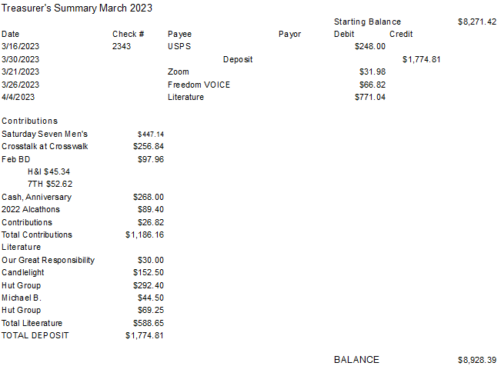
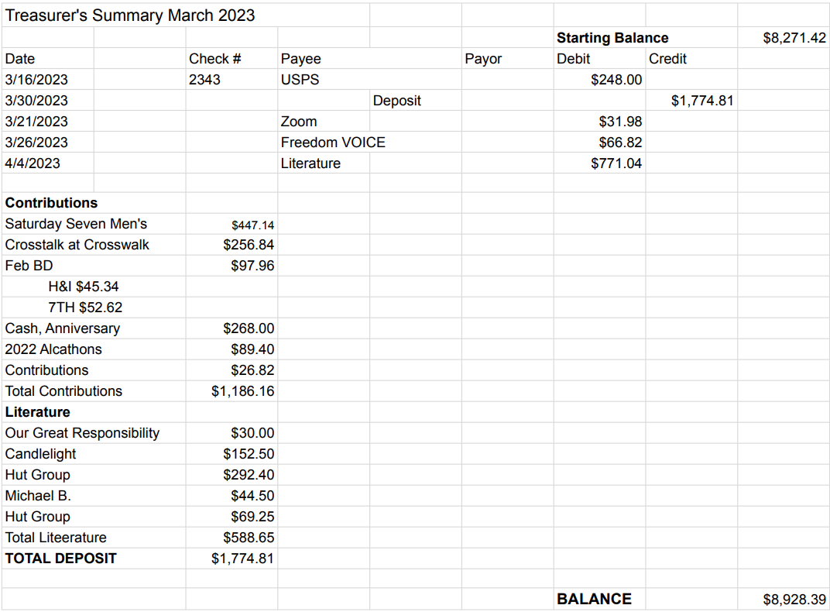

New Business:

MOTION to assemble IG Financial Oversight Committee passed – Voting will occur at the May NVIG meeting

Old Business:

- Tracey P. provided a detailed oral presentation regarding results of the first committee meeting for the Napa Valley Summer Picnic. A flyer will be published the week of 4/17 with details on the following:
  - Date: July 22, 2023 (Saturday)
  - Location: Kennedy Park is planned, pending reservations this coming week
  - What: Food, raffle, games for kids AND adults, etc. (more info to come)
  - Desire for this to become an annual event

Open Positions:

Available Service Commitments 2023:
- H&I Rep available
- District Liaison
- Printed schedules Chair
- NVIG Events Committee Chair
- Financial Oversight Committee
Announcements: None

Next Meeting: Saturday, May 13, 2023 10:00am (Officers at 9:00am)

Closing:

The Responsibility Statement

“I am Responsible. When anyone, anywhere, reaches out for help, I want the hand of A.A. always to be there. And for that: I am responsible.”

