Napa Valley Intergroup Meeting Minutes
May 13, 2023

TAKE BACKS:

- AA BBQ is happening July 2023! FOOD, FELLOWSHIP and GAMES for kids and kids at heart!
- H&I is asking general meetings to refrain from passing around the pink can till further notice because of the current balance
- Now looking to form our Financial Oversight Committee! If you have a passion for number crunching, are interest in learning, or just want to be involved in making budgetary suggestions, please join us at the June Intergroup meeting where our Financial Oversight Committee will be selected. (2-year commitment, 2-year sobriety requirement)
- Please verify that all meeting information is correct on the website for any meetings you attend or represent at all times and send revisions to reportmeetingchanges@aanapa.org
- Hotline needs volunteers. Contact Erik H. if interested or email hotline@aanapa.org
- Report website issues to webeditor@aanapa.org
- Literature Order form changes on aanapa.org for easier ordering
- Available NVIG Service Commitments 2023: H&I Rep, District Liaison, Printed Schedules Chair, NVIG Events Committee Chair, Financial Oversight Committee
- Beginners Meeting – Every Friday at 5:45pm at the Crosswalk Church. The meeting is hybrid and continues to need support.

Call To Order – 10:00 a.m.

A Moment of Silence followed by the Serenity Prayer

New Rep Introduction – Derek - Never Too Young
(New Intergroup Reps and Officers packets can be found on www.aanapa.org; Please provide contact information to the Secretary.)

Meeting Participant Introductions – 15 in attendance

Sobriety Birthdays – None.

Review and approval of minutes – Minutes approved as submitted.

Monthly Tradition Reading from 12 Traditions Illustrated & Discussion

Reader: Nell Z. – Tradition 5

Each group has but one primary purpose…to carry its message to the alcoholic who still suffers.

- Nell Z. read Tradition 5
- Derek will read Tradition 6 at June 2023 NVIG meeting.

7th Tradition

We have no dues or fees in A.A. We are entirely self-supporting, declining outside contributions. Visit https://www.aanapa.org and use the Venmo link or mail your contribution to NVIG, P.O Box 10948, Napa, CA 94581-2948

Venmo link for IG contributions: https://www.venmo.com/u/NapaIG-AA

Housekeeping Motions

No housekeeping motions

REPORTS

Chair: Frank F. chair@aanapa.org

Greetings Sisters and Brothers,
I attended several meetings between our last business meeting and this one. The rooms are bustling with eager new-comers and those who have been around for extended periods of time. It occurred to me that we have not sponsored any workshops since the outset of the pandemic.
Two workshops which seem to be extremely beneficial for all of us are Mindful Meditation and Sponsorship. I am bringing forth the suggestion to the IG Officers and if in favor, will bring to the reps for further consideration.
Thank to everyone for the wonderful Spirit of Service exhibited throughout our fellowship.

Alternate Chair: Ann E. altchair@aanapa.org

Ann facilitated the May meeting.

Secretary: Patty B. secretary@aanapa.org
Please continue to send updated contact information to secretary@aanapa.org for Intergroup Reps. New Rep packets are on the website. Contact for more information.

Literature Chair: Mary W. literature@aanapa.org

April 2023
Jennifer | 2 BB, 2 BB large print, 2 12x12 (HC), 2 12x12 large print,  1 Daily Reflection large print, 1 Service Manual  Paid cash $72.00, will send balance $16.20 | $88.20
Elisabeth B | 10 Service Manual/Concepts. Balance due $35.50 | $35.50
 | Total | $123.70

The literature order form is available as shown below on our website - aanapa.org
Select “Resources”, Select “Literature”, select “Printable Literature Order form”
It is helpful to have completed order form with contact information when submitting order.
Email to: literature@aanapa.org

Alex W has finished the online order form and it has been beta tested with positive reviews.
He will demonstrate it at the May intergroup meeting. It is ready to be put on our website after group review. We will still offer the option of a literature order form that can be printed out. A new one with updated prices has been prepared and will be put up when group gives go ahead. (Should new prices go into effect immediately or after next order? All books in our current inventory were bought under old pricing)

Over the last two months, there has been some discussion regarding charging for pamphlets. Some members have asked about costs of pamphlets to Intergroup. As best as I can tell, from reviewing old orders, Intergroup spent:
2021 $160.85
2022 $291.60
2023 $168.00 (to date)

Hotline Chair: Erik H. hotline@aanapa.org

Male Line: 18 Call
Female Line: 11 Calls
General Extension: 18 Calls
Most calls were short lasting less than a minute. There were 3 calls lasting longer than 10 minutes including 1 over 15 minutes.

Web Editor: Alex W. webeditor@aanapa.org
Website Committee Chair: Jeff D.

- Literature
  - Online Order Form Tested
  - Ready to deploy
  - New PDF Signup Order Form Created
- Volunteer Sign Up Sheet
  - Testing Started
  - Sign Ups for AA Summer BBQ
- Zoom
  - 30 meetings using Zoom - Auditing them all
  - 20 Audited
    - 16 OK
    - 5 Errors
      - 2 Didn’t Open
        - 6PM Tuesday
        - 7:30 Friday
      - 3 Not using (Fixed)
        - 7:30PM Tuesday
        - 7PM Thursday (No longer using - fixed)
        - 7:30 Wednesday (South Napa) - REMOVED
- Reaching out to other service entities for volunteers to web committee
  - Met w/ H&I - Jeff working
  - PI/CPC - Updated their page
  - Will meet w/NAPYPAA - Connected with new Rep - Starting engagement
- Meeting Schedule
  - Met with programmer. Gave prerequisites for tri-fold schedule.
  - Programmer started work. Will be meeting to review progress.

Meeting Schedule Chair: Jo M. meetings@aanapa.org

Printed schedules have been done for a while. It’ll be time for another. If we can inspire anyone to take on this position to work with the web committee, it should be relatively easy and I’d be glad to assist. With our new website, we have spoken about printing straight from the web info, so the format will be different, a few folded pages, probably not print so many, and maybe print a general Intergroup trifold for all that we do and especially the web address, hotline number, and space for people to write phone numbers for newcomers.

Newsletter Chair: Catherine F. newsletter@aanapa.org

No Submission.

Delegates at Large: Katie Z. and Bill C. delegateatlarge@aanapa.org

Wheel of Sobriety – April 10, 2023
Big Book Step Study Meeting – April 17, 2023 7:30pm
TGIW – 5:30pm
Saturday sharing meeting – 7:30pm
One zoom at a time – Wednesday 8:00pm
Rule 62 Monday & Friday 10:00pm

General Service Liaison: Jo M.
District is still looking for venues to meet in hybrid format
Next meeting is on Zoom, June 3rd, check aanapa.org to join the meeting

Upcoming Events:
-Post conference Dinner & Assembly – May 12th & 13th -San Francisco
-District 11 Unity Day - June 17thCrosswalk Church
-Summer Assembly - August12th TBA

District Positions Currently Available—come to the meetings, you need not be a GSR:
Recording secretary
Intergroup Liaison,
NAPYPAA liaison
Archives Chair
Accessibilities Chair

Hospitals and Institutions Liaison: John C. john@curnutt.org
No new report.

H&I welcomes anyone to join us at our monthly business meeting 6:45 pm on the first Friday of the month IN-PERSON at the Sea Scout Building 402 Riverside Drive Napa, CA 94559. Learn about the workings of H&I and how to get involved. Next meeting on June 2nd in-person Sea Scouts 6:45pm.

Did you know that there are facilities that you can attend without filling out clearance paperwork, make a commitment or even share?

You can learn more about H&I by going to http://www.handinorcal.org or by contacting John Curnutt 707-477-0422 john@curnutt.org

Online Contributions
Make credit card contributions online and get an immediate receipt: www.handinorcal.org/contribute

Financial Oversight Committee: financial@aanapa.org

The Financial Oversight Committee, comprised of an odd number of members, will work Open service positions available for IG to vote in June.

Birthday Meeting Co-Chairs birthdaymeeting@aanapa.org
Meghan T. & Heather B.

April 28, 2023
7th Tradition: $164.84 - H&I: $21.21
Total Income: $186.05
Total Expenses: $95.69 - Cake $25, AA Medallions $70.69
Net Income: $90.36

Treasurer: Christina (Tena) treasurer@aanapa.org

Disbursements are scheduled for January and June but there was a suggestion to disburse quarterly. (Four times a month) This item will be “New Business” in June.

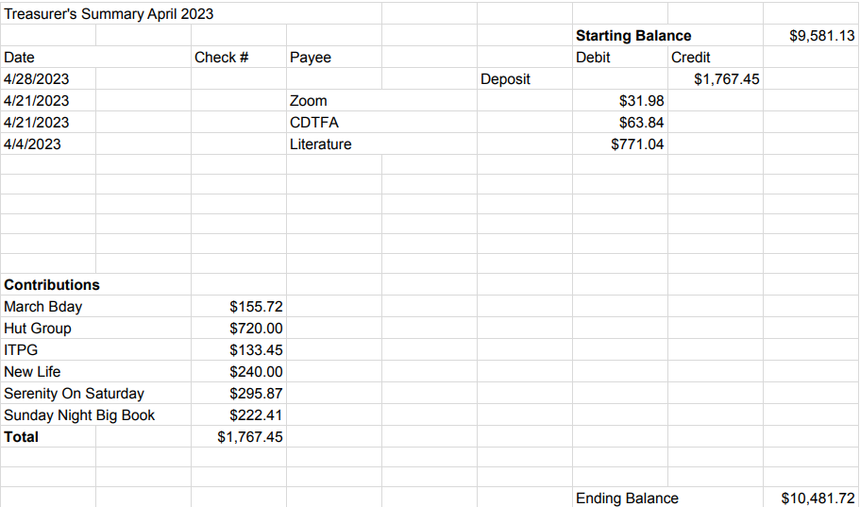

New Business:

No new business submitted.

Old Business:

- Budgetary discussion regarding Intergroup assistance for the Summer Picnic
- Intergroup Financial Oversite Committee Assembly

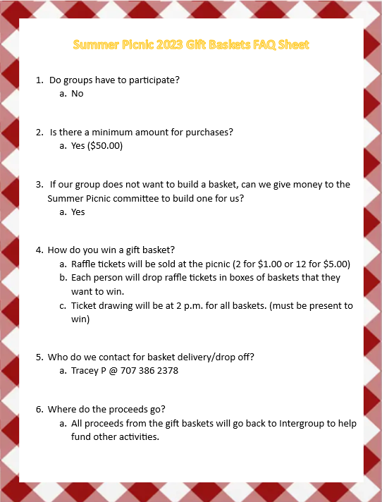

Open Positions:

Available Service Commitments 2023:
- H&I Rep available
- District Liaison
- Printed schedules Chair
- NVIG Events Committee Chair
- Financial Oversight Committee

Announcements: None

Next Meeting: Saturday, June 10, 2023 10:00am (Officers at 9:00am)

Closing: 11:00am

The Responsibility Statement

“I am Responsible. When anyone, anywhere, reaches out for help, I want the hand of A.A. always to be there. And for that: I am responsible.”

