Napa Valley Intergroup Meeting Minutes

October 14 2023
TAKE BACKS:

- The Napa AA 79th Anniversary Party is happening October 28, 2023. Don’t miss out on the fun! Use the QR Code to be of service!
- In December, Intergroup Officer terms will be voted on for 2024-2025 (It’s a 2-year commitment/2-year sobriety) Join the November 11, 2023 NVIG meeting for more information. Positions available are: Chair, Alt Chair, Birthday Co-Chairs, Hotline Chair, Meeting Schedule Chair, Newsletter Chair, Female delegate at large, General Service Liaison and H&I Liaison. Don’t miss out on this opportunity to grow in service!
- Have an idea for a workshop? Put it in the NVIG Agenda! Intergroup has budget to facilitate several AA workshops every year! Hit up the Chair or Secretary to get added to the next Agenda with your proposal.
- Our Hotline needs volunteers! The Holiday season is approaching and we want to be there for our fellows in need. (This is a minimal commitment. If you can volunteer a few days out of the month to be on-call, please contact the Hotline Chair)
- Our Beginners’ meeting could use support on Fridays at 5:45pm at Crosswalk Church. The meeting is hybrid and needs secretaries to take 6-week commitments to find speakers and also “regular” attenders. Beginners do attend and need to hear from US.
Call To Order – 10:00 a.m.

A Moment of Silence followed by the Serenity Prayer

New Rep Introduction
New Intergroup Reps and Officers packets can be found on aanapa.org
https://aanapa.org/service/intergroup/welcome-new-intergroup-reps
Please provide your email and contact information to the Secretary.

Meeting Participant Introductions – 17 in attendance

Sobriety Birthdays

Jay – 2 years 10/21
Luis – 2 years 10/9

Review and approval of minutes – Minutes approved as submitted.

Monthly Tradition Reading from 12 Traditions Illustrated & Discussion

Reader: Meghan – Tradition 10:

A.A., as such, ought never be organized but we may create service boards or committees directly responsible to those they serve.

- Meghan read Tradition 10
- Jason will read Tradition 11 at November 2023 NVIG meeting.
- Discussion

7th Tradition
We have no dues or fees in A.A. We are entirely self-supporting, declining outside contributions. Visit https://www.aanapa.org and use the Venmo link or mail your contribution to NVIG, P.O Box 10948, Napa, CA 94581-2948 . Venmo link for IG contributions: https://www.venmo.com/u/NapaIG-AA

Housekeeping Motions

None.

REPORTS

Chair: Frank F. chair@aanapa.org

Greetings,

Just as the seasons change, so too do the positions of service within Intergroup and at our beloved standalone meeting groups. We should all know of the importance of service at both the group level and beyond!
Perhaps you’ve been of service and are looking for another means in which to give back? Perhaps you’ve felt that you’ve "been there, done that”? Perhaps you’ve never felt that service wasn’t your thing so you’ve not jumped in. Well folks, without your compassionate service to AA we’d be in a real sad state. Coffee makers, greeters, secretaries and the many other areas of service are essential in keeping our rooms open and lights on. It saves lives…. I encourage anyone who reads this to speak of it, to another alcoholic and at group level whenever the opportunity arises. Elections for open Intergroup Officer positions will be held in December. Similarly, I would enthusiastically encourage our Intergroup Reps to consider transitioning into NVIG service commitment roles. Your continued service matters and is appreciated more than these meager words might ever convey.

You can now sign up for service at any of our upcoming events online at:
https://aanapa.org/volunteer-signup (Live sign-up demonstration)
Love and Thanks to All.

Frank F.
Chair – NVIG
ffradella@me.com
Mobile: 707-478-2886

Alternate Chair: Ann E. altchair@aanapa.org

Nothing to report.

Secretary: Patty B. secretary@aanapa.org

Thank you for your prompt submissions for the agenda! I will be re-formatting the take-backs for better flow. Please continue to send updated contact information to secretary@aanapa.org for Intergroup Reps.

Literature Chair: Mary W. literature@aanapa.org
SEPT 2023 | Literature Report
 | Meeting | Literature | Amount
Elisabeth B | PICPC | 10 Living Sober | 60.00
Bruce T | Thursday Night Participation | 3 Experience, Strength & Hope,  2 AA Comes of Age, 2 Pass it On,  2 Dr. Bob and the Good Old Timers | 88.00
District 11 |  | Balance due from previous sale | 15.00
Alex W | Freethinkers | 2 Big Book | 24.00
Christina L | Friday Night Discovery | 2 Big Books, 2 Daily Reflections | 49.00
Sean R | Crosstalk at Crosswalk | 10 Big Books, 10 Twelve by Twelve | 230.00
Individual | Living Sober | 1 Living Sober | 6.00
TOTAL $472.00

Good news! Most back-ordered pamphlets are now available. We have a good supply of most so let me know if your groups need some. These can be requested on online literature order and there is no charge.

The online literature order form is up and running. It, as well as the Printable Literature Order form, can be found on our website - aanapa.org
Select “Resources”, Select “Literature”, select “Online Literature Order form” or “Printable Literature Order form”

In Service,

Mary W.
literature@aanapa.org
707.260.5672

Hotline Chair: Erik H. hotline@aanapa.org

Male Line: 22 Calls
Female Line: 2 Calls
General Extension: 16 Calls
Most calls were short lasting less than 2 minutes.

There were 4 calls lasting longer than 10 minutes, including 1 over 50 minutes.

Stability of the hotline has improved with fewer missed calls and voicemails.

Web Editor: Alex W. (Intergroup) webeditor@aanapa.org Website Committee Chair: Jeff D. (District 11)

- Print Schedule
  - Programmed and working
- Event Signup Form
  - All Events in 1 place
  - Cross Promotion
- ADA Compliance
  - Working to ensure our website is ADA Compliant – Ongoing

Next month’s report will include the topic of archiving and records retention.

Meeting Schedule Chair: Mandy B. meetings@aanapa.org

Fall printed schedules have been disseminated to various meeting locations, hospitals, and institutions throughout the Napa Valley. A new format has been created by Alex, the Web Chair that has replaced the Word document so that up-to-date meeting and Zoom information can be accessed anytime, and anyone can print the trifold from their personal device. Thank you Alex!!! If anyone would like physical printed schedules for their meetings and/or groups, please contact Mandy at (707) 225-2309 and I can arrange getting them to you as we have about 200 copies left for the season.

Newsletter Chair: VACANT newsletter@aanapa.org

No Submission.

Delegates at Large: Katie Z. / Bill C. (John B. – Interim) delegateatlarge@aanapa.org

Thank God it’s (Tuesday) – 5:30 PM
Calistoga Gliders (Sunday) – 10:30 AM
New Life Women’s (Thursday) – 7:00 PM
Thank God it’s (Wednesday) – 5:30 PM
Rohlff’s Manor Meeting (Wednesday) – 12:00 PM
Men’s Stag (Saturday) – 8:00 AM

General Service Liaison: Jo M.
- Prudent reserve has been increased from $800- $3,000-plans to return to in person, insurance, travel, assembly increases.
- Beginners’ meeting could use support. Fridays at 5:45pm, hybrid at Crosswalk Church. Needs secretaries to take 6-week commitments to find speakers. Also needs “regular” attenders. Beginners do attend and need to hear from us.
- Positions available at District (2-year sobriety):
  - Recording Secretary
  - Archives Chair
  - Accessibilities Chair
  - Intergroup Liaison

Hospitals and Institutions Liaison: VACANT

No Submission.

Financial Oversight Committee: financial@aanapa.org

The Financial Oversight Committee (FOC) has been constituted to meet on an as-needs basis, which is currently monthly.

In the September meeting the following discussion points were addressed and are raised for the consideration of Intergroup.
- Composition and structure of FOC
- The composition of the FOC is suggested as being 4 voting members, with the Treasurer of NV Intergroup participating by invitation.
- The structure of the voting members of the committee is proposed as a Chair, a Secretary and 2 members at large.
- Jason A is proposed as the Chair of the FOC, and Meghan T as Secretary, both subject to ratification.
- Members will serve a 2-year commitment, with 50% of the committee rotating annually (two members of the inaugural committee will serve 1-year terms)

- Mandate of the FOC
- Meetings will be held the week following Intergroup, or on an ad-hoc basis as required. Items for consideration by the FOC should be communicated to the FOC Chair and Secretary in advance to be included in the agenda.
- The FOC is an advisory body who will consider critical financial policy and governance issues and bring recommendations to Intergroup.
- The FOC has no approval or authority to commit funds.

- New business
  - The Treasurer asked for guidance on the disbursement schedule from Intergroup to GSO etc., with a desire to distribute funds more regularly. The FOC discussed briefly and deferred further debate on the basis that this is an Intergroup Treasurer recommendation to Intergroup, that doesn’t require new policy or
  - The FOC was asked to consider whether there should increase of event budget for Intergroup supported events (particularly Alcathons / Anniversary party)
    - The FOC debated the merits of increasing the budgets and if the budget was recommended to be increased what would an appropriate amount be.
      - The FOC were unanimous in agreeing that the maximum budget per event should increase, given the macro inflationary environment and particularly the increase in costs specifically in the Napa Valley. As a reference point, the cumulative CPI since 2018 has been 23%. Costs for permits and insurance have also increased regularly.
      - Recent Intergroup sponsored events have anecdotally had costs more than the previously allotted $850.
      - Following the discussion, the FOC unanimously decided to recommend an increase in the maximum budget per event to $1,500. The FOC reiterated the need for a detailed and timely budget in advance of approvals, and a budget to actual statement and remittance of any inflows (such as 7th tradition, 50:50 proceeds etc.) within a reasonable time after the completion of the event. (NB – Intergroup sponsored events tend to recoup a substantial amount of costs through inflows and donations; however, these items are outside of our control and therefore the scope of discussion for budgeting purposes)

- Action items for Intergroup
- Discussion and formalization of proposed Composition, structure, and mandate of FOC
- Debate on merits of a budget increase and the magnitude of such increase where warranted.

Jason provided the FOC inaugural report. A budget of $1,350.00 was established by Intergroup Officers at the 10/14 Officers meeting. The mandate, composition and structure of the Financial Oversight Committee was well received by members in the meeting.

Birthday Meeting Co-Chairs: Meghan T. & Heather B. birthdaymeeting@aanapa.org

September 29, 2023
7th Tradition: $108.70
H&I: $9.37
AA Medallions Purchased: $4.00
Total Income: $122.07
Total Expenses: $129.90 - Cake $25.00, AA Medallions $104.90, AA Chips $4.00
Net Income: -$ 7.83

These positions are becoming available for the 2024-2025 term.

Treasurer: Christina (Tena) treasurer@aanapa.org

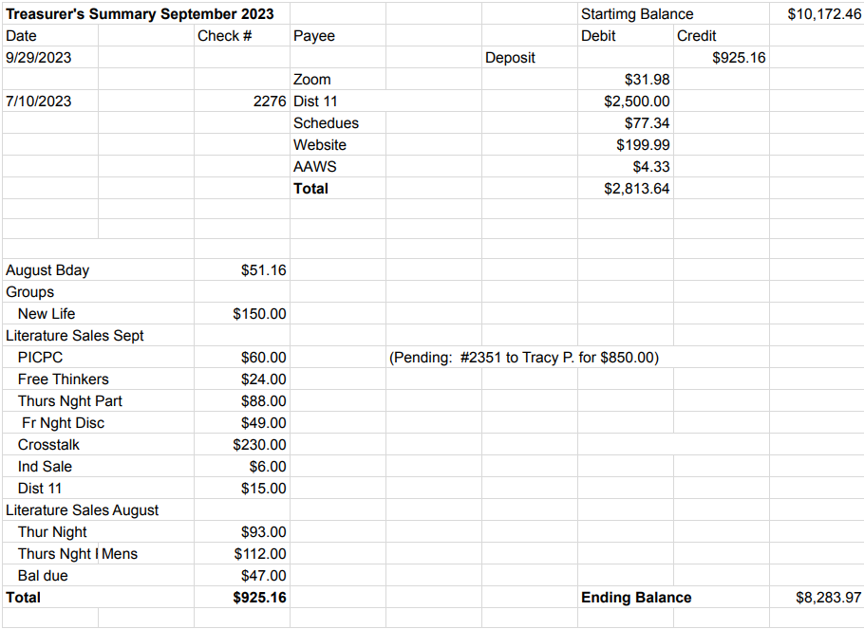

An increase in the Prudent Reserve will be added to November’s Agenda for discussion.

New Business

None.

Old Business

1.) 11th Step Meditation Workshop – October 7, 10:00-12:00pm at Crosswalk. Positive feedback was received regarding this workshop by an A.A. that attended the event and hopes it becomes a recurring event.

2.) Event Chair Updates: Discuss AA Anniversary Party (please announce at meetings)
Joy updated Intergroup on online sign-ups, venue and volunteering. She disclosed that no group has offered to chair and create a committee to execute. Meghan will be Chairing the Anniversary Party. Alcathon groups will be pleased to hear the funding increase was approved. Please continue to announce at your meetings.

Open Positions

1.) CURRENT Available Service Commitments 2023: District Liaison, Newsletter, H&I Liaison
2.) UPCOMING Service Commitments for the 2024-2025 Term: Birthday Co-Chairs, Hotline Chair, Chair & Alt Chair, Meeting Schedule Chair, Female delegate at large, General Service Liaison.

Announcements

Next Meeting Saturday, November 11, 2023 10:00am (Officers at 9:00am)

Closing – 11:37 am

The Responsibility Statement:

“I am Responsible. When anyone, anywhere, reaches out for help, I want the hand of A.A. always to be there. And for that: I am responsible.”

