Napa Valley Intergroup Meeting Minutes

November 11, 2023
TAKE BACKS:

December 9, 2023, Intergroup Officer terms will be voted on for 2024-2025!
(2-year commitment/2-year sobriety) Positions available are: Chair, Alt Chair, Birthday Co-Chairs, Hotline Chair, Meeting Schedule Chair, Newsletter Chair, Female delegate at large, General Service Liaison and H&I Liaison. 1-year commitments are: Secretary, District Liaison, Newsletter, H&I Liaison & Male Delegate at Large. If you are interested in any of those, take advantage of this opportunity to grow in service & join us on zoom 12/9!
Call To Order – 10:00 a.m.

A Moment of Silence followed by the Serenity Prayer

New Rep Introduction
New Intergroup Reps and Officers packets can be found on aanapa.org
https://aanapa.org/service/intergroup/welcome-new-intergroup-reps
Please provide your email and contact information to the Secretary.

Laura – Thanksgiving Alcathon Chair
Shari P. – Keep it Simple Sister

Meeting Participant Introductions – 14 in attendance

Sobriety Birthdays

Rick – 7 years 11/26

Review and approval of minutes – Minutes approved as submitted.

Monthly Tradition Reading from 12 Traditions Illustrated & Discussion

Reader: Jason – Tradition 11:

Tradition 11: Our public relations policy is based on attraction rather than promotion; we need always maintain personal anonymity at the level of press, radio and films.

- Jason read Tradition 11
- Michael B. will read Tradition 12 at December 2023 NVIG meeting.
- Discussion

7th Tradition
We have no dues or fees in A.A. We are entirely self-supporting, declining outside contributions. Visit https://www.aanapa.org and use the Venmo link or mail your contribution to NVIG, P.O Box 10948, Napa, CA 94581-2948 . Venmo link for IG contributions: https://www.venmo.com/u/NapaIG-AA

Housekeeping Motions

None.

REPORTS

Chair: Frank F. chair@aanapa.org

Greetings Trusted Servants,

I would like to share my joy regarding the wonderful and encouraging feedback I’ve received about our most recent IG Sponsored events.

First off, last month’s Meditation Workshop was so well attended and the calls for additional workshops are streaming in as a direct result. Secondly, our 79th Anniversary of AA in Napa was held over the Halloween Weekend. It too was well attended and produced a number of enthusiastic responses. Both events saw our fellowship engaged in super positive recovery scenarios and in vast numbers.

I am equally pleased to inform you that we now have all 3 Holiday Alcathons solidly sponsored by various groups and committees within the greater Valley Fellowship. Please visit https://aanapa.org/news for access to the flyers and to volunteer opportunities. We hope to see as many of you as possible in attendance at these cherished events. These events are some of the most fantastic things we can ever do for those in need of sober friends, warm surroundings and always a cornucopia of culinary delights…...uh, good food.

There it is, warmest wishes to all as we approach this Holiday Season sober, upright and together.

Frank F.
Chair – NVIG
ffradella@me.com
Mobile: 707-478-2886

Alternate Chair: Ann E. altchair@aanapa.org

Nothing to report.

Secretary: Patty B. secretary@aanapa.org

The Secretary Position will be accepting candidates to finish 1 year of the term due to relocation outside of the fellowship. If you or someone you know is interested, please make sure to attend the December Intergroup meeting to vote.

Literature Chair: Mary W. literature@aanapa.org
OCT 2023 | Literature Report
 | Meeting | Literature | Amount
Geoff M | Sunrise Group | 2 Big Book  1 Daily Reflection | 36.50 Check
Cindy | (Individual) | 1 Big Book | 12.00 Cash
Amy | (Individual) | Living Sober | 6.00 Cash
 |  | Donation | 2.00 Cash
TOTAL $56.50

The online literature order form is up and running. It, as well as the Printable Literature Order form, can be found on our website - aanapa.org. Select “Resources”, Select “Literature”, select “Online Literature Order form” or “Printable Literature Order form”

It appears there are still many members unaware that literature can be ordered online, or even how to go about ordering literature from Intergroup. Reps, please announce at meetings you attend. Thanks

Hotline Chair: Erik H. hotline@aanapa.org

Male Line: 26 Calls
Female Line: 9 Calls
General Extension: 21 Calls
Most calls were short lasting less than 2 minutes.
There were 6 calls lasting longer than 5 minutes including 1 over 25 minutes.

Stability of the hotline has improved with fewer missed calls and voicemails.

Web Editor: Alex W. (Intergroup) webeditor@aanapa.org Website Committee Chair: Jeff D. (District 11)

- ADA Compliance
  - Working to ensure our website is ADA Compliant – Ongoing
  - Seeking assistance to manage Spanish Translation

Meeting Schedule Chair: Mandy B. meetings@aanapa.org

Fall printed schedules continue to be restocked and disseminated to when requested. No one has made any corrections or comments, other than those directed to the web editor, so no news is good news! If anyone would like physical printed schedules for their meetings and/or groups, please contact Mandy at (707) 225-2309 and I can arrange getting them to you as we have about 100 copies left for the season.

Newsletter Chair: VACANT newsletter@aanapa.org

No Submission.

Delegates at Large: Katie Z. / Bill C. (John B. – Interim) delegateatlarge@aanapa.org

One Zoom at a Time (Wednesday) – 8:00 PM
Cottage Group (Sunday) – 7:30 PM
Thank God it’s (Thursday) – 5:30 PM
Rohlff’s Manor Meeting (Wednesday) – 12:00 PM
Men’s Stag (Saturday) – 7:00 AM

General Service Liaison: Jo M.
-District met in October and did not meet this month yet because of the Fall Inventory for our Area—held in Monterey this year this Saturday, following the Intergroup meeting.

-In October, our prudent reserve was increased from $800 to $3,000, in hopes for returning to in person meetings and expected costs.

-At the Fall Assembly, our Delegate to General Service in New York shared that the General Service Office is not fiscally strong and to please pass along our donations, as is possible. Our Area treasurer also informed us that Area has overspent income this last year, duplicating the plea to pass along funds our groups are holding.

-The Grapevine App has meant a great deal of investment and we are all encouraged to support it, as our sales of paper subscriptions and literature in general have been on the decline. Area has spent our funds on technology and interpretation, as has been approved by the Districts and Area officers to increase availability/access to our fellow alcoholics.
-There is a request for support for our Beginners’ Meeting on Friday nights at Crosswalk Church 5:45 PM. Secretaries have been found for the rest of the year, but we need members to show up for the newcomers who are coming to these meetings. It’s hybrid. Check aanapa.org to zoom.
Please refer to aanapa.org for events and further info on happenings.

Hospitals and Institutions Liaison: VACANT

H&I welcomes anyone to join us at our monthly business meeting 6:45 pm on the first Friday of the month at the Sea Scout Building 402 Riverside Drive Napa, CA 94559. Learn about the workings of H&I and how to get involved. Did you know that there are facilities that you can attend without filling out clearance paperwork, make a commitment or even share? Currently Area 51 brings 26 meetings a week and literature to the Women’s Jail, Men’s Jail, Men’s Jail Spanish, California Medical Facility, Crestwood Behavior Center Vallejo, Crestwood Behavior Center Angwin, National Vallejo, Napa South Shelter, Napa State Hospital Spanish, Napa State Hospital English, Queen of the Valley Hospital, and Vallejo Detox. You can learn more about H&I by going to http://www.handinorcal.org or by contacting John Curnutt 707-477-0422 john@curnutt.org

The word on the street is that Archway Recovery Services has been awarded the contract to take over the Napa County Drug and Alcohol recovery programs. https://www.recoveryatarchway.com/ This would be the replacement for CenterPoint program located outside the fence at Napa State Hospital. Once we find out more about when and in what capacity Archway will begin services, H&I will reach out to see if they would like us to provide AA meetings and literature to clients.

ABOUT ARCHWAY RECOVERY SERVICES: Substance Use Disorder Treatment & Rehabilitation Programs Since 1995. Founded in 1995 and incorporated in 2002, we have helped many on the journey to recovery. We have expanded our recovery services with detox, residential, outpatient, and sober living facilities in both Solano and Napa Counties.

Make credit card contributions online and get an immediate receipt: www.handinorcal.org/contribute Please make sure to write on contribution checks AREA 51. This allows H&I to track donations by the Napa area. H&I business meeting is back to in person meetings at the Sea Scouts. Next meeting on December 1st in person Sea Scouts 6:45pm.

Financial Oversight Committee: financial@aanapa.org

Since the Financial Oversight Committee (FOC) has been constituted to meet on an as-needs basis, there was nothing new to report.

Birthday Meeting Co-Chairs: Meghan T. & Heather B. birthdaymeeting@aanapa.org

October 27, 2023
7th Tradition: $344.00
H&I: $15.63
Total Income: $359.63
Total Expenses: $54.83 - Cake $25.00, Refreshment supplies $22.00, Negative balance September 2023 -7.83
Net Income: $ 304.80

18th Month Chip will be introduced at the December 2023 meeting

Treasurer: Christina (Tena) treasurer@aanapa.org

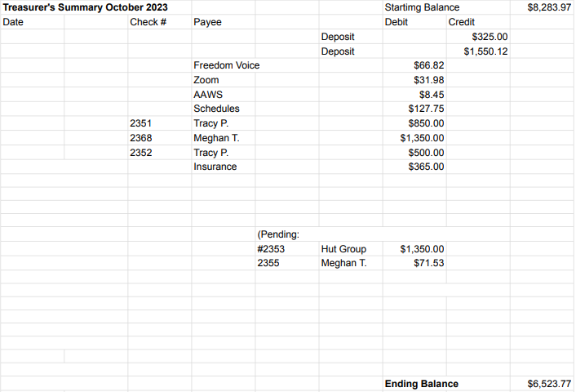

New Business

1.) Tracy wishes to host a “Sponsorship Workshop.” – will come back with a budget proposal at the December meeting for a January event.
2.) Thanksgiving Alcathon Update – Laura K
3.) New workshop budget review has been requested of FOC – will be brought at the December meeting

Old Business

None.

Open Positions

1.) CURRENT Available Service Commitments 2023: District Liaison, Newsletter, H&I Liaison, Secretary, Male delegate at large (1 year term)
2.) UPCOMING Service Commitments for the 2024-2025 Term: Birthday Co-Chairs, Hotline Chair, Chair, Alt Chair, Meeting Schedule Chair, Female delegate at large, General Service Liaison.

Announcements – Michael B.: Join us for Santa’s Helper Day – December 9, 2023 from 1-4 PM. Fun-filled kids’ event where adults can join the excitement too!

Next Meeting Saturday, December 9, 2023 10:00am (Officers at 9:00am)

Closing – 11:20 am

The Responsibility Statement:

“I am Responsible. When anyone, anywhere, reaches out for help, I want the hand of A.A. always to be there. And for that: I am responsible.”

